Chapter 13. Hosting PyTorch Models for Serving

In the earlier chapters of this book, we looked at many scenarios for training ML models, including those for computer vision, NLP, and sequence modeling. But that was just the first step—a model is of little use without a way for other people to use its power! In this chapter, we’ll take a brief tour of some of the more popular tools that allow you to give them a way to do that.

You should note that taking a trained PyTorch model to a production-ready service will involve a lot more than just deploying it, and that the machine learning operations (MLOps) discipline is designed with that in mind. When you get into the world of serving these models, you’ll need to understand new challenges, such as handling real-time requests, managing computational resources, ensuring reliability, and maintaining performance under varying loads.

Ultimately, MLOps is about bridging the gap between data science and software engineering. That’s beyond the scope of this chapter, but there are some great books about it out there from O’Reilly, including [*Implementing MLOps in the Enterprise*](https://learning.oreilly.com/library/view/implementing-mlops-in/9781098136574)by Yaron Haviv and Noah Gift and [*LLMOps*](https://learning.oreilly.com/library/view/llmops/9781098154196) by Abi Aryan.

This chapter will introduce two popular approaches to serving PyTorch models in production environments.

We’ll begin with TorchServe, the official serving solution from PyTorch, which provides a robust framework that’s designed specifically for serving deep-learning models at scale. TorchServe offers out-of-the-box solutions for standard serving requirements like model versioning, A/B testing, and metrics collection. It’s also an excellent choice for teams who are looking for a production-ready solution with minimal setup.

Then, we’ll explore how to build serving solutions using the popular Flask framework, which is for developers who need more flexibility or have more straightforward serving requirements. Flask’s simplicity and extensive ecosystem also make it an excellent choice for smaller-scale deployments and proof-of-concept services.

As you work through the chapter, you’ll take a hands-on approach in which you’ll take some of the models you created in earlier chapters, let us walk you through how to deploy them, and then call their hosting servers for inference.

Introducing TorchServe

*TorchServe* is PyTorch’s default serving framework that’s designed for performance and flexibility. You can find it at [*pytorch.org/serve*](http://pytorch.org/serve).

TorchServe’s goal was originally to be a reference implementation on how to properly serve models with a modular extensible architecture, but it has grown beyond that into a fully performant professional-grade framework that is likely more than enough for any serving needs.

It’s also built on a modular architecture with the aim to handle the complexity of serving models at scale. To this end, it’s built from the following key components:

*The model server*

The PyTorch model server is the central component that handles the lifecycle of models and handles all inference requests. It provides the endpoints for model management and inference, supporting REST and gRPC calls.

*Model workers*

These are independent processes that load models and perform inference on them. Each one is isolated, so in a multimodel serving environment, they are designed to continue operating should issues in one model arise.

*Frontend handlers*

These are custom Python classes that handle preprocessing, inference, and post-processing for specific model types. As you’ll see in a moment, when we get hands-on, frontend handlers are complementary to the training code for the model, and it’s good practice to create separate handler classes.

*The model store*

Model serving in PyTorch uses “model archives,” or MAR files, for the servable object. Once you’ve trained your model, you’ll convert it into this format. The model store is where these are kept.

You can see the architecture diagram for a TorchServe system in [Figure 13-1](https://learning.oreilly.com/library/view/ai-and-ml/9781098199166/ch13.html#ch13_figure_1_1748549772551219).

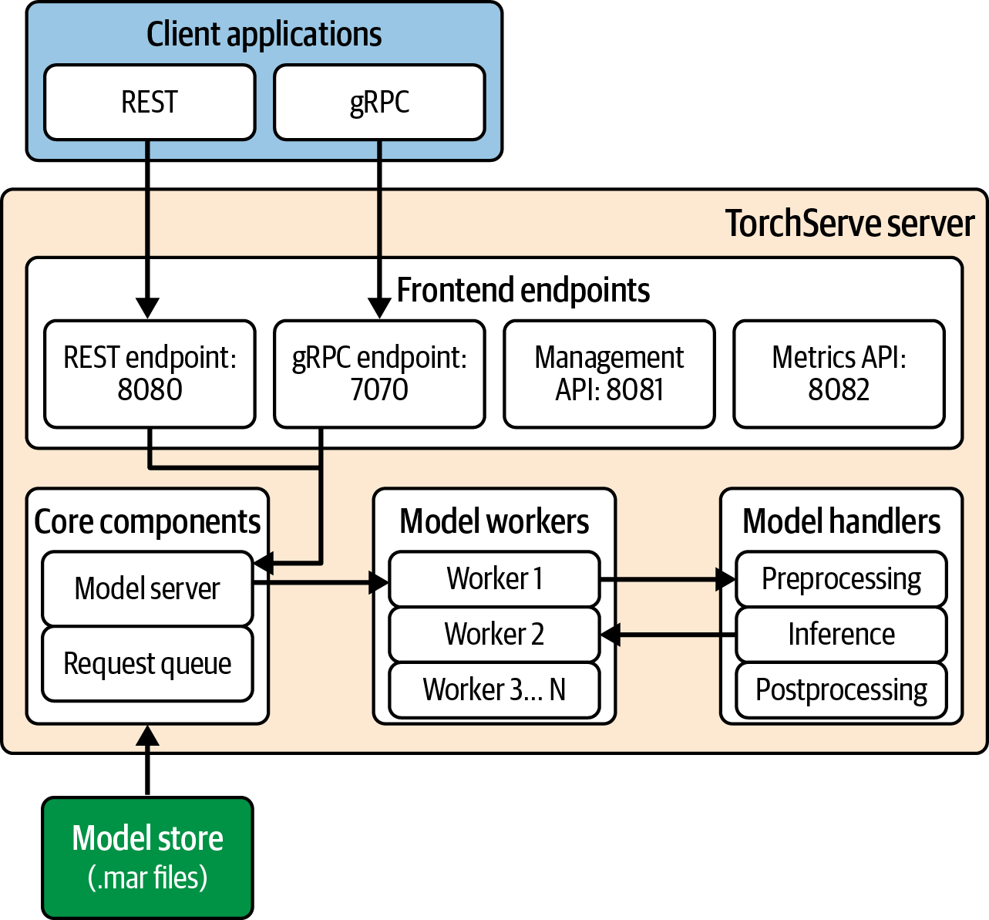

Figure 13-1. The TorchServe server infrastructure

For inference, the client application will call the server infrastructure over REST (via default port 8080) or gRPC (via default port 7070). It also provides management endpoints at 8081 and 8082, respectively.

The endpoint will then call the core model server, which in turn will spawn the appropriate number of model workers. The workers will then interface with the model handlers to do preprocessing, inference, and postprocessing. The model itself will be in the model store, and should it not be in memory, the model server will use the request queue to load it.

In the next section, we’ll explore setting up a TorchServe server and using it to provide inference for the first model you created in [Chapter 1](https://learning.oreilly.com/library/view/ai-and-ml/9781098199166/ch01.html#ch01_introduction_to_pytorch_1748548870019566).

Setting Up TorchServe

I find it’s easiest to learn something if I go through it step-by-step with a simple but representative scenario. So, for TorchServe, we’ll install the environment first and work from there.

**Preparing Your Environment**

I strongly recommend using a virtual environment, and I’ll be stepping through this chapter using venv, which is a freely available one from the Python community that you can find [in the Python documentation](https://oreil.ly/FNsPt).

Even if you’ve used virtual environments before, I’d recommend starting with a clean one to ensure you are going to install and use the right set of dependencies.

You can create a virtual environment like this:

python3 -m venv chapter12env

And once you’ve done that, you can start it with this:

source chapter12env/bin/activate

Then, you’ll be ready to install PyTorch. To get started, I recommend installing TorchServe, the model archiver, and the workflow archiver like this:

pip install torchserve torch-model-archiver torch-workflow-archiver

You aren’t limited to these, and you’ll often need to install other dependencies. One of the difficulties of working with TorchServe is that errors may be buried in log files, so it’s hard to figure out which dependencies you’ll also need. At a minimum, I’ve found that starting from a clean system, I also needed to install a JDK after version 11 and PyYAML. Your mileage may vary.

Once you’ve done this, you can change to the directory where you want to work, and within that, you can create a subdirectory called model_store:

mkdir model_store

With that in place, the first thing you’ll need to do is set up the configuration file for your PyTorch server. It will be a file called *config.properties*.

**Setting Up Your config.properties File**

There’s a lot going on in this file, and you can learn more about it on the [PyTorch site](https://oreil.ly/czQh5). But the important settings are the inference and management addresses, which are set to 0.0.0.0 and 8080/8081, respectively (similar to what’s shown in [Figure 13-1](https://learning.oreilly.com/library/view/ai-and-ml/9781098199166/ch13.html#ch13_figure_1_1748549772551219)). Also, it’s important to set the directory of the model store to be the one you just created. I’ve also set it to log debug messages to help catch dependency issues:

# config.properties

inference_address=http://0.0.0.0:8080

management_address=http://0.0.0.0:8081

metrics_address=http://0.0.0.0:8082

number_of_netty_threads=32

job_queue_size=1000

model_store=model_store

default_response_timeout=120

default_workers_per_model=1

log_level=DEBUG

Make sure these settings are in a file with the name *config.properties*.

**Defining Your Model**

In [Chapter 1](https://learning.oreilly.com/library/view/ai-and-ml/9781098199166/ch01.html#ch01_introduction_to_pytorch_1748548870019566), you created a model that learned the relationship between two sets of numbers, when the equation describing this relationship was *y* = 2*x* – 1. When you’re getting the model ready for serving, it’s best practice to have a separate file for the model definition and the model training. The model definition file will then be used in another Python file called the *handler*, which you’ll see momentarily. So, to that end, you should create a model definition file, like this:

import torch

import torch.nn as nn

class SimpleLinearModel(nn.Module):

def __init__(self):

super().__init__()

self.linear = nn.Linear(1, 1)

def forward(self, x):

return self.linear(x)

Then, save this into a file called *linear.py* so that you can then load and train it with code like the following. Also note the import for SimpleLinearModel that is bolded:

import torch

import torch.nn as nn

import torch.optim as optim

from linear import SimpleLinearModel

def train_model():

model = SimpleLinearModel()

optimizer = optim.SGD(model.parameters(), lr=0.01)

criterion = nn.MSELoss()

xs = torch.tensor([[–1.0], [0.0], [1.0], [2.0], [3.0], [4.0]],

dtype=torch.float32)

ys = torch.tensor([[–3.0], [–1.0], [1.0], [3.0], [5.0], [7.0]],

dtype=torch.float32)

for _ in range(500):

optimizer.zero_grad()

outputs = model(xs)

loss = criterion(outputs, ys)

loss.backward()

optimizer.step()

return model

# Save model

model = train_model()

torch.save(model.state_dict(), "model.pth")

In particular, note the last line, where, after training the model, it’s saved as a *model.pth* file, along with this piece of code: mode.state_dic(), which saves out the *state dictionary* (aka the current state of the trained model). I find that this way of saving out a model works best with TorchServe.

Then, you run this code to get the file. You’ll use this later to create a *.mar* file that goes in the model store. We’ll look at that shortly, but first, we’ll need a handler file. You’ll explore that next.

**Creating the Handler File**

Once you’ve trained and saved the model, you’ll need to create the handler file. It’s the job of the handler to do the heavy lifting of serving inference—it loads your model, handles data preprocessing, does the inference, and handles any postprocessing to turn the inferred values back into data your users may want.

This file should inherit from the base_handler torch class like this:

from ts.torch_handler.base_handler import BaseHandler

Once you’ve done this, you’ll need to create a model handler class that overrides this base class and implements a number of methods.

Let’s start with the class declaration and initialization. It’s pretty straightforward: just reporting on class initialization:

class ModelHandler(BaseHandler):

def __init__(self):

super().__init__()

self.initialized = False

logger.info("ModelHandler initialized")

Note that an initialized property is set to False in this code. That may seem odd, but the idea here is that this code will initialize the *class* but it won’t be ready to use until the initialize custom function is called. That function will then load the model and get it ready for inference, and at that point, we will set self.initialized to be True. Note that the model is initialized as a SimpleLinearModel, so you’ll need to import it in the same way as you did the training code.

Here’s the code:

def initialize(self, ctx):

self.manifest = ctx.manifest

properties = ctx.system_properties

model_dir = properties.get("model_dir")

# Load model

serialized_file = "model.pth"

model_pt_path = os.path.join(model_dir, serialized_file)

self.device = torch.device("cuda:" + str(properties.get("gpu_id"))

if torch.cuda.is_available() else "cpu")

# Initialize model

self.model = SimpleLinearModel()

state_dict = torch.load(model_pt_path, weights_only=True)

self.model.load_state_dict(state_dict)

self.model.to(self.device)

self.model.eval()

self.initialized = True

return self

It begins by reading ctx.manifest—which is information in the*MAR* file (such as the model directory) that lets you use the model. We’ll see how to create that file shortly.

The rest of the code is pretty straightforward: we create an instance of the model (called SimpleLinearModel, as shown in the previous code) and load its weights from where they were saved in (*model.pth*). We can then push the model to the device, where we will do inference, such as the CPU or CUDA, if it’s available. Then, we’ll put the model into evaluation mode for inference. I have found that TorchServe works best if you save the model with its state dictionary, so be sure to load that back, as shown.

At that point, we set self.initialized to True, and we’re good to go for inference!

The next method we need to override is the *preprocess method*, which will take the input data and turn it into the format the model needs. There are many ways in which you could post the data to the backend server, and it’s in the preprocess function that you’d handle them. You could, for example, just take basic parameters, or you could allow your user to post a JSON file. It’s up to you, and this flexibility in the TorchServe architecture opens up those possibilities.

For the sake of simplicity, I’m just going to take a basic parameter in this code:

def preprocess(self, data):

# Get the value directly without decoding

value = float(data[0].get("body"))

tensor = torch.tensor([value], dtype=torch.float32).view(1, 1)

return tensor.to(self.device)

As you can see, the main purpose of this is not only to *get* the parameters but also to *reformat* them into the format the model needs. So, it gets the parameter from the request call and turns it into a single-dimension tensor, which it will then return. This tensor will be used in the inference method.

The next method to override is the inference method, and here’s where we will pass the data into the model and get its response back. Here’s the code:

def inference(self, data):

"""Run inference on the preprocessed data"""

with torch.no_grad():

results = self.model(data)

return results

This receives the preprocessed data from the previous step, so we can just get the output by passing in this data. We run it with torch.no_grad() because we aren’t interested in backpropagation, just a straight inference.

Finally, there’s postprocessing. The end user isn’t expecting a tensor back, but they are expecting more human-readable data, so we do the reverse of the preprocess step and cast the result back to a float by using NumPy:

def postprocess(self, inference_output):

"""Return inference result"""

return inference_output.tolist()

These steps are, as you can see, very customized to this model, and I’ve deliberately made them bare-bones so you can see the flow—but the general architecture remains the same for other models, regardless of the complexity. The goal is to give you a standard way to approach the problem, and code that extends the BaseHandler like this makes it easy for you to take advantage of all the unseen aspects of the server infrastructure—not least, passing the data around!

**Creating the Model Archive**

Starting with a trained model, you can create the archive file for it by calling torch-model-archiver, which is a command-line tool that’s provided as part of TorchServe.

There are a few things you need to note and be careful of here. Here’s the command, and I’ll discuss the parameters afterward:

torch-model-archiver

--model-name simple_linear

--version 1.0

--serialized-file model.pth

--handler model_handler.py

--model-file models/linear.py

--export-path model-store

--force

--extra-files models/linear.py,models/__init__.py

Before running it, make sure you have a *model-store* (or similar) directory that you will store the archived model in. Don’t mix it up with your source code! This can simply be a subdirectory, and you’ll specify that directory in the export-path parameter.

The model-name parameter will specify the name of the model in the model store. You can call it whatever you want—it doesn’t have to be the class name. In this case, I called it simple-linear.

The version parameter can be whatever you want, and you’ll use it for tracking. As you train new versions of your model for new and different scenarios or bug fixes, you’ll likely want to keep track of which version does what. You can let the server know about that here.

When you trained the model, you saved the weights and the state dictionary out to a file. You specify this file with the serialized-file parameter. In this case, it’s model.pth.

The handler file is specified with the handler parameter.

A common problem I have encountered occurs when the model training file contains the model definition *and* the handler also contains it. TorchServe gets confused as to where to get the model definition, and that’s why I separated it out in this case. But if you need to do that, it’s important to specify *where* the model definition is, and you can do that with the model-file parameter. Note that following this methodology, you should also point to the location of the model file by using the extra-files parameter. To make the model file importable to both the model training and model handler as a package, I put the file in a directory called *models* and put an empty file called *_ _init_ _.py* in there. To make sure that the model archiver uses these, *both* of these files are specified in the extra-files parameter.

The force parameter just overwrites any existing model archive in the *model-store* directory. When you’re learning, this parameter saves you from having to delete the model archive manually when trying different things. However, in a production system, you should use it carefully!

Once this line runs correctly, your *model-store* directory should contain a *simple_linear.mar* file.

**Starting the Server**

Once you’ve created your archive, you can start TorchServe and have it load that model. Here’s an example command:

torchserve

--start

--model-store model-store

--ts-config config/config.properties

--disable-token-auth

--models simple_linear=model_store/simple_linear.mar

The start parameter instructs TorchServe to start. You can also use --stop in the same way to stop it from executing (and filling your terminal with a wall of text).

The model-store parameter should also point to the directory where you store the *.mar* file that you created earlier.

The ts-config parameter should point to the configuration properties file you created earlier.

When you’re learning and testing, you can use --disable-token-auth so that commands you send to the server to test your models don’t need authentication. However, in proper production systems, you probably wouldn’t want to use it!

The models parameter is a list of models that you want the server to make available to your users. In this case, there’ll just be one, and it’s the simple_linear model we defined. If you give the path to this model as the value, you’ll see that it’s the location of the *mar* file in the model_store.

If all goes well, you should then see TorchServe start in your terminal and give you a wall of status text, a little like in [Figure 13-2](https://learning.oreilly.com/library/view/ai-and-ml/9781098199166/ch13.html#ch13_figure_2_1748549772551268).

Note that if this text is constantly scrolling, it’s likely that there was an error in starting up TorchServe. From experience, I would say that there are dependencies that TorchServe needs (like PyYAML) that haven’t been installed. If that’s the case, then the configuration file was set to debug, and you can inspect the *models_log.log* file in the *logs* directory to see what’s going on.

You may also see errors like the one in [Figure 13-2](https://learning.oreilly.com/library/view/ai-and-ml/9781098199166/ch13.html#ch13_figure_2_1748549772551268), where it can’t find the nvgpu module. This module is used by TorchServe to do GPU-based inference with an Nvidia GPU. Because I was running on a Mac in this case, you can safely ignore the error, and all inference will just run on the CPU, as per the code in the handler.

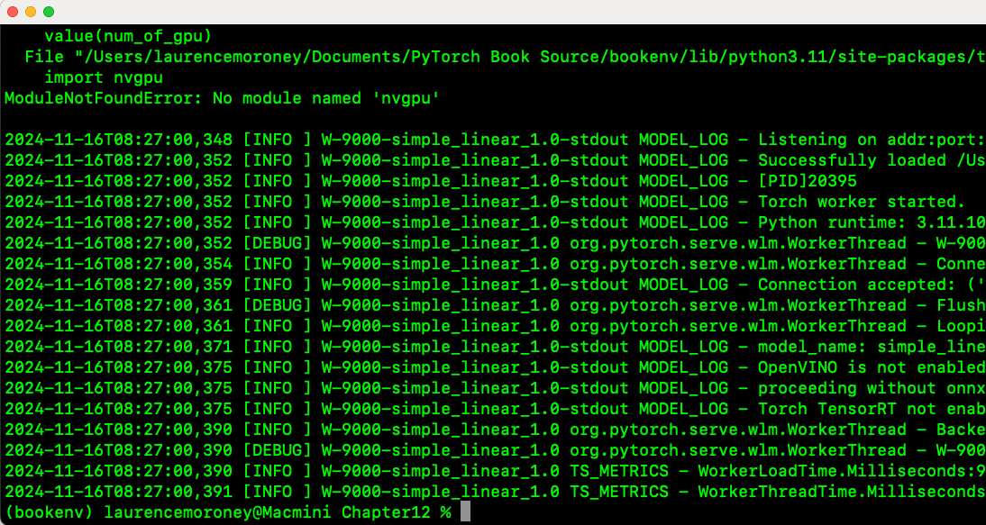

Figure 13-2. Starting TorchServe

**Testing Inference**

Once the server is successfully up and running, you can test it by using curl from another terminal.

So, to get an inference from the model, you can curl like this:

curl -X POST http://127.0.0.1:8080/predictions/simple_linear -H

"Content-Type: text/plain" -d "5.0"

Notice that it is an HTTP POST to the predictions endpoint. We specify the simple_linear model name as defined with the *.mar* file earlier, and we can then add the header (with the -H parameter) as plain text containing the data 5.0.

As you may recall, the model learned the linear relationship *Y*= 2*x* – 1, so in this case, *x* will be 5 and the result will be a number close to 9.

The return should look like this:

[

8.997674942016602

]

Your value may vary, based on how your model was trained, but it should be a value very close to 9.

You can also use the management endpoint to inspect the models that the server is hosting, like this:

curl http://localhost:8081/models

The response will contain the name and location of the *.mar* file for each model on the server:

{

"models": [

{

"modelName": "simple_linear",

"modelUrl": "model_store/simple_linear.mar"

}

]

}

Note that earlier, when you did inference on the model, you used the predictions endpoint followed by a model name, which in that case was simple_linear. This key should map to a model name in this models collection, or you would have gotten an error.

Finally, if you want to explore the details of a specific model, you can call the management URL (via port 8081, as earlier) with the model’s endpoint and the name of the model you want to know more about:

curl http://localhost:8081/models/simple_linear

The server will return some detailed specs on the model, along with information you can use to help debug any issues. Here’s an example:

[

{

"modelName": "simple_linear",

"modelVersion": "1.0",

"modelUrl": "model_store/simple_linear.mar",

"runtime": "python",

"minWorkers": 1,

"maxWorkers": 1,

"batchSize": 1,

"maxBatchDelay": 100,

"responseTimeout": 120,

"startupTimeout": 120,

"maxRetryTimeoutInSec": 300,

"clientTimeoutInMills": 0,

"parallelType": "",

"parallelLevel": 0,

"deviceType": "gpu",

"continuousBatching": false,

"useJobTicket": false,

"useVenv": false,

"stateful": false,

"sequenceMaxIdleMSec": 0,

"sequenceTimeoutMSec": 0,

"maxNumSequence": 0,

"maxSequenceJobQueueSize": 0,

"loadedAtStartup": true,

"workers": [

{

"id": "9000",

"startTime": "2024-11-16T08:26:59.394Z",

"status": "READY",

"memoryUsage": 0,

"pid": 20395,

"gpu": true,

"gpuUsage": "failed to obtained gpu usage"

}

],

"jobQueueStatus": {

"remainingCapacity": 1000,

"pendingRequests": 0

}

}

]

Notice, for example, that the deviceType is expecting gpu. However, since I don’t have nvgpu on this system (see the earlier note about when you ran the server), it can’t load from the GPU, and the workers reported on that. It’s OK for that to be the case in my dev box, which doesn’t have the Nvidia GPU—but should you be running this on a server that *does* have the Nvidia GPU, that message is something you’d want to follow up on, and it’s likely an issue in your handler file.

**Going Further**

The foregoing was a bare-bones example to help you understand the nuts and bolts of how TorchServe works. As you use more sophisticated models that take in more complex data, the basic pattern you followed here should follow suit. In particular, the breakdown of preprocessing, inference, and postprocessing in the handler file is an enormous help! Additionally, the PyTorch ecosystem has add-ons for common scenarios to help you avoid having to write preprocessing code to begin with! For example, if you are interested in image classification and are worried about taking an image and turning it into tensors so that you can do inference on that image, the ImageClassifier class builds on the base handler to do this for you, and you can have image classification without needing to write a preprocessor. To see more of this in action, take a look at the open source examples at the PyTorch repository. In particular, you can go to [this GitHub page](https://oreil.ly/YA4v4) for an example of how to create a handler for MNIST images.

You’ll find many more useful examples in that repo, but I would still recommend going through the steps to get a bare-bones example like the one we showed here up and running first. There are a lot of steps and a lot of concepts, and it’s easy to get lost in the maze.

Serving with Flask

While TorchServe is extremely powerful, a great alternative that’s super easy to use is Flask. Flask is a lightweight and flexible web framework for Python that enables efficient development of web applications and APIs.

You can use Flask to build everything from minimal single-endpoint services to complex web applications, starting with just a few lines of code. It perfectly complements PyTorch by giving you the ability to host models for inference, as we’ll explore in this section.

As a microframework, Flask provides the essential components for web development—routing, request handling, and templating—while allowing you to select additional functionality as needed. It is highly extensible, with stuff like a backend database, authentication, etc., and there’s also a vibrant ecosystem of extensions available to use off-the-shelf. Because of all of this, Flask has become a standard tool in web development, powering applications across industries at all scales.

In this chapter, we’ll just explore Flask from the hosting model’s perspective, but I’d encourage you to dig deeper into the framework if you’re interested in serving Python code—not just PyTorch!

Now, let’s take a look at the same example that we used for TorchServe. This will help you see how simple Flask makes serving applications!

**Creating an Environment for Flask**

First, to use Flask, you’ll need to install it and any dependencies. If you’ve been using the same environment as earlier in this chapter, you can simply update it with this:

pip install flask

Then, just ensure that you have a model definition and training file—exactly the same as those from earlier in this chapter—and that you have trained a model and saved it with its state dictionary as a file called *model.pth*.

With those in hand, all you’ll need is a single Python file that I’m going to call *app.py*, which will be the primary server application that Flask will use. We’ll explore the code in that file next.

**Creating a Flask Server in Python**

To create a server with Flask, you implement an app that creates a new Flask instance by using the following code:

app = Flask(__name__)

Then, on the app object, you can specify routes, such as predict for doing prediction on models. To serve, you implement the code for the endpoints at these routes. Here’s an example of a full Flask server for our simple app:

from flask import Flask, request, jsonify

import torch

from model_def import SimpleLinearModel

app = Flask(__name__)

# Load the trained model

model = SimpleLinearModel()

model.load_state_dict(torch.load("model.pth"))

model.eval()

@app.route("/predict", methods=["POST"])

def predict():

value = float(request.form.get('value', 0))

input_tensor = torch.tensor([[value]], dtype=torch.float32)

with torch.no_grad():

prediction = model(input_tensor)

return jsonify({

"input": value,

"prediction": prediction.item()

})

if __name__ == "__main__":

app.run(port=5001)

**Note**

Flask documentation and samples tend to use port 5000. If you’re using a Mac as your development box, you might have issues with this as it conflicts with the port used by Airplay. To that end, I’ve used 5001 in this sample.

In this case, we declare the SimpleLinearModel and load it along with its state dictionary. Then, we put it into eval() mode to get it ready for inference.

Then, it becomes as simple as creating a route that we call predict and then implementing the inference within it. As you can see, we handle getting the value from the HTTP POST, converting it into a tensor, and getting the prediction back when we pass that tensor to the model.

To make the return a little friendlier, I used jsonify to turn it into a name-value pair. As you can see, that’s much simpler than using TorchServe, but for that simplicity, you give up power. There’s no set of base classes to handle preprocessing, post-processing, etc., and if you want to scale or implement multiple worker threads, you’ll have to do it yourself.

I think this is a really useful and powerful server mechanism for smaller-scale environments, as well as for learning how to serve. For large-scale production environments, it’s a lot of extra work, but it can definitely handle the load.

For inference, you can curl a POST to the model like this:

curl -X POST -d "value=5" http://localhost:5001/predict

And the response will be the JSON payload:

{"input":5.0,"prediction":8.993191719055176}

In addition to TorchServe and Flask, there are many other serving options, such as ONNX and FastAPI.

Summary

In this chapter, we explored two popular approaches to serving PyTorch models in production environments. You started with TorchServe, which is PyTorch’s official serving solution that offers a robust framework with built-in support for model versioning, A/B testing, and metrics collection. It’s also designed to be highly scalable at runtime, with a worker-thread architecture that’s configurable based on the needs of your app. And while TorchServe requires more setup and understanding of its components like model workers and frontend handlers, I think it’s worth investing the time in rolling up your sleeves and understanding all the different components and how they work together. To that end, you explored step-by-step how to take the simple linear model example from [Chapter 1](https://learning.oreilly.com/library/view/ai-and-ml/9781098199166/ch01.html#ch01_introduction_to_pytorch_1748548870019566), save it, archive it, build a handler for it, and launch the server with the model details.

Then, you explored how to use Flask as a lightweight alternative that’s extremely quick and simple to get up and running. You saw how its minimalist approach makes it ideal for smaller-scale deployments or proof-of-concept services. It’s not limited to those, but as you move to production scale, you’ll likely need to implement more code. Of course, that’s not necessarily a disadvantage, as it gives you more granular control over your serving environment.

Both approaches have their place in the ML serving ecosystem. TorchServe shines in enterprise environments requiring comprehensive model management, while Flask’s simplicity makes it perfect for smaller projects or learning environments with a smooth glide path toward scalable production. Of course, you aren’t limited to just these two, and new frameworks are coming online all the time—in particular, one called FastAPI, which is rapidly growing in popularity. Which one you should choose ultimately depends on your specific needs around scaling, monitoring, and deployment complexity.

Next, in [Chapter 14](https://learning.oreilly.com/library/view/ai-and-ml/9781098199166/ch14.html#ch14_using_third_party_models_and_hubs_1748549787242797), you’re going to look at third-party models that have been pretrained for you and various registries and hubs that you can load them from.

Chapter 14. Using Third-Party Models and Hubs

The success of the open source PyTorch framework has led to the growth of supplementary ecosystems. In this chapter, we’ll look at the various options of pretrained models and the associated tools and resources used to download, instantiate, and use them for inference.

While the PyTorch framework provides the foundation for deep learning, the community has created numerous repositories and hubs that store models that are ready to use and extend, making it easier for you to use and extend existing work rather than starting from scratch. I like to call this “standing on the shoulders of giants.”

Since the advent of generative AI, these hubs have exploded in popularity, and many scenarios of generative ML models within workflows have grown out of this. As a result, when it comes to using pretrained models, there are many options. You might use them directly for inference, taking advantage of those trained on massive datasets that would be impractical to replicate. Or you might use these models as starting points for fine-tuning, adapting them to specific domains or tasks while retaining their learned features. This can take the form of low-rank adaption (LoRA), as we’ll discuss in [Chapter 20](https://learning.oreilly.com/library/view/ai-and-ml/9781098199166/ch20.html#ch20_tuning_generative_image_models_with_lora_and_diffu_1748550104901965), or *transfer learning*, in which knowledge from one task is applied to another. Transfer learning or other fine-tuning has become a standard practice, especially when working with limited data or computational resources.

The advantages of using pretrained models extend beyond saving computational resources and time. These models often represent state-of-the-art architectures, and they’ve been trained on diverse, high-quality datasets that you may not have direct access to.

Additionally, the providers generally release the model with extensive documentation, performance benchmarks, and community support, giving you a long head start. Given the importance of responsible AI, these models often come with model cards that help you understand any research and work done so you can navigate any potential responsibility issues.

There is no “One Hub to Rule Them All,” so it’s useful to understand each of the major ones and how you can make the most of them. To that end, we’ll look at some of the more popular ones in this chapter.

Hugging Face has become the de facto standard for transformer models, while PyTorch Hub offers officially supported implementations. Platforms like Kaggle provide competition-winning models, and GitHub-based TorchHub enables direct access to research implementations.

I think it’s important for you to understand these resources and how to use them effectively. As the field of deep learning continues to advance, these hubs play an increasingly crucial role in widening access to state-of-the-art models and enabling rapid development of AI applications. And as the role of AI developer matures and grows, I’m personally seeing huge growth in the careers of software developers who don’t train models from scratch and instead use or fine-tune existing ones. To that end, I hope this chapter helps you grow!

The Hugging Face Hub

In recent years, particularly with the rise of generative AI, the Hugging Face Hub has emerged as a leading platform for discovering and using pretrained ML models, particularly for NLP. Much of its usefulness (and a significant driver of its success) is the open source availability of two things: a transformers library (which makes using pretrained language models very easy to use) and a diffusers library (which does the same for text-to-image generative models like stable diffusion).

As a result, what started as a repository for transformer-based models has evolved into a comprehensive ecosystem supporting computer vision, audio processing, and reinforcement learning models. It has grown into a one-stop shop combining version control for models, documentation, and model cards—and because of the PyTorch-friendly libraries like transformers and diffusers, using these models with your Python and PyTorch skills is relatively easy.

Collaboration has also been one of the keys to the Hub’s success. You can download, use, and fine-tune models with just a few lines of code, and many developers and organizations have shared their models or fine-tunes with the community. There were over 900,000 publicly available models at the time of writing, so there’s plenty to choose from!

**Using Hugging Face Hub**

Before rolling up your sleeves to code with Hugging Face Hub, you should get an account and use it to get an API token.

**Getting a Hugging Face token**

This section will walk you through the [*HuggingFace.co*](http://huggingface.co/) user interface as it existed at the time of writing. It may have changed by the time you’re reading this, but the principles are still the same. Hopefully, they’ll still apply!

Start by visiting [*Huggingface.co*](http://huggingface.co/), and if you don’t already have an account, you can use the Sign Up button at the top right to create one (see [Figure 14-1](https://learning.oreilly.com/library/view/ai-and-ml/9781098199166/ch14.html#ch14_figure_1_1748549787233053)).



Figure 14-1. Signing up for Hugging Face

Once you’ve signed up and gotten an account, you can sign in, and in the top-right-hand corner of the page, you’ll see your avatar icon. Select this and a drop-down menu will appear. On this menu, you’ll see an option to Access Tokens, and you can select it to view your access tokens (see [Figure 14-2](https://learning.oreilly.com/library/view/ai-and-ml/9781098199166/ch14.html#ch14_figure_2_1748549787233102)).

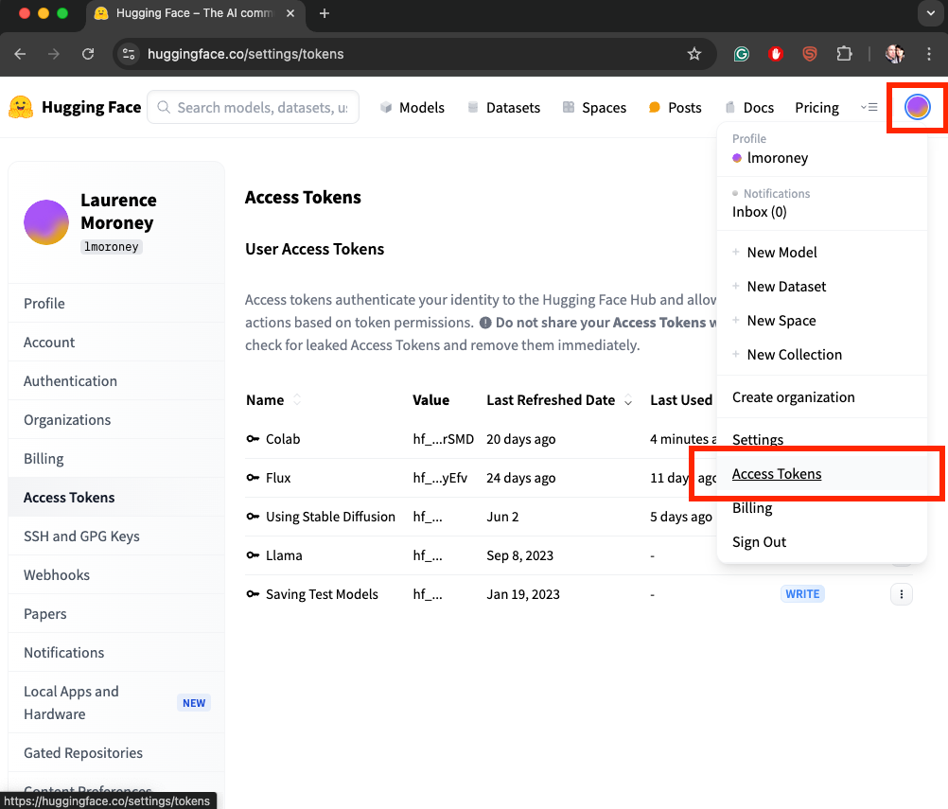

Figure 14-2. Access tokens

On this page, you’ll see a Create New Token button, which will take you to a screen where you can specify your token details. Select the Read tab and give the token a name. For example, in [Figure 14-3](https://learning.oreilly.com/library/view/ai-and-ml/9781098199166/ch14.html#ch14_figure_3_1748549787233128), you can see where I created a new Read token called PyTorch Book.

You’ll also see a pop-up asking you to save your access token (see [Figure 14-4](https://learning.oreilly.com/library/view/ai-and-ml/9781098199166/ch14.html#ch14_figure_4_1748549787233152)). Note that it tells you that you will not be able to see the token again after you close this dialog modal, so be sure to hit the Copy button to have the token ready for the next steps.

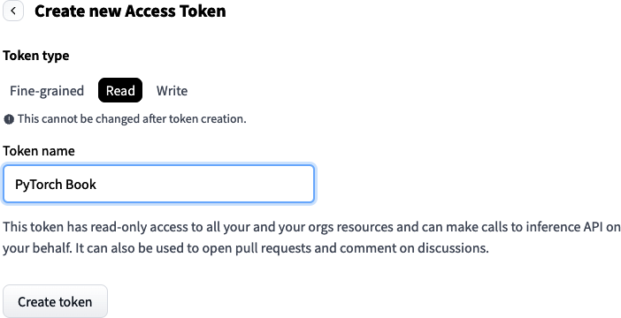

Figure 14-3. Creating an access token

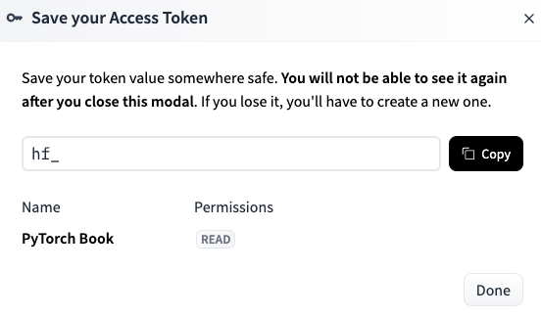

Figure 14-4. Saving your access token

If you *do* forget the token, you’ll have to Invalidate and Refresh it on the token list screen. To do this, you select the three dots to the right of the token and then select Invalidate and Refresh from the drop-down menu (see [Figure 14-5](https://learning.oreilly.com/library/view/ai-and-ml/9781098199166/ch14.html#ch14_figure_5_1748549787233175)).

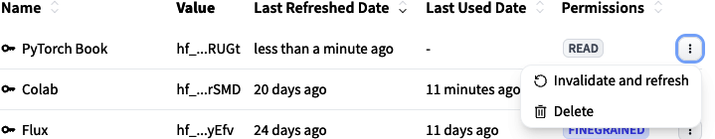

Figure 14-5. Invalidating and refreshing a token

Then, go back to the dialog from [Figure 14-4](https://learning.oreilly.com/library/view/ai-and-ml/9781098199166/ch14.html#ch14_figure_4_1748549787233152) with a new token value. Copy it if you want to use it.

Now that you have a token, let’s explore how to configure Colab to use it.

**Getting permission to use models**

Many models on Hugging Face will require additional permission to use them. In those cases, you should always check the model page and apply for permission on the link provided. Your permission to use the model will be tracked using the Hugging Face token. If you do *not* have permission, you’ll see an error like this:

GatedRepoError: 401 Client Error.

(Request ID: [...])

Cannot access gated repo for url [...]

Access to model [...] is restricted.

You must have access to it and be authenticated to access it.

Please log in.

When this happens, the easiest thing to do is use the model name to find its landing page on the Hugging Face Hub and follow the steps to get permission to use it from there.

**Configuring Colab for a Hugging Face token**

If you want to use models from Hugging Face in Google Colab, then you need to configure a Colab secret in which code executing in Colab will read the token value, send it to Hugging Face on your behalf, and grant you access to the object.

It’s pretty easy to do. First, in Colab, you select the key icon on the left of the screen (see [Figure 14-6](https://learning.oreilly.com/library/view/ai-and-ml/9781098199166/ch14.html#ch14_figure_6_1748549787233195)).

You should see a list of secrets that looks like the one in [Figure 14-7](https://learning.oreilly.com/library/view/ai-and-ml/9781098199166/ch14.html#ch14_figure_7_1748549787233216). Don’t worry if you don’t have any API keys there yet. At the bottom of the list is a button that says Add new secret, and you’ll select that.

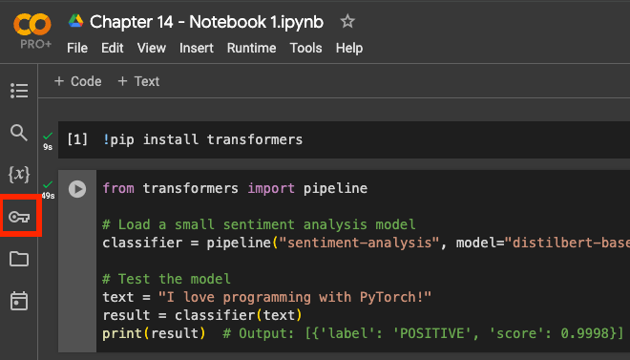

Figure 14-6. Selecting the Colab secrets

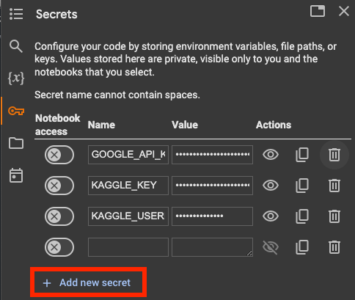

Figure 14-7. List of Colab secrets

Use the name “HF_TOKEN” in the Name field, and paste the value of the key into the Value field. Then, flip the switch to give Notebook Access to the secret (see [Figure 14-8](https://learning.oreilly.com/library/view/ai-and-ml/9781098199166/ch14.html#ch14_figure_8_1748549787233237)).



Figure 14-8. Configuring the HF_TOKEN in Colab

Your code in Colab will now use this token to access Hugging Face.

**Using the Hugging Face token in code**

If you just want to use the token directly in your code, whether in Colab or not, you’ll have to log in to the Hugging Face Hub in your code and pass the key to it. It’s pretty straightforward, with the Hugging Face Hub libraries providing the required support.

To start, just import the login class like this:

from huggingface_hub import login

You can then pass the token to the login class and initialize by using it in your Python session like this:

login(token="YOUR_TOKEN_HERE")

The Hugging Face classes will then use the token for the remainder of your session.

**Using a Model From Hugging Face Hub**

Once you have your token set up, getting and using a model is very simple. For this walk-through, we’ll explore using a language model for text classification and sentiment analysis. This will require you to use the transformers library, so be sure to have it installed with this:

pip install transformers

The transformers API offers a pipeline class that lets you download and use a model based on its name in the Hugging Face repository. This one was fine-tuned using the SST sentiment analysis dataset from Stanford:

# Load a small sentiment analysis model

classifier = pipeline("sentiment-analysis",

model="distilbert-base-uncased-finetuned-sst-2-english")

Pipeline offers much more than just downloading. It encapsulates what’s needed to perform common tasks with models. The first parameter, which in this case is sentiment analysis, describes the overall pipeline task that you’ll do. Transformers offer a variety of task types, including this, text classification, text generation, and a whole lot more.

When using the pipeline class, a number of key steps take place under the hood. These include the following:

*Tokenization*

In this step, the text is converted into tokens (as we discussed in [Chapter 4](https://learning.oreilly.com/library/view/ai-and-ml/9781098199166/ch04.html#ch04_using_data_with_pytorch_1748548966496246)).

*Input processing*

In this step, special tokens are added and the text is converted into tensors.

*The model forward pass*

In this step, the tokenized input is passed through the model’s layers to get a result.

*Output processing*

In this step, the output is decoded from tensors back to the desired labels.

You can see this workflow in [Figure 14-9](https://learning.oreilly.com/library/view/ai-and-ml/9781098199166/ch14.html#ch14_figure_9_1748549787233257).

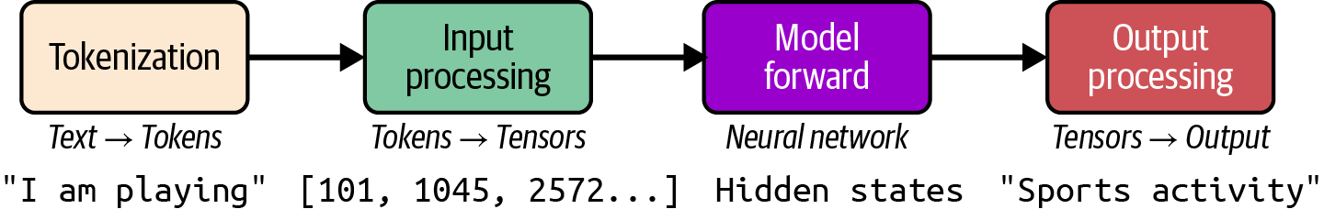

Figure 14-9. NLP pipeline flow

Then, when you want to use it, the burden of coding is removed from you as the developer and you just use the model like this:

# Test the model

text = "I love programming with PyTorch!"

result = classifier(text)

print(result) # Output: [{'label': 'POSITIVE', 'score': 0.9998}]

All of the steps required for text classification and sentiment analysis are encapsulated and abstracted away from you. It makes your code much simpler!

Similarly, if you want to use the diffusers library, it comes with a number of pipelines that are often associated with a model type. So, for example, if you want to use the popular Stable Diffusion model for text to image—in which you give a prompt and the model will draw an image based on that prompt—you can do so very easily.

Let’s explore this with an example.

First, from the diffusers library, you can import the pipeline that supports Stable Diffusion like this:

from diffusers import StableDiffusionPipeline

With this, you can specify the name of the model in the Hugging Face repository and use it to initialize the pipeline:

import torch

from diffusers import StableDiffusionPipeline

model_id = "CompVis/stable-diffusion-v1-4"

device = "cuda"

pipe = StableDiffusionPipeline.from_pretrained(model_id,

torch_dtype=torch.float16)

pipe = pipe.to(device)

Similar to the preceding text example, the pipeline encapsulates and abstracts a number of steps away from you. This means you can write relatively simple code like this:

prompt = "a cute colorful cartoon cat"

image = pipe(prompt).images[0]

image.save("cat.png")

But a number of steps have been handled for you. These include the following:

1. In the text encoding step, Stable Diffusion uses a technology called CLIP to take the text prompts and turn them into embeddings that the model can understand.
2. An initial image is then constructed from random noise.
3. The embeddings are then fed into the model, which uses a process of denoising to create pixels and features that match the embeddings.
4. The final output of the model is then converted from tensors into an RGB image.

The overall process of creating an image from text is beyond the scope of this chapter, but it’s well explained in [this video from Google Research](https://oreil.ly/zNjUT).

The important thing to note here is that because the image-generation process begins by creating random noise, any images you create with the preceding code will be different. So, don’t be alarmed if you’re not getting the same picture consistently! There are ways of guiding this noise by using a seed, which we’ll discuss in later chapters.

PyTorch Hub

One of the primary reasons for PyTorch’s success—particularly in the research community—is the foresight of the developers in creating a hub where people could share their models. While this functionality has been massively superseded by Hugging Face Hub, as described earlier in this chapter, it’s still worth looking at because many new and innovative models (or updates to existing ones) like YOLO are often shared on the Hub.

**Note**

YOLO is “You Only Look Once,"” a popular and efficient object detection model.

As with Hugging Face Hub, the primary benefit of PyTorch Hub is that it gives you access either to models that you may not have the compute resources to train yourself or to the required data used to train them. At its core, PyTorch Hub functions as a centralized repository where researchers and developers can publish, share, and access models that have been trained on diverse datasets across various domains.

In this section, we’ll explore PyTorch Hub and the APIs that you’ll use to access models within it. Unfortunately, the APIs aren’t as consistent as they could be, and it can sometimes be a little bit of a struggle to understand everything. But hopefully, this chapter will help!

We’ll start with the PyTorch Vision libraries, which are composed of image classifiers, object detectors, and other computer vision models.

**Using PyTorch Vision Models**

Before you begin, you’ll need to ensure that you have torchvision installed. Use this:

pip install torchvision

When you have installed it, you’ll see the install version. This is really important when using Hub, in particular when you want to list the models to see what’s available. You can also see the versions of these [on GitHub](https://oreil.ly/KIiFD).

So, to list the models that are available, you’ll use code like this:

models = torch.hub.list('pytorch/vision:v0.20.1')

for model in models:

print(model)

Note the version number (which you can get from the GitHub page we just mentioned).

At the time of writing, there were close to a hundred models on this list. Do note that your version of the tag should match your version of torchvision, so if you are having problems, you can use this code to see your current version:

print(torchvision.__version__)

You can also choose a model from those available and load it into memory like this:

# Load ResNet-50 from PyTorch Hub

model = torch.hub.load('pytorch/vision:v0.20.1', 'resnet50',

pretrained=True)

# Set the model to evaluation mode

model.eval()

The model will be downloaded, cached, and then placed into evaluation mode.

Next up, you’ll need to get your data ready for inference, and that requires you to have some domain knowledge of the model. So, for example, in the code we just cited, we used resnet50 as the model. This model (ResNet) is a very popular one for image classification that uses CNNs. A great place to go to learn more about this is the [PyTorch Hub site](https://pytorch.org/hub).

From here, you can dig into model details—such as the size of the desired input, the labels that it can classify, etc. Then, with this information in hand, you can write inference code for the model. Here’s an example:

# Load and preprocess the image

image_path = "example.jpg" # Replace with your image path

image = Image.open(image_path).convert('RGB')

preprocess = transforms.Compose([

transforms.Resize(256),

transforms.CenterCrop(224),

transforms.ToTensor(),

transforms.Normalize(mean=[0.485, 0.456, 0.406],

std=[0.229, 0.224, 0.225]),

])

input_tensor = preprocess(image)

input_batch = input_tensor.unsqueeze(0)

You saw similar code in [Chapter 3](https://learning.oreilly.com/library/view/ai-and-ml/9781098199166/ch03.html#ch03_going_beyond_the_basics_detecting_features_in_ima_1748570891074912) and [Chapter 4](https://learning.oreilly.com/library/view/ai-and-ml/9781098199166/ch04.html#ch04_using_data_with_pytorch_1748548966496246), where you explored building your own image classifier. This code resizes the images to 256 × 256 and then crops a 224 × 224 image from the center of that. Images are typically 32 bit RGB, in which each pixel is represented by 8 bits of alpha, 8 bits of red, 8 bits of green, and 8 bits of blue. However, for image classification, the neural network usually expects normalized values (i.e., between 0 and 1), so the transform to normalize the image performs this.

When you’re using models in PyTorch, even though you know the desired dimensions (in this case, 224 × 224), you’ll also need to batch the images for inference, even if you’re just doing a single image. The input_tensor.unsqueeze(0) adds this extra dimension to the input tensor to handle this.

Next up, you’ll do the actual inference, which just means you’ll load the model onto the appropriate device—which is cuda if you have a GPU and the CPU otherwise. You’ll then pass the input batch to the model to get an output:

# Perform inference

device = torch.device("cuda" if torch.cuda.is_available() else "cpu")

model.to(device)

input_batch = input_batch.to(device)

with torch.no_grad():

output = model(input_batch)

_, predicted_idx = torch.max(output, 1)

The predicted_idx is the output for the class that has the highest probability of matching the input image. You’ll see something numeric, like tensor([153]), in the output here. Recall that models’ output layers will be neurons that correspond to the index of the required label. In the case of ResNet, the number 153 is a Maltese dog.

To decode this, you can use code like the following. You can find the URL of the labels file by digging into the model page on PyTorch Hub:

# Get class labels and map to prediction

url = "https://raw.githubusercontent.com/anishathalye/imagenet-simple-labels/

master/imagenet-simple-labels.json"

class_labels = json.load(urllib.request.urlopen(url))

predicted_label = class_labels[predicted_idx]

print("Predicted Label:", predicted_label)

This code will then print out the label for predicted_idx. So, in the case of tensor([153]), this will output the label for a Maltese dog.

**Natural Language Processing**

The PyTorch Hub for NLP ultimately directs to two different repositories: those implemented using [Hugging Face Transformers](https://oreil.ly/j1w3-) as outlined earlier in this chapter and those from [Facebook’s fairseq research team](https://oreil.ly/mmQeY).

If you use the fairseq models, you may encounter a lot of sharp edges. Therefore, I thoroughly recommend setting up an environment with Python 3.11 (no later than that).

Within that, you can set up fairseq2 like this:

pip install fairseq

You’ll likely also need other dependencies like hydra-core, OmegaConf, and requests.

Once you have the full system set up, you can use fairseq models like this:

import torch

en2de = torch.hub.load(

'pytorch/fairseq','transformer.wmt19.en-de.single_model')

en2de.translate('Hello Pytorch', beam=5)

# 'Hallo Pytorch'

Do note that the environment will be very picky about which versions of PyTorch, pip, and many other libraries you can use. It can make for a very brittle experience, and unless you really want to use the models from the fairseq repository, I’d recommend just going with the Hugging Face transformer versions.

**Other Models**

PyTorch Hub also has repos for a variety of other model types, including audio, reinforcement learning, generative AI, and more. I’ve found the best way to explore them is to browse at the [PyTorch Hub](https://pytorch.org/hub) and use the links on the landing pages to navigate to the requisite GitHub.

Summary

This chapter explores the ecosystem of pretrained models and model repositories for PyTorch, focusing on two major platforms: Hugging Face Hub and PyTorch Hub. While PyTorch Hub was the granddaddy that started the ball rolling, Hugging Face Hub has rapidly taken over as the go-to resource for pretrained models.

We took a look at how to use the transformers and diffusers libraries from Hugging Face, which encapsulate model loading and instantiation. With these, you have the keys to over 900,000 publicly available models. As a bonus, many of these have comprehensive documentation and model cards to get you up and running quickly and responsibly. You also got hands-on with using them, including setting up your account and getting authentication from Hugging Face using tokens.

Hugging Face APIs offer pipelines that encapsulate many of the common tasks of using models, such as tokenization and sequencing for NLP under the hood, making your coding surface much easier. We explored these with a text sentiment analysis scenario as well as another for image classification.

While PyTorch Hub has a lot less in it and accessing the models can be brittle in comparison, it’s worth looking at because it’s still well used in the research community. We looked at how to access PyTorch Vision models, prepare data for inference, and handle model outputs. The Hub also includes practical examples of using pretrained models like ResNet50 for image classification.

Ultimately, you should consider the advantages of using pretrained models, which have been built by expert researchers who have used expensive hardware and high-quality datasets that you may not otherwise have access to. To that end, you may find that using and fine-tuning existing models rather than training from scratch might be better for your scenario. We’re going to explore that over the next few chapters, starting with [Chapter 15](https://learning.oreilly.com/library/view/ai-and-ml/9781098199166/ch15.html#ch15_transformers_and_transformers_1748549808974580), where we will go deeper into using LLMs with Hugging Face Transformers.

Chapter 15. Transformers and transformers

With the paper [“Attention Is All You Need” by Ashish Vaswani et al.](https://oreil.ly/R7og7) in 2017, the field of AI was changed forever. While the abstract of the paper indicates something lightweight and simple—an evolution of the architecture of convolutions and recurrence (see Chapters [4](https://learning.oreilly.com/library/view/ai-and-ml/9781098199166/ch04.html#ch04_using_data_with_pytorch_1748548966496246) through [9](https://learning.oreilly.com/library/view/ai-and-ml/9781098199166/ch09.html#ch09_understanding_sequence_and_time_series_data_1748549698134578) of this book)—the impact of the work was, if you’ll forgive the pun, transformative. It utterly revolutionized AI, beginning with NLP. Despite the authors’ claim of the simplicity of the approach, implementing it in code is and was inherently complex. At its core was a new approach to ML architecture: *Transformers* (which we capitalize to indicate that we’re referring to them as a concept).

In this chapter we’ll explore the ideas behind Transformers at a high level, demonstrating the three main architectures: encoder, decoder and encoder-decoder. Please note that we will just be exploring at a very high level, giving an overview of how these architectures work. To go deep into these would require several books, not just a single chapter!

We’ll then explore *transformers*, which we lowercase to indicate that they are the APIs and libraries from Hugging Face that are designed to make using Transformer-based models easy to use. Before transformers, you had to read the papers and figure out how to implement the details for yourself for the most part. So, the Hugging Face transformers library has widened access to models created using the Transformer architecture and has become the de facto standard for using the many models that have been created using the transformer-based architecture.

**Note**

Just to clarify, for the rest of this chapter, I’ll refer to the architecture, models, and concepts as Transformers (with a capital *T*) and the Hugging Face libraries as transformers (with a lowercase *t*) to prevent confusion.

Understanding Transformers

Since the publication of the original paper mentioned in the introduction to this chapter, the field of Transformers has evolved and grown, but its underlying basis has remained pretty much the same. In this section, we’ll explore this.

When working with LLMs anywhere (not just with Hugging Face), you’ll hear of the terms *encoder*, *decoder*, and *encoder-decoder*. Therefore, I think it’s a good idea for you to get a high-level understanding of them. Each of these architectures represents a different approach to text management—be it processing, classification, or generation. They have specific strengths for particular scenarios, and to optimize for your scenario, it’s good to understand them so you can choose the appropriate ones.

**Encoder Architectures**

Encoder-only architectures (e.g., BERT, RoBERTa) generally excel at *understanding* text because of how rigorous they are in processing it. They’re bidirectional in nature, being able to “see” the entire input sequence at once. With that nature of understanding, they’re particularly effective for tasks that require a deep understanding and comprehension of the text and its semantics. So, they’re particularly suited for tasks such as classification, named-entity recognition, and extraction of meaning for things like question answering. Their strength is transforming text into rich, contextual representations, but they’re not designed to *generate* new text.

You can see the encoder-based architecture in [Figure 15-1](https://learning.oreilly.com/library/view/ai-and-ml/9781098199166/ch15.html#ch15_figure_1_1748549808951859).

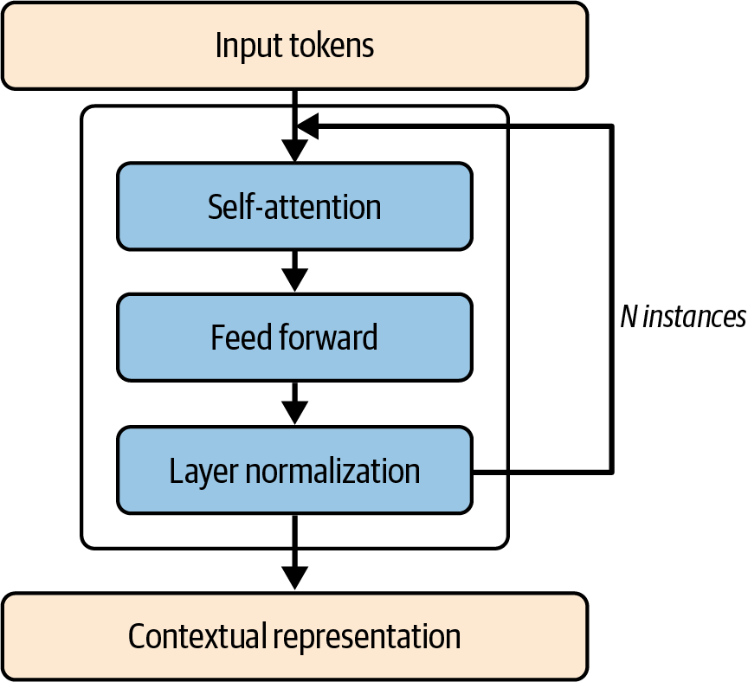

Figure 15-1. Encoder-based architecture

Let’s explore this architecture in a little more detail. It begins with the tokenized inputs, which are then passed to the self-attention layer.

**The self-attention layer**

*Self-attention* is the core mechanism that allows tokens to “pay attention” to other tokens in the input sequence. So, for example, consider the sentence “I went to high school in Ireland, so I had to study how to speak Gaelic.” The last word in this sentence is *Gaelic*, and it’s effectively triggered by the word *Ireland* earlier in the sentence. If a model pays attention to the entire sentence, it can predict the word *Gaelic* to be the next word. On the other hand, if the model didn’t pay attention to the entire sentence, then it might interpret from the sentence something more appropriate to “how to speak,” such as *politely* or another adjective.

However, the self-attention mechanism—by considering the entire sentence—can understand context like that more granularly. It works by having each token in the sentence get three vectors associated with it. These are the query (Q) vector (aka “What am I looking for that’s relevant to this token?”), the key (K) vector (aka “What tokens might reference me?”), and the value (V) vector (aka “What type of information do I carry?”). The representations in these vectors are learned over time, in much the same process as we saw in earlier chapters of this book. An attention score is then calculated as a function of these, and using Softmax, the embeddings for the words will be updated with the attention details, bending word embeddings closer to one another when there are similarities learned between them.

Do note that self-attention is generally bidirectional, so the order of the words doesn’t matter.

The self-attention mechanism usually also has the context of *heads*, which are effectively multiple, parallel instances of the three vectors (Q, K, and V) that we saw previously, which can learn different representations and effectively specialize in different aspects of the input. A high-level representation of these heads is shown in [Figure 15-2](https://learning.oreilly.com/library/view/ai-and-ml/9781098199166/ch15.html#ch15_figure_2_1748549808951907).

Thus, each head has its own set of learned weights for Q, K, and V vectors. The processing and learning for these vectors is done in parallel, with their results concatenated, and their final output projection is then a combination of information from each of the heads. As models have grown larger over time, one of the factors for this growth is the number of heads. For example, BERT-base has 12 heads and BERT-large has 16 heads. Architectures that also use a decoder, such as GPT, have grown similarly. GPT-2 had 12 attention heads, whereas GPT-3 grew to 96!

Returning to [Figure 15-1](https://learning.oreilly.com/library/view/ai-and-ml/9781098199166/ch15.html#ch15_figure_1_1748549808951859), the self-attention instance (in which [Figure 15-2](https://learning.oreilly.com/library/view/ai-and-ml/9781098199166/ch15.html#ch15_figure_2_1748549808951907) can be encapsulated into the self-attention box from [Figure 15-1](https://learning.oreilly.com/library/view/ai-and-ml/9781098199166/ch15.html#ch15_figure_1_1748549808951859)) then outputs to a *feedforward network* (FFN), which is often more accurately referred to as a *position-wise feedforward network*.

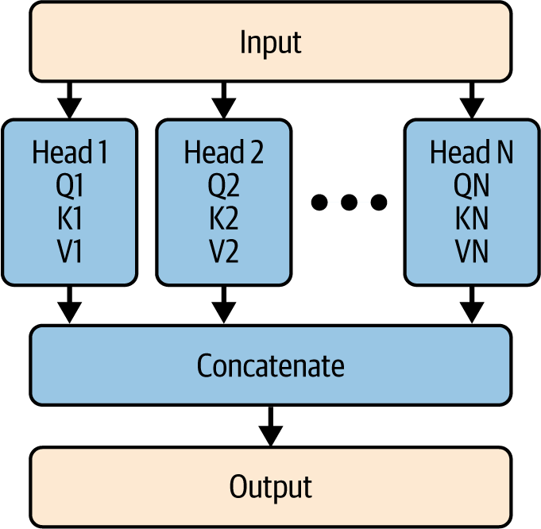

Figure 15-2. Multihead self-attention

**The feedforward network layer**

The FFN layer is vital in supporting the model’s capacity to learn complex patterns in the text. It does this by introducing nonlinearity into the model.

Why is that important? First of all, let’s understand the difference between linearity and nonlinearity. A *linear equation* is one for which the value is relatively easy to predict. For example, consider an equation that determines a house price. A linear version of this might be the cost of the land plus a particular dollar amount per square foot, and every house would follow the same formula. But as we know, house prices are far more complex than this—they don’t (unfortunately) follow a simple linear equation.

Understanding sentiment can be the same. So, for example, if you were to assign coordinates on a graph (like we did when explaining embeddings in [Chapter 7](https://learning.oreilly.com/library/view/ai-and-ml/9781098199166/ch07.html#ch07_recurrent_neural_networks_for_natural_language_pro_1748549654891648)) to the words *good* and *not*, where *good* might be +1 and *not* might be –1, then a linear relationship between these for *not good* would give us 0, which is neutral, whereas *not good* is clearly negative. So, we need equations that are more nuanced (i.e., nonlinear) when capturing sentiment and effectively understanding our text.

That’s the job of the FFN. It achieves this nonlinearity by expanding the dimensions of its input vector, applying a transformation to that, and using ReLU to “remove” the negative values (and thus remove the linearity) before restoring the vector back to its original dimensions. You can see this in [Figure 15-3](https://learning.oreilly.com/library/view/ai-and-ml/9781098199166/ch15.html#ch15_figure_3_1748549808951933).

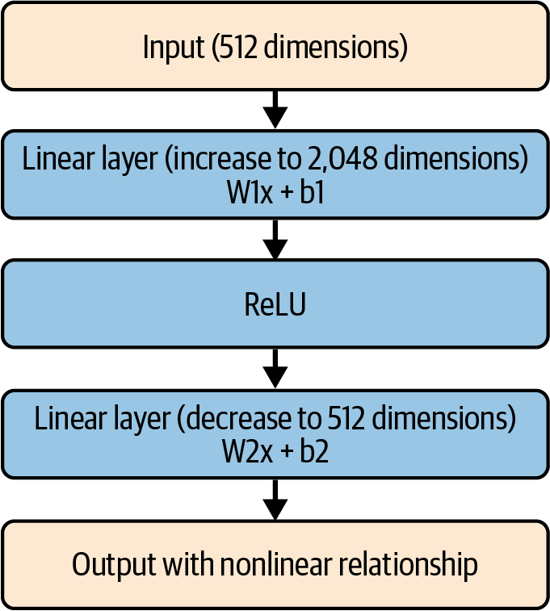

Figure 15-3. A feedforward network

The underlying math and logic behind how it works are a little beyond the scope of this book, but let’s explore them with a simple example. Consider this code, which simulates what’s happening in [Figure 15-3](https://learning.oreilly.com/library/view/ai-and-ml/9781098199166/ch15.html#ch15_figure_3_1748549808951933):

import torch

import torch.nn as nn

# Simplified example with small dimensions

d_model = 2 # Input/output dimension

d_ff = 4 # Hidden dimension

# Create some sample input

x = torch.tensor([[–1.0, 2.0]])

# First linear layer (2 → 4)

W1 = torch.tensor([

[1.0, –1.0],

[–1.0, 1.0],

[0.5, 0.5],

[–0.5, –0.5]

])

b1 = torch.tensor([0.0, 0.0, 0.0, 0.0])

layer1_out = torch.matmul(x, W1.t()) + b1

print("After first linear layer:", layer1_out)

# Apply ReLU

relu_out = torch.relu(layer1_out)

print("After ReLU:", relu_out)

# Notice how negative values became 0; this is the nonlinear operation!

# Second linear layer (4 → 2)

W2 = torch.tensor([

[1.0, –1.0, 0.5, –0.5],

[–1.0, 1.0, 0.5, –0.5]

])

b2 = torch.tensor([0.0, 0.0])

final_out = torch.matmul(relu_out, W2.t()) + b2

print("Final output:", final_out)

We start with a simple 2D tensor: [–1.0, 2.0].

The first linear layer has the following weights and biases:

W1 = torch.tensor([

[1.0, –1.0],

[–1.0, 1.0],

[0.5, 0.5],

[–0.5, –0.5]

])

b1 = torch.tensor([0.0, 0.0, 0.0, 0.0])

When we pass our 2D tensor through this layer to get layer1_out, the matrix multiplication gives us a 4D output that looks like this:

After first layer: [–3.0, 3.0, 0.5, –0.5]

There are two negative values in this layer (–3 and –0.5), so when we pass it through the ReLU, they are set to zero and our matrix becomes this:

Output: [0.0, 3.0, 0.5, 0.0]

This process is called *bending*. By taking these values out, we’re now introducing nonlinearity into the equation. The relationships between the values have become much more complex, so a process that attempts to learn the parameters of those relationships will have to deal with that complexity, and if it succeeds in doing so, it will avoid the linearity trap.

Next, we’ll convert back to a 2D tensor by going through another layer, with weights and biases like this:

W2 = torch.tensor([

[1.0, –1.0, 0.5, –0.5],

[–1.0, 1.0, 0.5, –0.5]

])

b2 = torch.tensor([0.0, 0.0])

The output of the layer will then look like this:

Final output: [–2.75, 3.25]

So, the effect of the FFN is to take in a vector and output a vector of the same dimension, with linearity removed.

We can explore this with our simple code. Consider what happens when we take our input and apply simple, linear changes to it. So, if we take [–1.0, 2.0] and double it to [–2.0, 4.0], the nonlinearity introduced by the FFN will mean that the output won’t be a simple doubling. And similarly, if we negate it, the output again won’t be a simple negation:

Input: [–1.0, 2.0] → Output: [–2.75, 3.25]

Input: [–2.0, 4.0] → Output: [–5.5, 6.5] # Not a simple doubling!

Input: [1.0, –2.0] → Output: [2.75, –3.25] # Not a simple negation!

Over time, the parameters that are learned for the weights and biases should maintain the relationships between the tokens and allow the network to learn more nuanced, nonlinear equations that define the overall relationships between them.

**Layer normalization**

Referring back to [Figure 15-1](https://learning.oreilly.com/library/view/ai-and-ml/9781098199166/ch15.html#ch15_figure_1_1748549808951859), the next step in the process is called *layer normalization*. At this point, the goal is to stabilize the data flowing through the neural network by removing outliers and high variance. Layer normalization does this by calculating the mean and variance of the input features, which it then normalizes and scales/shifts before outputting (see [Figure 15-4](https://learning.oreilly.com/library/view/ai-and-ml/9781098199166/ch15.html#ch15_figure_4_1748549808951956)).

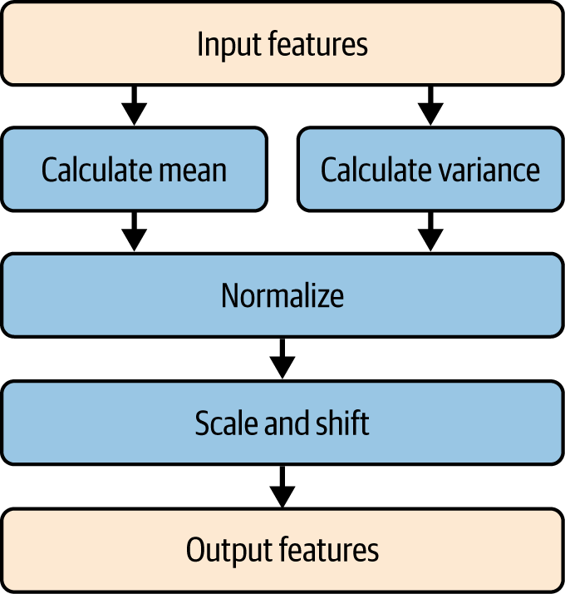

Figure 15-4. Layer normalization

From a statistical perspective, the idea of removing the outliers from using mean and variance and then normalizing them is quite straightforward. I won’t go into details on the statistics here, but that’s generally the goal of doing these types of calculations.

The *Scale and Shift* box then becomes a mystery. Why would you want to do this? Well, if you dig a little bit into the logic, the idea here is that the process of *normalization* will drive the mean of a set of values to 0 and the standard deviation to 1. The process itself can destroy distinctiveness in our input features by making them too alike. So, if there’s a process that we can use to return some level of variance to them with parameters that are learned, we can clean up the data without destroying it—meaning we won’t throw the baby out with the bathwater!

Therefore, multiplying our outputs by values with offsets can change this. These values are typically called *gamma* and *beta* values, and they act a little like weights and biases. It’s probably easiest to show this in code.

So, consider this example, in which we’ll take an input feature containing some values and then normalize them. We’ll see that the normalized values will have a mean of 0 and a standard deviation of 1:

import torch

# Create sample feature values

features = torch.tensor([5.0, 1.0, 0.1])

print("\nOriginal features:", features)

print("Original mean:", features.mean().item())

print("Original std:", features.std().item())

# Standard normalization

mean = features.mean()

std = features.std()

normalized = (features - mean) / std

print("\nJust normalized:", normalized)

print("Normalized mean:", normalized.mean().item())

print("Normalized std:", normalized.std().item())

# With learnable scale and shift

gamma = torch.tensor([2.0, 0.5, 1.0]) # Learned parameters

beta = torch.tensor([1.0, 0.0, —1.0]) # Learned parameters

scaled_shifted = gamma * normalized + beta

print("\nAfter scale and shift:", scaled_shifted)

print("Final mean:", scaled_shifted.mean().item())

print("Final std:", scaled_shifted.std().item())

But when we move the values through the scale and shift by using gamma and beta values, we get a new set of parameters that maintain a closer relationship to the originals but with massive variance (aka noise) removed. The output of this code should look like this:

Original features: tensor([5.0000, 1.0000, 0.1000])

Original mean: 2.0333333015441895

Original std: 2.6083199977874756

Just normalized: tensor([ 1.1374, —0.3962, —0.7412])

Normalized mean: 0.0

Normalized std: 1.0

After scale and shift: tensor([ 3.2748, —0.1981, —1.7412])

Final mean: 0.44515666365623474

Final std: 2.5691161155700684

Like the FFN, this is effectively destroying and then reconstructing the features in a clever way. In this case, it’s designed to do it to remove variance, which has the effect of amplifying or dampening features as needed by shifting the overall distribution to better ranges for activation functions.

I like to think of this as what you do with your TV to get a better image—sometimes, you adjust the contrast or the brightness. By finding the optimal values of these settings, you can see the important details of a particular image better. Think of the contrast as the scale and the brightness as the shift. If a network can learn these for your input features, it will improve its ability to understand them!

**Repeated encoder layers**

Referring back to [Figure 15-1](https://learning.oreilly.com/library/view/ai-and-ml/9781098199166/ch15.html#ch15_figure_1_1748549808951859), you’ll see that the self-attention, feedforward, and layer normalization layers can be repeated N times. Typically, smaller models will have 12 instances and larger ones will have 24. The deeper the model, the more computational resources are required. More layers provide more capacity to learn complex patterns, but of course, this means longer training time, more GPU memory overhead, and potentially greater risks of overfitting. Additionally, larger models can impact the corresponding data requirements, leading to a possibly negative knock-on effect for complexity.

For the most part, there’s a trade-off between the depth of the model (the number of layers) and the width (the size of each layer, including the number of heads). In some cases, models can reuse the same layer multiple times to reduce the overall parameter count—and ALBERT is an example of this.

**The Decoder Architecture**

While the encoder architecture specializes in understanding text by having attention across the entire context of the input sequence, the decoder architecture serves as the generative powerhouse. It is designed to produce sequential outputs one element at a time. While the encoder processes all inputs simultaneously (or as many of them as it can, based on the parallelization of the system), the decoder operates autoregressively. It generates each output token while considering both the encoded input representations *and* the previously generated outputs. The goal is to maintain coherence and contextual relevance through the process.

You can see a diagram of the encoder architecture in [Figure 15-5](https://learning.oreilly.com/library/view/ai-and-ml/9781098199166/ch15.html#ch15_figure_5_1748549808951977).

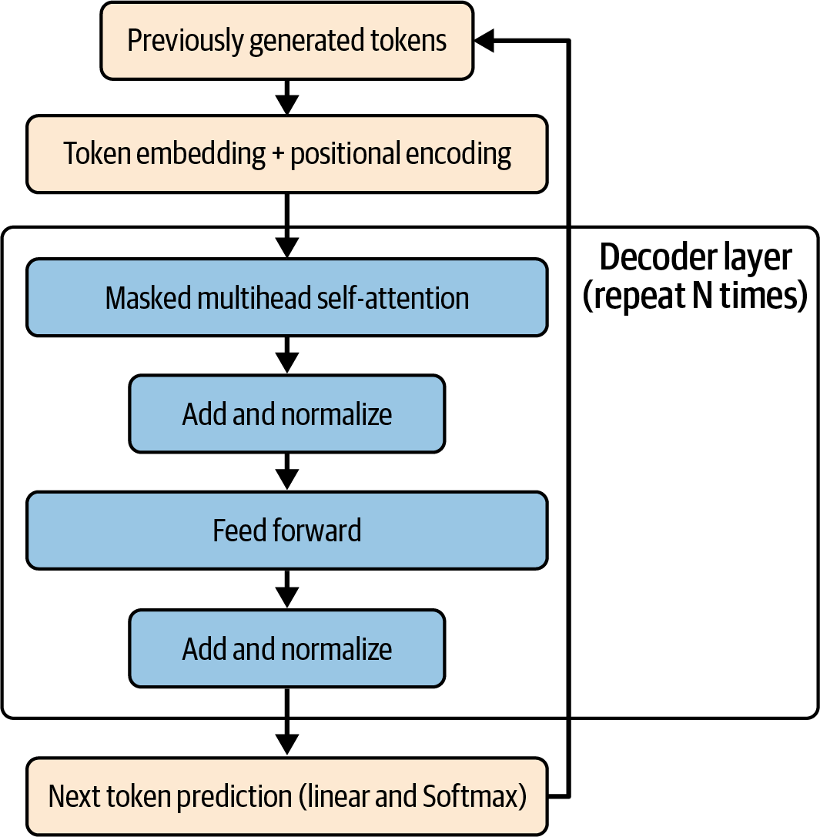

Figure 15-5. The decoder architecture

Let’s explain this from the top down. The first box is the previously generated tokens. In a pure decoder architecture, this is the set of tokens that have already been generated or provided. When they’re provided, they’re typically called the prompt. So, say you provide the following tokens:

[“If”, “you”, “are”, “happy”, “and”, “you”, “know”, “it”]

after one is run through the decoder, the token for “clap” will be generated. You will now have these:

[“If”, “you”, “are”, “happy”, “and”, “you”, “know”, “it”, “clap”]

These tokens will flow into the box for token embedding + positional encoding.

**Understanding token and positional encoding**

This transforms each token into a vector representation called an *embedding* (as explained in [Chapter 5](https://learning.oreilly.com/library/view/ai-and-ml/9781098199166/ch05.html#ch05_introduction_to_natural_language_processing_1748549080743759)), which clusters words of similar semantic meaning in a similar vector space. Remember that these embeddings are learned over time.

So, for example, if we think about the words *it* and *cla*p at the end of the aforementioned token list, they may have token embeddings that look like this:

"it" -> [0.2, –0.5, 0.7] (position 7)

"clap" -> [–0.3, 0.4, 0.1] (position 8)

I have simplified the embedding to just three dimensions for readability.

The next step is to perform the *positional* encoding, which is a huge innovation in Transformers. In addition to an encoding in a vector space for the semantics and meaning of the word, an innovative method using sine and cosine waves is performed to encode the word’s position and the impact of this position on neighbors.

So, for example, given that we have 3D vectors for our encodings, we’ll create a 3D vector using sine waves for the odd-numbered indices and cosine waves for the even-numbered ones, like this:

Position 7 -> [sin(7), cos(7), sin(7)] = [.122, .992, .122]

Position 8 -> [sin(8), cos(8), sin(8)] = [.139, .990, .139]

We then add these together to get this:

“It” -> [0.2+.122, —0.5+.992, 0.7+.122] = [0.322, 0.492, 0.822]

“Clap” -> [—0.3+.139, 0.4+.990, 0.1+.139] = [—0.161, 1.390, 0.239]

While this may seem arbitrary, the positional encodings actually come from a specific formula. These are shown here:

# For Even-numbered dimensions

PE(pos, d) = sin(pos / 10000^(d/d_model))

# For Odd-numbered dimensions

PE(pos, d) = cos(pos / 10000^(d-1/d_model))

If you plot these values as a table, they’ll look like [Table 15-1](https://learning.oreilly.com/library/view/ai-and-ml/9781098199166/ch15.html#ch15_table_1_1748549808960051).

| **Position** | **Dimension 0** | **Dimension 1** | **Dimension 2** | **Dimension 3** | **Dimension 4** | **Dimension 5** | **Dimension 6** | **Dimension 7** |
| --- | --- | --- | --- | --- | --- | --- | --- | --- |
| **0** | 0.000 | 1.000 | 0.000 | 1.000 | 0.000 | 1.000 | 0.000 | 1.000 |
| **1** | 0.841 | 0.540 | 0.100 | 0.995 | 0.010 | 1.000 | 0.001 | 1.000 |
| **2** | 0.909 | –0.416 | 0.199 | 0.980 | 0.020 | 1.000 | 0.002 | 1.000 |
| **3** | 0.141 | –0.990 | 0.296 | 0.955 | 0.030 | 1.000 | 0.003 | 1.000 |
| Table 15-1. Positional encodings | | | | | | | | |

The ultimate goal here is to have a relationship between each position on the list and every other position that, in some dimensions, has tokens that are typically far apart being a little closer and those that are typically closer being a little further apart!

So, imagine you have an input sequence of four tokens in positions 0 through 3, as charted in the table. The token in position 3 is as far away as possible from the token in position 0, so they are at extreme ends of the sequence.

With a positional encoding like this, we are given the possibility that in some dimensions, they are closer together. You can see in the first column that the values for dimension 0 places position 3 closer to position 0 than either of the others, whereas in the column for dimension 2, they are further apart. By using these positional encodings, we’re opening up the possibility that words can be clustered, even if they’re far apart in a sentence.

Think back to the sentence “I went to high school in Ireland, so I had to study how to speak Gaelic.” In that case, the final token “Gaelic” was most accurate because it described a language in “Ireland,” which was earlier in the sentence. Without positional encoding, this would have been missed!

Also, the positional encodings are *added* to the token embeddings, so they provide a sort of pressure to keep together the words that might be semantically related in different parts of the sentence, but they don’t completely override the embeddings.

This is then fed into the multihead masked attention. We’ll look at that next.

**Understanding multihead masked attention**

Earlier in this chapter, in the section on attention, we saw how the Q, K, and V vectors for each token are learned and used to update the embeddings of the word with attention to the other words. The idea behind *masked attention* updates this to ignore words that we shouldn’t be paying attention to. In other words (sic), the goal is that we should only pay attention to *previous* positions in the sequence.

So, imagine you have a sequence of eight words and you want to predict the ninth. When you’re processing the third word in the sentence, it should only pay attention to the second and first word but nothing after them. You can achieve this with a triangular matrix like this:

1 0 0

1 1 0

1 1 1

So, imagine this for a set of words like *the*, *cat*, and *sat* (see [Table 15-2](https://learning.oreilly.com/library/view/ai-and-ml/9781098199166/ch15.html#ch15_table_2_1748549808960104)).

|  | **the** | **cat** | **sat** |
| --- | --- | --- | --- |
| the | 1 | 0 | 0 |
| cat | 1 | 1 | 0 |
| sat | 1 | 1 | 1 |
| Table 15-2. Simple masked attention | | | |

When processing *the*, using this method means we can only pay attention to *The* itself. When processing *cat*, we can pay attention to both *the* and *cat*. When processing sat, we can pay attention to *the*, *cat*, and *sat*.

So, recalling that the K, Q, and V vectors will amend the embeddings for the word in a way that bends them closer together for instances where the words may not have close syntactical meaning but are impacting one another through attention (like *Ireland* and *Gaelic* in the earlier example), the goal of the masked attention layer will only do this bending for words that we’re allowed to pay attention to.

When this is performed multiple times, in parallel, across multiple heads, and aggregated together, we get an attention adjustment of the embeddings that’s very similar to the one we did with the encoder—except that the masking prevents any amendment of the token from words *after* it in the sequence, particularly those that are generated.

**Adding and normalizing**

Next, we take the attention output from the masked attention layer and add it to the original input. This is called making a *residual connection*.

So, for example, the process might look like this:

Original input (word "cat" embedding):

[0.5, —0.3, 0.7, 0.1] # Contains basic info about "cat"

Attention output (learned changes):

[0.2, 0.1, —0.1, 0.3] # Contains contextual updates based on other words

After adding (final result):

[0.7, —0.2, 0.6, 0.4] # Original meaning of "cat" PLUS contextual information

As we think about this, we’ll see that we don’t *replace* the original information with the attention mechanism but instead we *add* the new learned embeddings from the attention mechanism, thus preserving the original information. Over time, this will have the effect of helping the network learn. If some attention updates aren’t useful, then the network will just make them close to zero through the backpropagation of gradients.

This is beyond the scope of this book, and it’s generally found in the papers behind the creation of these models. But ultimately, the goal here is to get rid of a problem called the *vanishing gradient problem*—in which, if the original input was *not* maintained, then the gradients of the attention layer can get smaller and smaller with successive layers, thus limiting the number of layers you can use. But if you always add the gradients to the original input, then there will be a floor—such as the [0.5, –0.3, 0.7, 0.1] for the cat gradient previously mentioned—so the small changes from the attention gradients won’t push these values close to zero and cause the overall gradients to vanish.

This is then pushed through a layer normalization, as described in the encoder chapter, to remove outliers while keeping the knowledge of the sequences intact.

**The feedforward layer**

The feedforward layer operates in exactly the same way as those layers used in encoders (see earlier in this chapter), with the goal of reducing any linear dependencies in the token sequence. The output from this is again added to the original data and then normalized, the logic being that the process of removing the outliers with the FFN should also prevent the gradients from vanishing and thus preserve important information. The normalization also keeps the values in a stable range, as repeatedly adding as we’re doing here might push some values far above 1.0 or below –1.0, and normalized values in these ranges tend to be better for matrix calculation.

We can repeat this process of masked attention -> add and normalize -> feedforward -> add and normalize multiple times before we get to the next layer, where we’ll use the learned values to predict the next token.

**The linear and Softmax layers**

The linear and Softmax layers are responsible for turning the decoder’s representations into probabilities for the next token.

The linear layer will learn representations for each of the words in the dictionary with the transposed size of the decoder’s representations. This is a bit of a mouthful, so let’s explore it with an example.

Say our decoder output, having flowed through all the layers, is a 4D representation, like in [Table 15-3](https://learning.oreilly.com/library/view/ai-and-ml/9781098199166/ch15.html#ch15_table_3_1748549808960134).

|  |  |  |  |
| --- | --- | --- | --- |
| 0.2 | –0.5 | 0.8 | –0.3 |
| Table 15-3. Simulated decoder output | | | |

We now have a weights matrix for each word in our vocabulary that is learned during training, and that matrix might look like the one in [Table 15-4](https://learning.oreilly.com/library/view/ai-and-ml/9781098199166/ch15.html#ch15_table_4_1748549808960160).

| **cat** | **dog** | **sat** | **mat** | **the** |
| --- | --- | --- | --- | --- |
| 1.0 | 0.5 | 2.0 | 0.3 | 0.7 |
| -0.3 | 0.8 | 1.5 | 0.4 | 0.2 |
| 2.0 | 0.3 | 2.1 | 0.5 | 0.8 |
| 0.4 | 0.6 | 0.9 | 0.2 | 0.5 |
| Table 15-4. Weights matrix for words in our vocab | | | | |

Note that the decoder representation is 1 × 4 and that each matrix for each word is 4 × 1. That’s the transposition, and multiplying them out is now easy.

So, for *cat*, our final score will be this:

(0.2 × 1.0) + (–.5 × –.3) + (0.8 × 2.0) + (–0.3 × 0.4) = 1.8

We can then get final scores for each word, as in [Table 15-5](https://learning.oreilly.com/library/view/ai-and-ml/9781098199166/ch15.html#ch15_table_5_1748549808960183):

| **cat** | **dog** | **sat** | **mat** | **the** |
| --- | --- | --- | --- | --- |
| 1.8 | -0.2 | 1.1 | 0.2 | 0.5 |
| Table 15-5. Final scores for each word | | | | |

Using the Softmax function, these are then turned into probabilities, as in [Table 15-6](https://learning.oreilly.com/library/view/ai-and-ml/9781098199166/ch15.html#ch15_table_6_1748549808960204).

| **cat** | **dog** | **sat** | **mat** | **the** |
| --- | --- | --- | --- | --- |
| 47.5% | 6.4% | 23.6% | 9.6% | 12.9% |
| Table 15-6. Probabilities from Softmax function | | | | |

And then we can take the highest-probability word as the next token, in a process called *greedy decoding*. Alternatively, we can take 1 from *k* possible top values, in a process called *top-k decoding*, in which we pick, for example, the top three probabilities and choose one value from there.

This is then fed back into the top box as the new token list so that the process can continue to predict the next token.

And that’s pretty much how decoders work, at least from a high level. In the next section, we’ll look at how they can be combined in the encoder-decoder architecture.

The Encoder-Decoder Architecture

The *encoder-decoder architecture*, also known as *sequence-to-sequence*, combines the two aforementioned architecture types. It does this to tackle tasks that require transformation between input and output sequences of varying lengths. It’s proven to be very effective for machine translation in particular, but it also can be used in models for text summarization and question answering.

As you can see in [Figure 15-6](https://learning.oreilly.com/library/view/ai-and-ml/9781098199166/ch15.html#ch15_figure_6_1748549808951997), it’s very similar to the decoder architecture, for the most part. The difference is the addition of a cross-attention layer that takes in the output from the encoder and injects it into the middle of the workflow.

The encoder will process the entire input sequence, creating a rich contextual representation that captures the full meaning of the input. The decoder layer can then query this, combining it with its representations to allow the decoder to focus additionally on relevant parts of the input when generating each new token.

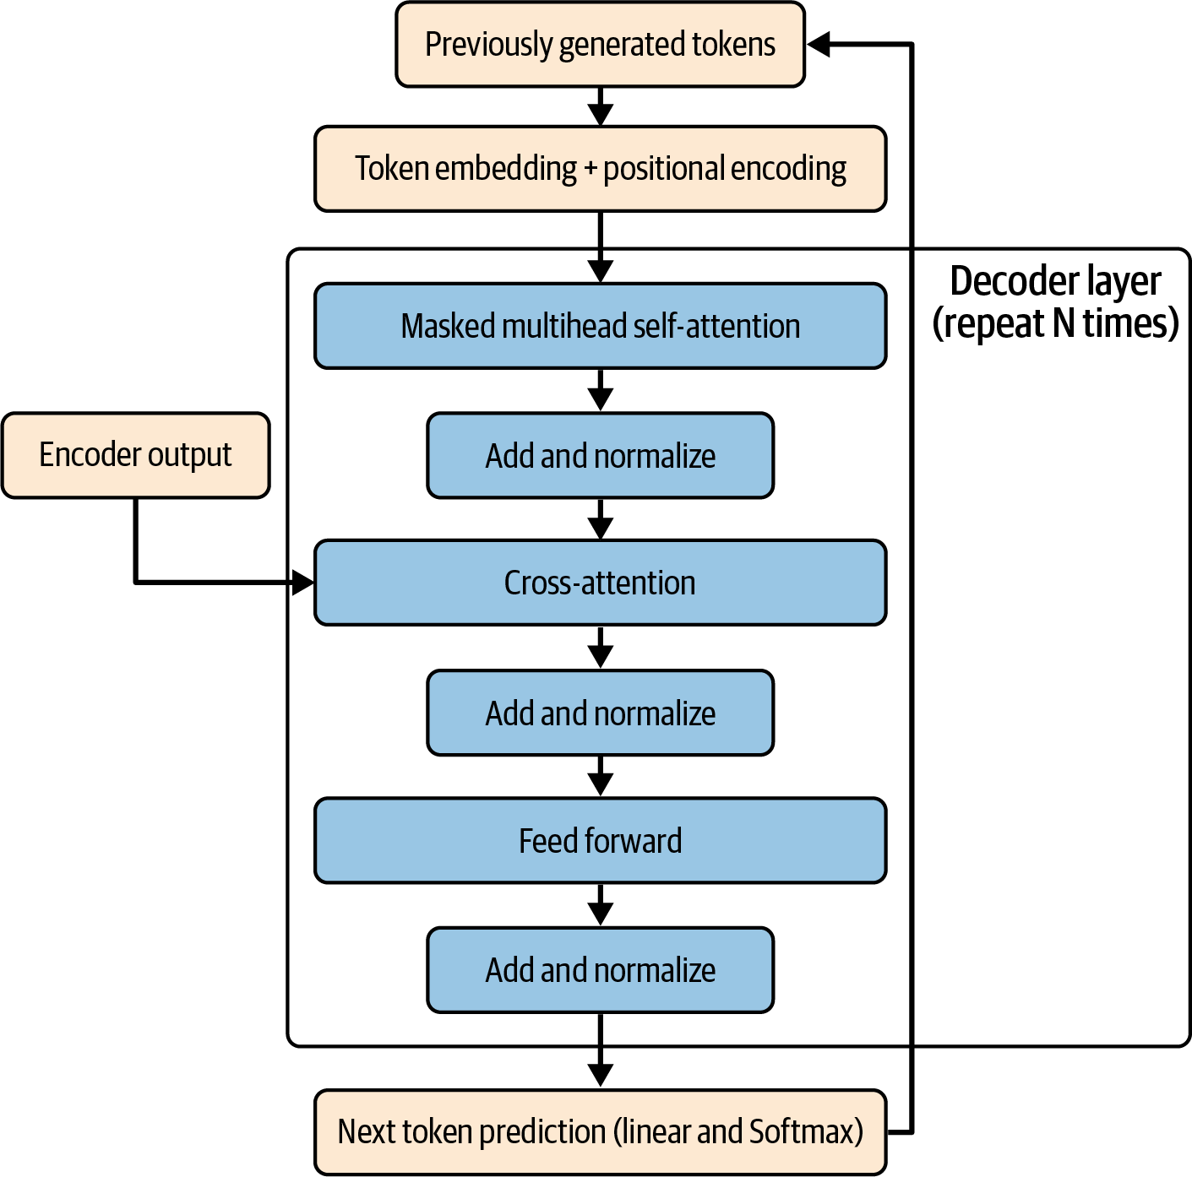

Figure 15-6. The encoder-decoder architecture

Now, you might wonder at this point why the encoder-decoder architecture needs the encoder’s output, which it merges with cross-attention. Why can’t it just unmask in its own self-attention block? The fundamental reason boils down to the fact that this is more powerful for the following reasons:

*Separation of concerns and parameter focus*

If the decoder self-attention block were to be unmasked, it would have to handle the tasks of both understanding the input *and* generating the output simultaneously. That could lead to issues with learning because there’s a poor target. But if we separate them, each can focus on its own specialized role.

*Quality*

If we separate concerns, each role can build up a rich representation that’s suitable for its task. In particular with the encoder, we have a well-known, battle-tested architecture for artificial understanding that we know works for that task.

The major innovation here is the *cross-attention block*. We can demonstrate the intuition behind this with the analogy of a human language translator. When a person translates a sentence from French to English, they don’t just memorize the entire French corpus and then write English. Instead, while writing the English words, they actively look at different parts of the French sentence, focusing on the most relevant parts of the sentence for the word they are currently writing.

In French, the sentence “Le chat noir” translates to “The black cat,” but the noun and adjective are reversed. A straight translation would be “The cat black.” The human translator, when paying attention, would know this and would focus on other words in the French sentence. Cross-attention does the same thing. As the decoder generates each new word, it needs to refer to the source material to figure out what word to generate next. The words that have gone before in its output may not be enough.

You can see this mechanism in action in [Figure 15-7](https://learning.oreilly.com/library/view/ai-and-ml/9781098199166/ch15.html#ch15_figure_7_1748549808952017).

Ultimately, an encoder creates a rich, contextual representation of the input because it artificially understands the source sentence. Cross-attention is a selective spotlight that highlights what the model believes to be the most relevant parts of this understanding for each word it generates, and this highlighting makes the model more effective at generating the correct words. You can see how this is very effective for machine translation, but it’s not much of a stretch to understand how it might be useful for other tasks!

The mechanism for cross-attention works with the K, Q, and V vectors as before, but the innovation here is that the Q vector will code from the decoder, while the K and V vectors will come from the encoder.

This concludes a very high-level look at Transformers and how they work. There’s lots more detail—in particular, about *how*they learn things like the Q, K, and V vectors—that’s beyond the scope of this chapter, and I’d recommend reading the original paper to learn more.

Now, let’s switch gears to the transformers (with a lowercase *t*) API from Hugging Face, which makes it really easy for you to use Transformer-based models in code.

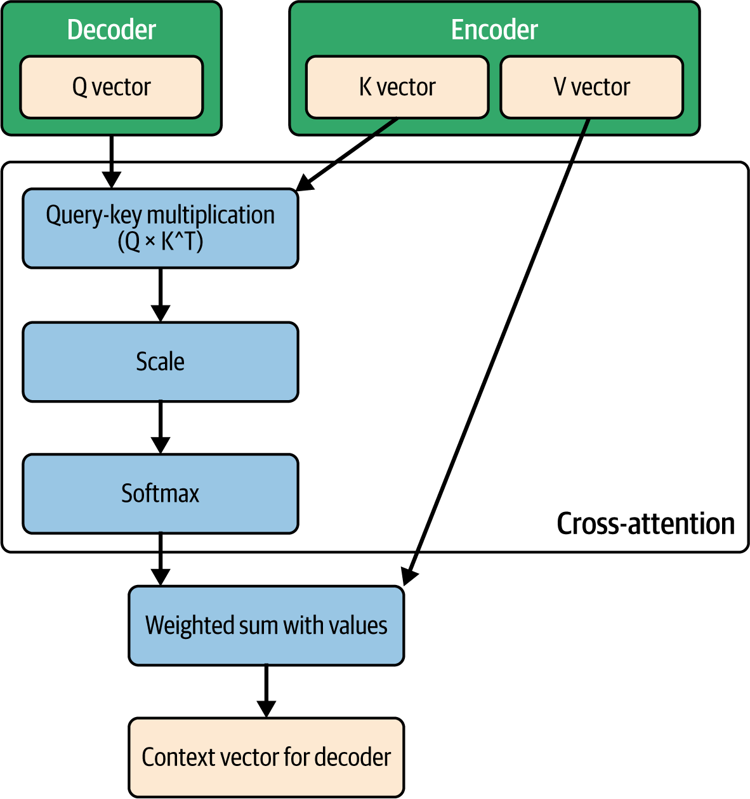

Figure 15-7. Cross-attention

The transformers API

At their core, transformers provide an API for working with pretrained models that use Python and PyTorch. The library’s success stems from three key innovations: a simple interface for using pretrained models, an extensive collection of pretrained models (as we explored in [Chapter 14](https://learning.oreilly.com/library/view/ai-and-ml/9781098199166/ch14.html#ch14_using_third_party_models_and_hubs_1748549787242797)), and a vibrant community that frequently contributes improvements and new models.

The library has evolved beyond its NLP roots to support multiple types of models, including those that support computer vision, audio processing, and multimodal tasks. Originally, the goal of the transformer-based architecture was to be effective in learning how a sequence of tokens is followed by another sequence of tokens. Then, innovative models built on this idea to allow concepts such as sound to be expressed as a sequence of tokens, and as a result, transformers could then learn sound patterns.

For developers, transformers offer multiple abstraction levels. The high-level pipeline API, which we explored in [Chapter 14](https://learning.oreilly.com/library/view/ai-and-ml/9781098199166/ch14.html#ch14_using_third_party_models_and_hubs_1748549787242797), enables immediate use of models for common tasks, while lower-level interfaces provide fine-grained control for custom implementations. Also, the library’s modular design allows developers to mix and match components like tokenizers, models, and optimizers.

Perhaps most powerfully, transformers emphasize transparency and reproducibility. All model implementations are open source, well documented, and accompanied by model cards describing their capabilities, limitations, and ethical considerations. It’s a wonderful learning process to crack open the transformers library on GitHub and explore the source code for common models like GPT and Gemma.

This commitment to openness has made the transformers API an invaluable tool for you, and it’s something that’s well worth investing your time to learn!

Getting Started with transformers

In [Chapter 14](https://learning.oreilly.com/library/view/ai-and-ml/9781098199166/ch14.html#ch14_using_third_party_models_and_hubs_1748549787242797), we explored how to access a model from the Hugging Face Hub, and we saw how easy it was to instantiate one and then use it with the various pipelines. We’ll go a little deeper into that in this chapter, but let’s begin by installing the requisite libraries:

pip install transformers

pip install datasets # for working with HuggingFace datasets

pip install tokenizers # for fast tokenization

Many of the models in the Hugging Face Hub, which are accessible via transformers, need you to have an authentication token on Hugging Face, along with permission to use that model. In [Chapter 14](https://learning.oreilly.com/library/view/ai-and-ml/9781098199166/ch14.html#ch14_using_third_party_models_and_hubs_1748549787242797), we showed you how to get an access token. After that, depending on the model you choose to use, you may need to ask permission on its landing page if you want access to it. You also learned how to use the transformers library in Google Colab, but there are, of course, many other ways to use transformers other than in Colab!

Once you have a token, you can use it in your Python code like this:

from huggingface_hub import login

login(token="your_token_here")

Or, if you prefer, you can set an environment variable:

export HUGGINGFACE_TOKEN="your_token_here"

With that, your development environment can now support development with transformers. Next, we’ll look at some core concepts within the library.

Core Concepts

There are a number of important core concepts of using transformers that you can take advantage of. The simplicity of the transformers design hides the core concepts from you until you need them, but let’s take a look at some of them here in a little more detail.

We’ll start with the pipelines that you learned about in [Chapter 14](https://learning.oreilly.com/library/view/ai-and-ml/9781098199166/ch14.html#ch14_using_third_party_models_and_hubs_1748549787242797).

**Pipelines**

The pipeline class implements transformers’ most useful abstraction, with a goal of making complex transformer operations accessible with minimal code. You can get the core default functionality of the model by using the appropriate pipeline with its defaults, and you can also override the defaults to create custom functionality.

Pipelines encapsulate all of ML processing—from data preprocessing to model inference to result formatting—in a single method.

To see the power of pipelines in action, let’s look at an example:

from transformers import pipeline

# Basic sentiment analysis

classifier = pipeline("sentiment-analysis")

result = classifier("I love working with transformers!")

In this case, we didn’t specify a model but rather a scenario (sentiment-analysis), and the pipeline configuration chose the default model for that scenario and did all of the initialization for us. As you saw in Chapters [5](https://learning.oreilly.com/library/view/ai-and-ml/9781098199166/ch05.html#ch05_introduction_to_natural_language_processing_1748549080743759) and [6](https://learning.oreilly.com/library/view/ai-and-ml/9781098199166/ch06.html#ch06_clean_making_sentiment_programmable_by_using_embeddings_1748752380728888), when you’re dealing with text, you need to tokenize and sequence it. You also need to know which tokenizer was used by a particular model so you can ensure that your text is encoded correctly and then converted to tensors in the correct, normalized format. You also need to parse and potentially detokenize the output, yet none of that code is present here. Instead, you simply say that you want sentiment analysis and then point the pipeline toward the text you want to classify.

We’re not just limited to text sentiment analysis, of course. We can also do text classification, generation, summarization, and translation. Other scenarios include entity recognition and question answering. As more multimodal transformer-based models come online, there’s also image classification and segmentation, object detection, image generation, and audio scenarios including speech recognition and generation.

While there are default models for a scenario, like we saw just now, there’s also the ability to override the defaults and send custom parameters to a model.

So, for example, with text generation, we can use the default experience like this:

generator = pipeline("text-generation")

text = generator("The future of AI is")

print(text)

Or we can customize it further by passing parameters for things like the number of tokens to generate (max_length), the temperature (how creative it will be), and the number of tokens to evaluate when outputting a new one (top_k):

# Text generation with specific parameters

generator = pipeline(

"text-generation",

model="gpt2",

max_length=50,

temperature=0.7,

top_k=50

)

text = generator("The future of AI is")

This gives you the flexibility you need to have fine control of any particular model, meaning it lets you set your desired parameters to override the default behavior. Importantly, the pipeline’s abstraction handles the crucial steps of using the model.

To reiterate: when you’re using a pipeline, you’re getting more than just the model download. Depending on your scenario, you’ll typically get the following steps:

*Model loading*

When you specify a model name, the pipeline API automatically downloads and caches the model and any associated tools, such as the tokenizer.

*Preprocessing*

This takes your raw inputs in their typical data format (strings, bitmaps, wave files, etc.) and turns them into model-compatible formats, even when multiple steps are needed. For example, it can tokenize a string and then turn the resulting tokens into embeddings or tensors.

*Tokenization*

As mentioned previously, this helps you with the specific tokenization strategy that a particular model needs. One tokenization scheme does not fit all!

*Batching*

This abstracts away the need for you to calculate optimal batch sizes. It will efficiently handle batching for you while respecting memory constraints.

*Post-processing*

Models output tensors of probabilities, and the pipeline will turn them into a human-readable format that you or your code can work with.

Now that we’ve had a quick look at pipelines and what they are (and you’ll be using them a lot in this book), let’s continue our tour of the core concepts and switch to tokenizers.

**Tokenizers**

We’ve spoken about tokenizers a lot, and we’ve even built our own in [Chapter 5](https://learning.oreilly.com/library/view/ai-and-ml/9781098199166/ch05.html#ch05_introduction_to_natural_language_processing_1748549080743759) and [Chapter 6](https://learning.oreilly.com/library/view/ai-and-ml/9781098199166/ch06.html#ch06_clean_making_sentiment_programmable_by_using_embeddings_1748752380728888). But prebuilt tokenizers can be very powerful and useful tools as you create your own apps. Hugging Face transformers give you the AutoTokenizer class, and they make your life a lot easier when you’re dealing with tokenizers by handling many of the complex scenarios for you. Even if you are creating your own models and training them from scratch, using an AutoTokenizer is probably a much smarter way of handling this task, rather than rolling your own.

To go a little deeper, the tokenizer is fundamental to how transformer models will process text. It’s the first step in converting your raw text into a format that the model can work with. It’s also often overlooked in discussions of building models, and that’s a big mistake. The tokenization strategy is vital in the design of any system, and a badly designed one can negatively impact your overall model performance. Therefore, it’s important to have a well-designed tokenizer for the task at hand.

At its core, the tokenizer’s job is to break down text into smaller, numeric units called tokens. They can be words, parts of words (aka *subwords*), or even individual characters. To choose the right tokenization strategy, you’ll need to make trade-offs among vocabulary size, the length of the sequences of tokens you will use in the model architecture, and your desire and requirements to handle words that are uncommon.

The transformers library supports multiple approaches, with subword tokenization being the most common one. It’s a nice balance between character- and word-level tokenization that allows for less frequent words to still be in the corpus, because they’re made of more common subwords. For example, the word *antidisestablishmentarianism* isn’t a frequently used term, but it is made up of the letter combinations *anti*, *di*s, *est*, *ab*, *lish*, *ment*, *ari*, *an,* and *ism*, which are! It’s also a fun word to use with AI models that interpret your speech, to see if it can complete the word before you do!

As you can see, this can give you terrific *vocabulary efficiency*, which is the ability to maintain a manageable vocabulary size while still being able to capture meaningful semantics. It can also handle *out-of-vocabulary* effectively, which means being effective and handling unseen words by breaking them down into known subwords.

Here’s a really interesting example of this. In the very early days of transformers (pre-GPT), I worked on a project in which I created a transformer that I trained with the scripts of the TV show *Stargate,* and then I worked with the producers and actors on the show to do a table read of an AI-generated script. Given that the TV show is science fiction, with a lot of made-up words (aka technobabble), I used a subtoken tokenizer, following the logic that it could make up new words too. However, it ended up getting a little too creative! You can see the actors struggling with the new words in [this video of the table read](https://oreil.ly/A42Ko).

So now, let’s explore some common tokenizers in the ecosystem and see how they work. Note that tokenizers are associated with their model type, so when you explore models in the Hugging Face Hub (see [Chapter 14](https://learning.oreilly.com/library/view/ai-and-ml/9781098199166/ch14.html#ch14_using_third_party_models_and_hubs_1748549787242797)), you’ll be able to find their tokenizer. You must use the correct tokenizer with each model, or it won’t be able to understand your input. Depending on the licenses associated with the tokenizers, you could also use them to train or tune your own models, instead of rolling your own as we did in Chapters [4](https://learning.oreilly.com/library/view/ai-and-ml/9781098199166/ch04.html#ch04_using_data_with_pytorch_1748548966496246) and [5](https://learning.oreilly.com/library/view/ai-and-ml/9781098199166/ch05.html#ch05_introduction_to_natural_language_processing_1748549080743759).

**The WordPiece tokenizer**

The WordPiece tokenizer, which is associated with the BERT model, is a common tokenizer that’s highly efficient at managing subwords. It starts with a basic vocabulary and then iteratively adds the most frequent combinations it sees. The subwords are denoted by *##*. While generally created for English, it also works well for similar languages that have clear word boundaries denoted by spaces and other punctuation.

So now, let’s consider an example sentence that contains complex words:

# Let's use a sentence with some interesting words to tokenize

text = "The ultramarathoner prequalified for the

immunohistochemistry conference in neuroscience."

To load the tokenizer, you instantiate an instance of AutoTokenizer and call the from_pretrained method, passing the name of the tokenizer. For Bert’s WordPiece, you can use bert-base-uncased as the tokenizer name:

from transformers import AutoTokenizer

# Load BERT tokenizer which uses WordPiece

tokenizer = AutoTokenizer.from_pretrained('bert-base-uncased')

Then, to tokenize the text, all you need to do is call the tokenize method and pass it your string. This will output the list of tokens:

# Tokenize the text

tokens = tokenizer.tokenize(text)

print("Tokens:", tokens)

This will then output the list of tokens from the sentence, which looks like this:

Tokens: ['the', 'ultra', '##mara', '##th', '##one', '##r', 'pre',

'##qual', '##ified', 'for', 'the', 'im', '##mun', '##oh', '##isto',

'##chemist', '##ry', 'conference', 'in', 'neuroscience', '.']

Long words that aren’t commonly used (like *marathoner* and *immunohistochemistry*) are broken into subwords, whereas others (like *conference* and *neuroscience*) are kept as whole words. This is based on the training corpus used in BERT, and the decisions about which ones are common enough and which ones are not (for example, I would have expected *qualified* to be quite common) were made by the original researcher.

If you want to see the IDs for these tokens, you can get them with the encode method, like this:

# Get the token IDs

token_ids = tokenizer.encode(text)

print("\nToken IDs:", token_ids)

The list of IDs is shown here:

Token IDs: [101, 1996, 14357, 2108, 2339, 3840, 2837, 13462, 2005, 1996, 19763,

2172, 3075, 7903, 5273, 13172, 1027, 2005, 23021, 1012, 102]

Note that the first and last tokens are 101 and 102, which are special tokens for the start and end of the sentence that the tokenizer inserted and which are expected by the model.

Now, say that you decode the list of token IDs back into a string, like this:

# Decode back to show special tokens

decoded = tokenizer.decode(token_ids)

print("\nDecoded with special tokens:", decoded)

Then, you’ll see how the sentence has these special tokens inserted:

Decoded with special tokens: [CLS] the ultramarathoner prequalified for the

immunohistochemistry conference in

neuroscience. [SEP]

I would recommend that you continue to experiment with the tokenizer to understand how it manages text by turning it into tokens and special characters. Having this knowledge is often important when you’re debugging model behavior or if you’re doing some kind of fine-tuning to manage how your vocabulary will be used.

**Byte-pair encoding**

The GPT family uses a format called *byte-pair encoding* (BPE), which is a data compression algorithm as well as a tokenization one. It starts with the vocabulary of individual characters, which progressively learns common byte or character pairs to merge into new tokens.

The algorithm initially splits the training corpus into characters, assigning tokens to each. It then iteratively merges the most frequent pairs into new tokens, adding them to the vocabulary. The process continues for a predetermined number of merges. So, for example, over time, common patterns in words become their own tokens. This tends to veer toward the beginnings of the words with common prefixes (like *inter*) or the ends of words with common suffixes (like *er*) ending up having their own token. Instead of using the ## string to determine the beginning of a subword, BPE uses a special character (usually *Ġ*).

Here’s the code you can use to tokenize the same sentence. You’ll use the gpt2 AutoTokenizer from OpenAI:

from transformers import AutoTokenizer

# Load GPT-2 tokenizer which uses BPE

tokenizer = AutoTokenizer.from_pretrained('gpt2')

# Same sentence as before

text = "The ultramarathoner prequalified for the immunohistochemistry

conference in neuroscience."

# Tokenize the text

tokens = tokenizer.tokenize(text)

print("Tokens:", tokens)

The output is shown here:

Tokens: ['The', 'Ġult', 'ram', 'ar', 'athon', 'er', 'Ġpre', 'qualified', 'Ġfor',

'Ġthe', 'Ġimmun', 'oh', 'ist', 'ochemistry', 'Ġconference',

'Ġin', 'Ġneuroscience', '.']

Over time, you’ll see that the splits will be slightly different, which reflects the difference between the training sets. BERT was trained on Wikipedia and the Toronto BookCorpus, while GPT-2 was trained on web text.

**SentencePiece**

SentencePiece, which is used by the T5 model, is a unique tokenizer. It treats all input text as a raw sequence of Unicode characters, which gives it strong support for non-English languages. As part of this, it treats whitespaces like any other characters. That makes it effective for languages like Japanese and Chinese that don’t always have clear word boundaries, and it also removes the need for language-specific preprocessing. In fact, while it was being built, this tokenizer learned its subword units directly from raw sentences in multiple languages.

Here’s how to use it:

from transformers import AutoTokenizer

# Load T5 tokenizer which uses SentencePiece

tokenizer = AutoTokenizer.from_pretrained('t5-base')

# Same sentence as before

text = "The ultramarathoner prequalified for the immunohistochemistry

conference in neuroscience."

# Tokenize the text

tokens = tokenizer.tokenize(text)

print("Tokens:", tokens)

This produces the following set of tokens:

Tokens: ['▁The', '▁ultra', 'marathon', 'er', '▁pre', 'qualified', '▁for',

'▁the', '▁immun', 'oh', 'ist', 'ochemistry', '▁conference', '▁in',

'▁neuroscience', '.']

As mentioned, where it’s particularly powerful is with non-English languages. So, for example, consider this code:

# Let's also try a multilingual example with mixed scripts

text2 = "Tokyo 東京 is beautiful! Preprocessing in 2024 costs $123.45"

tokens2 = tokenizer.tokenize(text2)

print("\nMultilingual example tokens:", tokens2)

It will output the following:

Multilingual example tokens: ['▁Tokyo', '▁東', '京', '▁is', '▁beautiful', '!',

'▁Pre', '-', 'processing', '▁in', '▁2024',

'▁costs', '▁$', '123', '.', '45']

Note how the Japanese characters for Tokyo were split into multiple tokens and the numbers were kept whole (i.e., 123 and 45).

Given that transformers were initially designed to improve machine translation, you can see that SentencePiece, which predates generative AI like GPT, was designed with internationalization in mind!

Summary

In this chapter, we looked at Transformers, the architecture that underpins modern LLMs, and transformers, the library from Hugging Face that makes Transformers easy to use.

We explored how the original Transformer architecture revolutionized AI through its use of attention mechanisms, in which context vectors for words were amended based on learned details of where the sequence might be paying appropriate attention to other parts of the sequence. We also looked at encoders that excel at artificial understanding of text, decoders that can intelligently generate text, and encoder-decoders that bring the best of both for sequence-to-sequence models. We also double-clicked into their architecture to understand how the mechanisms such as attention, feedforward, normalization, and many other parts of the architecture work.

We then looked into transformers, which form the library from Hugging Face that makes downloading and instantiation of Transformer-based models (including the entire inference pipeline) very easy. There’s a whole lot more still in there, and hopefully, this gave you a good head start.

In the next chapter, you’re going to go a little further and explore how to adapt LLM models to your specific needs, taking custom data and using it to fine-tune or prompt tune models to make them work for your specific use cases. Get ready to turn theory into practice!

Chapter 16. Using LLMs with Custom Data

In [Chapter 15](https://learning.oreilly.com/library/view/ai-and-ml/9781098199166/ch15.html#ch15_transformers_and_transformers_1748549808974580), we looked at Transformers and how their encoder, decoder, and encoder-decoder architectures work. The results of their revolutionizing NLP can’t be disputed! Then, we looked at transformers, which form the Python library from Hugging Face that’s designed to make it easier to use Transformers.

Large Transformer-based models, which are trained on vast amounts of text, are very powerful, but they aren’t always ideal for specific tasks or domains. In this chapter, we’ll look at how you can use transformers and other APIs to adapt these models to your specific needs.

Fine-tuning allows you to customize pretrained models with your specific data. You could use this approach to create a chatbot, improve classification accuracy, or develop text generation for a more specific domain.

There are several techniques for doing this, including traditional fine-tuning and parameter-efficient tuning with methods like LoRA and parameter-efficient fine-tuning (PEFT). You can also get more out of your LLMs with retrieval-augmented generation (RAG), which we’ll explore in [Chapter 18](https://learning.oreilly.com/library/view/ai-and-ml/9781098199166/ch18.html#ch18_introduction_to_rag_1748550073472936).

In this chapter, we’ll explore some hands-on examples, starting with traditional fine-tuning.

Fine-Tuning an LLM

Let’s take a look, step by step, at how to fine-tune an LLM like BERT. We’ll take the IMDb database and fine-tune the model on it to be better at detecting sentiment in movie reviews. There are a number of steps involved in doing this, so we’ll look at each one in detail.

**Setup and Dependencies**

We’ll start by setting up everything that we need to do fine-tuning with PyTorch. In addition to the basics, there are three new things that you’ll need to include:

*Datasets*

We covered datasets in [Chapter 4](https://learning.oreilly.com/library/view/ai-and-ml/9781098199166/ch04.html#ch04_using_data_with_pytorch_1748548966496246). We’re going to use these to load the IMDb dataset and the built-in splits for training and testing.

*Evaluate*

This library provides metrics for measuring load performance.

*transformers*

As we covered in Chapters [14](https://learning.oreilly.com/library/view/ai-and-ml/9781098199166/ch14.html#ch14_using_third_party_models_and_hubs_1748549787242797) and [15](https://learning.oreilly.com/library/view/ai-and-ml/9781098199166/ch15.html#ch15_transformers_and_transformers_1748549808974580), the transformers Hugging Face library is designed to make using LLMs much easier.

We’ll use some classes from the Hugging Face transformers library for this chapter’s fine-tuning exercise. These include the following:

*AutoModelForSequenceClassification*

This class loads pretrained models for classification tasks and adds a classification head to the top of the base model. This classification head is then optimized for the specific classification scenario you are fine-tuning for, instead of being a generic model. If we specify the checkpoint name, it will automatically handle the model architecture for us. So, to use the BERT model with a linear classifier layer, we’ll use bert-base-uncased.

*AutoTokenizer*

This class automatically initializes the appropriate tokenizer. This converts text to the appropriate tokens and adds the appropriate special tokens, padding, truncation, etc.

*TrainingArguments*

This class lets us configure the training settings and all the hyperparameters, as well as setting up things like the device to use.

*Trainer*

This class manages the training loop on your behalf, handling batching, optimization, loss, backpropagation, and everything you need to retrain the model.

*DataCollatorWithPadding*

The number of records in the dataset doesn’t always line up with the batch size. This class therefore efficiently batches examples to the appropriate batch sizes while also handling details like attention masks and other model-specific inputs.

We can see this in code here:

# 1. Setup and Dependencies

import torch

from datasets import load_dataset

from transformers import (

AutoModelForSequenceClassification,

AutoTokenizer,

TrainingArguments,

Trainer,

DataCollatorWithPadding

)

import evaluate

import numpy as np

Now that the dependencies are in place, we’ll load the data.

**Loading and Examining the Data**

Next up, let’s load our data by using the datasets API. We’ll also explore the test and training dataset sizes. You can use the following code:

# 2. Load and Examine Data

dataset = load_dataset("imdb") # Movie reviews for sentiment analysis

print(f"Train size: {len(dataset['train'])}")

print(f"Test size: {len(dataset['test'])}")

That will output the following:

Train size: 25000

Test size: 25000

The next step is to initialize the model and the tokenizer.

**Initializing the Model and Tokenizer**

We’ll use the bert-base-uncased model in this example, so we need to initialize it by using AutoModelForSequenceClassification and getting its associated tokenizer:

# 3. Initialize Model and Tokenizer

model_name = "bert-base-uncased"

tokenizer = AutoTokenizer.from_pretrained(model_name)

model = AutoModelForSequenceClassification.from_pretrained(

model_name,

num_labels=2

)

device = torch.device("cuda" if torch.cuda.is_available() else "cpu")

model = model.to(device)

Note the AutoModelForSequenceClassification needs to be initialized with the number of labels that we want to classify for. This defines the new classification head with two labels. The IMDb database that we’ll be using has two labels for positive and negative sentiment, so we’ll retrain for that.

At this point, it’s also a good idea to specify the device that the model will run on. Training with this model is computationally intensive, and if you’re using Colab, you’ll likely need a high-RAM GPU like an A100. Training with that will take a couple of minutes, but it can take many hours on a CPU!

**Preprocessing the Data**

Once we have the data, we want to preprocess it just to get what we need to train. The first step in this, of course, will be to tokenize the text, and the preprocess function here handles that, giving a sequence length of 512 characters with padding:

# 4. Preprocess Data

def preprocess_function(examples):

result = tokenizer(

examples["text"],

truncation=True,

max_length=512,

padding=True

)

# Trainer expects a column called labels, so copy over from label

result["labels"] = examples["label"]

return result

tokenized_dataset = dataset.map(

preprocess_function,

batched=True,

remove_columns=dataset["train"].column_names

)

One important note here is that the original data came with columns for text denoting the review and label being 0 or 1 for negative or positive sentiment. However, we don’t *need* the text column to train the data, and the Hugging Face Trainer (which we will see in a moment) expects the column containing the label to be called labels (plural). Therefore, you’ll see that we remove all of the columns in the original dataset, and the tokenized dataset will have the tokenized data and a column called labels instead of label, with the original values copied over.

**Collating the Data**

When we’re dealing with passing sequenced, tokenized data into a model in batches, there can be differences in batch or sequence size that need processing. In our case, we shouldn’t have to worry about the sequence size because we used a tokenizer that forces the length to be 512 (in the previous set). However, as part of the transformers library, the collator classes are still equipped to deal with it, and we’ll be using them to ensure consistent batch sizing.

So ultimately, the role of the DataCollatorWithPadding class is to take multiple examples of different lengths, provide padding if and when necessary, convert the inputs into tensors, and create attention masks if necessary.

In our case, we’re really only getting the conversion to tensors for input to the model, but it’s still good practice to use DataCollatorWithPadding if we want to change anything in the tokenization process later.

Here’s the code:

# 5. Create Data Collator

data_collator = DataCollatorWithPadding(tokenizer=tokenizer)

**Defining Metrics**

Now, let’s define some metrics that we want to capture as we’re training the model. We’ll just do accuracy, where we compare the predicted value to the actual value. Here’s some simple code to achieve that:

# 6. Define Metrics

metric = evaluate.load("accuracy")

def compute_metrics(eval_pred):

predictions, labels = eval_pred

predictions = np.argmax(predictions, axis=1)

return metric.compute(predictions=predictions, references=labels)

It’s using evaluate.load from Hugging Face’s evaluate library, which provides a simple standardized interface that’s specifically designed for tasks like this one. It can handle the heavy lifting for us, instead of requiring us to roll our own metrics, and for an evaluate task, we simply pass it the set of predictions and the set of labels and have it do the computation. The evaluate library is prebuilt to handle a number of metrics, including f1, BLEU, and many others.

**Configuring Training**

Next up, we can configure *how* the model will retrain by using the TrainingArguments object. This offers a large variety of hyperparameters you can set—including those for the learning rate, weight decay, etc., as used by the optimizer and loss function. It’s designed to give you granular control over the learning process while abstracting away the complexity.

Here’s the set that I used for fine-tuning with IMDb:

# 7. Configure Training

training_args = TrainingArguments(

output_dir="./results",

learning_rate=2e-5,

per_device_train_batch_size=32,

per_device_eval_batch_size=8,

num_train_epochs=3,

weight_decay=0.01,

logging_dir='./logs',

logging_steps=500,

evaluation_strategy="epoch",

save_strategy="epoch",

load_best_model_at_end=True,

metric_for_best_model="accuracy",

push_to_hub=False,

gradient_accumulation_steps=4,

gradient_checkpointing=True,

report_to="none",

fp16=True

)

It’s important to note and tweak hyperparameters for different results. In addition to the aforementioned ones for the optimizer, you’ll want to consider the batch sizes. You can set different parameters for training or evaluation.

One very useful parameter—in particular for training sessions that are longer than the three epochs here—is load_best_model_at_end. Instead of always using the final checkpoint, it will keep track of the best checkpoint according to the specified metric (in this case, accuracy) and will load that one when it’s done. And because I set the evaluation and save strategies to epoch, it will only do this at the end of an epoch.

Note also the report_to parameter: the training uses weights and biases as the backend for reporting by default. I set report_to to none to turn off this reporting. If you want to keep it, you’ll need a Weights and Biases API key. You can get this very easily from the status window or by going to the [Weights and Biases website](https://oreil.ly/yMX1A). As you train, you’ll be asked to paste in this API key. Be sure to do so before you walk away, particularly if you are paying for compute units on Colab.

There’s a wealth of parameters to experiment with, and being able to parameterize easily like this also allows you easily to do a neural architecture search with tools like [Ray Tune](https://oreil.ly/fDAhG).

**Initializing the Trainer**

As with the training parameters, transformers give you a trainer class that you can use alongside them to encapsulate a full training cycle.

You initialize it with the model, the training arguments, the data, the collator, and the metrics strategy that you’ve previously initialized. All the previous steps build up to this. Here’s the code you’ll need:

# 8. Initialize Trainer

trainer = Trainer(

model=model,

args=training_args,

train_dataset=tokenized_dataset["train"],

eval_dataset=tokenized_dataset["test"],

tokenizer=tokenizer,

data_collator=data_collator,

compute_metrics=compute_metrics,

)

**Training and Evaluation**

With everything now set up, it becomes as simple as calling the train() method on the trainer to do the training and the evaluate() method to do the evaluation.

Here’s the code:

# 9. Train and Evaluate

train_results = trainer.train()

print(f"\nTraining results: {train_results}")

eval_results = trainer.evaluate()

print(f"\nEvaluation results: {eval_results}")

As an example, while you could train this model with the free tiers in Google Colab, your experience in timing might vary. With the CPU alone, it can take many hours. I trained this model with the T4 High Ram GPU, which costs 1.6 compute units per hour. The entire training process was about 50 minutes, but I’ll round that up to an hour to include all the downloading and setup. At the time of writing, a pro Colab subscription gets one hundred compute Units with the US$9.99 per month subscription. You could also choose the A100 GPU, which is much faster (training took me about 12 minutes with it) but also more expensive, at about 6.8 compute units per hour.

After training, the results looked like this:

Training results:

TrainOutput(global_step=585,

training_loss=0.18643947177463108,

metrics={'train_runtime': 597.9931,

'train_samples_per_second': 125.42,

'train_steps_per_second': 0.978,

'total_flos': 1.968912649469952e+16,

'train_loss': 0.18643947177463108,

'epoch': 2.9923273657289})

Evaluation results:

{'eval_loss': 0.18489666283130646,

'eval_accuracy': 0.93596,

'eval_runtime': 63.8406,

'eval_samples_per_second': 391.601,

'eval_steps_per_second': 48.95,

'epoch': 2.9923273657289}

We can see quite high accuracy on the evaluation dataset (about 94%) after only three epochs, which is a good sign—but of course, there may be overfitting going on that would require a separate evaluation. But after about 12 minutes of work fine-tuning an LLM, we’re clearly moving in the right direction!

**Saving and Testing the Model**

Once we’ve trained the model, it’s a good idea to save it out for future use, and the trainer object makes this easy:

# 10. Save Model

trainer.save_model("./final_model")

Once we’ve saved the model, we can start using it. To that end, let’s create a helper function that takes in the input text, tokenizes it, and then turns those tokens into a set of input vectors of keys and values (k, v):

# 11. Example Usage

def predict_sentiment(text):

inputs = tokenizer(

text,

truncation=True,

padding=True,

return_tensors="pt"

)

inputs = {k: v.to(device) for k, v in inputs.items()}

We can then use PyTorch in inference mode to get the outputs from those inputs and turn them into a set of predictions:

with torch.no_grad():

outputs = model(**inputs)

predictions = torch.nn.functional.softmax(outputs.logits, dim=-1)

The returned predictions will be a tensor with two dimensions. Neuron 0 is the probability that the prediction is negative, and neuron 1 is the probability that the prediction is positive. Therefore, we can look at the positive probability and return a sentiment and confidence with its values. We could also have done the same with the negative one; it’s purely arbitrary:

positive_prob = predictions[0][1].item()

return {

'sentiment': 'positive' if positive_prob > 0.5 else 'negative',

'confidence': positive_prob if positive_prob > 0.5 else 1 – positive_prob

}

We can now test the prediction with code like this:

# Test prediction

test_text = "This movie was absolutely fantastic! The acting was superb."

result = predict_sentiment(test_text)

print(f"\nTest prediction for '{test_text}':")

print(f"Sentiment: {result['sentiment']}")

print(f"Confidence: {result['confidence']:.2%}")

And the output would look something like this:

Test prediction for 'This movie was absolutely fantastic!

The acting was superb.':

Sentiment: positive

Confidence: 99.16%

We can see that this statement is positive, with high confidence!

In this process, you can see how, step by step, you can fine-tune an existing LLM on new data to turn it into a classification engine! In many circumstances, this may be overkill (and training your own model instead of fine-tuning an LLM may be quicker and cheaper), but it’s certainly worth evaluating this process. Sometimes, even untuned LLMs will work well for classification! In my experience, using the general artificial-understanding nature of LLMs will lead to the creation of far more effective classifiers with stronger results.

Prompt-Tuning an LLM

A lightweight alternative to fine-tuning is *prompt tuning,* in which you can adapt a model to specific tasks. With prompt tuning, you do this by prepending trainable *soft prompts* to each input instead of modifying the model weights. These soft prompts will then be optimized during training.

These soft prompts are like learned instructions that guide the model’s behavior. Unlike discrete text prompts (such as Classify the sentiment), the idea of soft prompts is that they exist in the model’s embedding space as continuous vectors. So, for example, when processing “This movie was great,” the model would see “[V1][V2]…[V20]This movie was great.” In this case, [V1][V2]...[V20] are vectors that will help steer the model toward the desired classification.

Ultimately, the advantage here is efficiency. So instead of fine-tuning a model, amending its weights for each task, and saving the entire model for reuse, you only need to save the soft prompt vectors. These are much smaller, and they can help you have a suite of fine-tunes that you can easily use to guide the model to a specific task without needing to manage multiple models.

Prompt tuning like this can actually match or exceed the performance of full fine-tuning, particularly with larger models, and it’s significantly more efficient.

Now, let’s explore how to prompt-tune the BART LLM with the IMDb dataset in direct comparison to the fine-tuning earlier in this chapter.

**Preparing the Data**

Let’s start by preparing our data, loading it from the IMDb dataset, and setting up the virtual tokens. Here’s the code you’ll need:

# Data preparation

dataset = load_dataset("imdb")

tokenizer = AutoTokenizer.from_pretrained("bert-base-uncased")

max_length = 512

num_virtual_tokens = 20

def tokenize_function(examples):

return tokenizer(

examples["text"],

padding="max_length",

truncation=True,

max_length=max_length - num_virtual_tokens

)

This will also tokenize our incoming examples so you should note that the maximum length of any example will now be reduced by the number of virtual tokens. So, for example, with BERT, we have a maximum length of 512, but if we’re going to have 20 virtual tokens, then the sequence maximum length will now be 492.

We’ll now load a subset of the data and try with 5,000 examples, instead of 25,000. You can experiment with this number and trade off smaller amounts for faster training against larger amounts for better accuracy.

First, we’ll create the indices that we want to take from the dataset for training, and we’ll test them. Think of these as pointers to the records we’re interested in. We’re randomly sampling here:

# Use only 5000 examples for training

train_size = 5000

np.random.seed(42)

train_indices = np.random.choice(len(dataset["train"]), train_size,

replace=False)

test_indices = np.random.choice(len(dataset["test"]), train_size, replace=False)

tokenized_train = dataset["train"].map(tokenize_function, batched=True)

tokenized_test = dataset["test"].map(tokenize_function, batched=True)

Then, the last two lines define the mapping function, which simply takes the values from the dataset we’re interested in and tokenizes them. We’ll see that in the next step.

**Creating the Data Loaders**

Now that we have sets of tokenized training and test data, we want to turn them into data loaders. We’ll do this by first selecting the raw examples from the underlying data that match the content in our indices:

# Create subset for training

tokenized_train = tokenized_train.select(train_indices)

tokenized_test = tokenized_test.select(test_indices)

Then, we’ll set the format of the data that we’re interested in. There may be many columns in a dataset, but you won’t use them all for training. In this case, we’ll want the input_ids, which are the tokenized versions of our input content; the attention_mask, which is a set of vectors that tells us which tokens in the input_ids we should be interested in (this has the effect of filtering out padding or other nonsemantic tokens); and the label:

tokenized_train.set_format(type="torch", columns=["input_ids",

"attention_mask", "label"])

tokenized_test.set_format(type="torch", columns=["input_ids",

"attention_mask", "label"])

Now, we can specify the DataLoader that takes these training and test sets. I have a large batch size here because I was testing on a 40Gb GRAM GPU in Colab. In your environment, you may need to adjust these:

train_dataloader = DataLoader(tokenized_train, batch_size=64, shuffle=True)

eval_dataloader = DataLoader(tokenized_test, batch_size=128)

Now that the data is processed and loaded into DataLoaders, we can go to the next step: defining the model.

**Defining the Model**

First, let’s see how to instantiate the model, and then we can go back to the raw definition. Typically, in our code, once we’ve set up our DataLoaders, we’ll want to create an instance of the model. We’ll use code like this:

# Define the model

model = PromptTuningBERT(num_virtual_tokens=num_virtual_tokens,

max_length=max_length)

device = torch.device('cuda' if torch.cuda.is_available() else 'cpu')

model.to(device)

This keeps it nice and simple, and we’ll encapsulate the underlying BERT in an override for a prompt-tuning version. Now, as nice as it would be for transformers to have one, they don’t, so we need to create this class for ourselves.

As we would with any PyTorch class that defines a model, we’ll create it with an __init__ method to set it up and a forward method that PyTorch’s training loop will call during the forward pass. So, let’s start with the __init__ method and the class definition:

class PromptTuningBERT(nn.Module):

def __init__(self, model_name="bert-base-uncased",

num_virtual_tokens=50,

max_length=512):

super().__init__()

self.bert = AutoModelForSequenceClassification.from_pretrained(

model_name,

num_labels=2)

self.bert.requires_grad_(False)

self.n_tokens = num_virtual_tokens

self.max_length = max_length - num_virtual_tokens

vocab_size = self.bert.config.vocab_size

token_ids = torch.randint(0, vocab_size, (num_virtual_tokens,))

word_embeddings = self.bert.bert.embeddings.word_embeddings

prompt_embeddings = word_embeddings(token_ids).unsqueeze(0)

self.prompt_embeddings = nn.Parameter(prompt_embeddings)

There’s a lot going on here, so let’s break it down little by little. First of all, I set the defaults for the num_virtual_tokens to 50 and the max_length default to 512. If you don’t specify your own defaults when you instantiate the class, you’ll get these values. In this case, the calling code sets them to 20 and 512, respectively, but you’re free to experiment.

Next, the code sets up the transformers AutoModelForSequenceClassification class to get BERT:

self.bert = AutoModelForSequenceClassification.from_pretrained(

model_name,

num_labels=2)

As with fine-tuning for IMDb, we’re interested in training the model to recognize two labels, so they’re set up here. However, one difference from fine-tuning is that we’re not going to change any of the weights within the BERT model itself, so we set that we don’t want gradients and freeze it like this:

self.bert.requires_grad_(False)

The secret sauce in generating the soft prompts that we’re going to use comes at the end of the init. We’ll create a vector to contain our number of virtual tokens, and I just initialized it with random tokens from the vocabulary. There are smarter things that we might do here to make training more efficient over time, but for the sake of simplicity, let’s go with this:

token_ids = torch.randint(0, vocab_size, (num_virtual_tokens,))

The pretrained BERT model in transformers comes with embeddings, so we can use them to turn our list of random tokens into embeddings:

word_embeddings = self.bert.bert.embeddings.word_embeddings

prompt_embeddings = word_embeddings(token_ids).unsqueeze(0)

Importantly, we should now specify that the prompt_embeddings are parameters of the neural network. This will be important later, when we define the optimizer. We recently specified that all of the BERT parameters were frozen, but *these* parameters are not part of that and thus are not frozen, so they will be tweaked by the optimizer during training:

self.prompt_embeddings = nn.Parameter(prompt_embeddings)

We have now initialized a subclassed version of the tunable BERT, specified that we don’t want to amend its gradients, and created a set of soft prompts that we will append to the examples as we’re training—and we’ll tweak only those soft prompts to soft-tune the two output neurons.

Now, let’s look at the forward function that will be called during the forward pass at training time. Given that we’ve set up everything, this is pretty straightforward:

def forward(self, input_ids, attention_mask, labels=None):

batch_size = input_ids.shape[0]

input_ids = input_ids[:, :self.max_length]

attention_mask = attention_mask[:, :self.max_length]

embeddings = self.bert.bert.embeddings.word_embeddings(input_ids)

prompt_embeddings = self.prompt_embeddings.expand(batch_size, –1, –1)

inputs_embeds = torch.cat([prompt_embeddings, embeddings], dim=1)

prompt_attention_mask = torch.ones(batch_size, self.n_tokens,

device=attention_mask.device)

attention_mask = torch.cat([prompt_attention_mask, attention_mask], dim=1)

return self.bert(

inputs_embeds=inputs_embeds,

attention_mask=attention_mask,

labels=labels,

return_dict=True

)

Let’s look at it step-by-step. During the forward pass in training, this function will be passed batches of data. Therefore, we need to understand what the size of this batch is and then extract the input_ids (the tokens for the values read from the dataset) and the attention mask for that particular ID:

batch_size = input_ids.shape[0]

input_ids = input_ids[:, :self.max_length]

attention_mask = attention_mask[:, :self.max_length]

We’ll also need to convert the input_ids into embeddings:

embeddings = self.bert.bert.embeddings.word_embeddings(input_ids)

Our soft prompts are also tokenized sentences. Originally, they were initialized to random words, and we’ll see over time that they’ll adjust appropriately. But for this step, these tokens need to be converted to embeddings:

prompt_embeddings = self.prompt_embeddings.expand(batch_size, –1, –1)

The expand method just adds the batch size to the prompt embeddings. When we defined the class, we didn’t know how large each batch coming in would be (and the code is written to let you tweak that based on the size of your available memory), so using expand(batch_size, –1, –1) turns the vector of prompt embeddings, which was of shape [1, num_prompt_tokens, embedding_dimensions], into [batch_size, num_prompt_tokens, embedding_dimensions].

Our soft prompt tuning involved prepending the soft embeddings to the embeddings for the actual input data, so we do that with this:

inputs_embeds = torch.cat([prompt_embeddings, embeddings], dim=1)

BERT uses an attention_mask to filter out the tokens we don’t want to worry about at training or inference time, which are usually the padding tokens. But we want BERT to pay attention to all of the soft prompt tokens, so we’ll set the attention mask for them to be all 1s and then append that to the incoming attention mask(s) for the training data. Here’s the code:

prompt_attention_mask = torch.ones(batch_size, self.n_tokens,

device=attention_mask.device)

attention_mask = torch.cat([prompt_attention_mask, attention_mask],

dim=1)

Now that we’ve done all our tuning, we need to pass the data to the model to have it optimize and calculate the loss:

return self.bert(

inputs_embeds=inputs_embeds,

attention_mask=attention_mask,

labels=labels,

return_dict=True

)

We will see how this data is used in the training loop, next.

**Training the Model**

The key to this training is that we’re going to do a full, normal training loop but in a special circumstance. In this case, we previously froze *everything* in the BERT model, *except* for the soft prompts that we defined as model parameters. Therefore, say we define the optimizer like this:

optimizer = AdamW(model.parameters(), lr=1e-2)

In this case, we’re using standard code, telling it to tweak the model’s parameters. But the only ones that are available to tune are the soft prompts, so this should be quick!

Note that the value for the learning rate is quite large. This helps the system learn quickly, but in a real system, you’d likely want the value to be smaller—or at least adjustable, starting large and then shrinking in later epochs.

So now, let’s get into training. First, we’ll set up the training loop:

num_epochs = 3

# Perform the training

for epoch in range(num_epochs):

model.train()

total_train_loss = 0

**Managing data batches**

For each batch, we’ll get the columns (input_ids and attention_masks) as well as the labels and pass them to the model:

for batch in tqdm(train_dataloader,

desc=f'Training Epoch {epoch + 1}'):

batch = {k: v.to(device) for k, v in batch.items()}

labels = batch.pop('label')

outputs = model(**batch, labels=labels)

This looks a little different from ones earlier in this book, but it’s pretty much doing the same thing. The tqdm code just gives us a status bar because we’re training. We read the data batch by batch, but we want the data to be on the same device as the model. So, for example, if the model is running on a GPU, we want it to access data in the GPU’s memory. Therefore, this line will iterate through each column, reading the key and passing the value to the device:

batch = {k: v.to(device) for k, v in batch.items()}

It redefines the batch that was read in to ensure that the data is on the same device as the model. But we don’t want the labels to be in the batch because the model expects them to be fed in separately, so we remove them from the batch with the pop() method:

labels = batch.pop('label')

Now, we can use the shorthand of **batch to pass the set of input values (in this case, the input_ids and the attention_mask) to the forward method of the model and unpack the dictionary along with the labels, like this:

outputs = model(**batch, labels=labels)

**Handling the loss**

The forward pass sends the data to the model and gets the loss back. We use this to update our overall loss, and we can then backward pass:

loss = outputs.loss

total_train_loss += loss.item()

loss.backward()

With the gradients flowing back, the optimizer can now do its job.

**Optimizing for loss**

Remembering that the model.parameters() will only manage the *trainable unfrozen* parameters, we can now call the optimizer. I added something called *gradient clipping* here to make the training a little more efficient, but the rest is just calling the optimizer’s next step and then zeroing out the gradients so we can use them next time:

clip_grad_norm_(model.parameters(), max_grad_norm) # Add here

optimizer.step()

optimizer.zero_grad()

**Note**

The idea behind *gradient clipping* is that sometimes, during backpropagation, the gradients can be too large and the optimizer might take very large steps. This can lead to a problem called *exploding gradients*, in which the value changes hide the nuances of what might be learned. But clipping scales the gradients down if their values grow too large, and in a situation like this one, they may not even be necessary.

**Evaluation During Training**

We also have a set of test data, so we can evaluate how the model performs during the training cycle. In each epoch, once the forward and backward passes are done and the model parameters are reset, we can switch the model into evaluation mode and then start passing all of the test data through it to get inference. We’ll also compare the results of the inference against the actual labels to calculate accuracy:

model.eval()

val_accuracy = []

total_val_loss = 0

Then, we’ll have similar code—but this time, it will be to read the eval batches, turn them into outputs with labels, and get predictions and loss values from the model:

with torch.no_grad():

for batch in tqdm(eval_dataloader, desc='Validating'):

batch = {k: v.to(device) for k, v in batch.items()}

labels = batch.pop('label')

outputs = model(**batch, labels=labels)

total_val_loss += outputs.loss.item()

predictions = torch.argmax(outputs.logits, dim=-1)

val_accuracy.extend((predictions == labels).cpu().numpy())

Once we’ve calculated these values, then at the end of each epoch, we can report on them and on training loss.

**Reporting Training Metrics**

During training in each epoch, we calculated the training loss, so we can now get the average across all records. We can do the same thing with the validation loss and (of course) with the validation accuracy and then report on them:

avg_train_loss = total_train_loss / len(train_dataloader)

avg_val_loss = total_val_loss / len(eval_dataloader)

val_accuracy = np.mean(val_accuracy)

print(f"\nEpoch {epoch + 1}:")

print(f"Average training loss: {avg_train_loss:.4f}")

print(f"Average validation loss: {avg_val_loss:.4f}")

print(f"Validation accuracy: {val_accuracy:.4f}")

Running this training for three epochs gives us this:

Training Epoch 1: 100%|██████████| 79/79 [01:01<00:00, 1.28it/s]

Validating: 100%|██████████| 40/40 [00:27<00:00, 1.44it/s]

Epoch 1:

Average training loss: 0.6559

Average validation loss: 0.6037

Validation accuracy: 0.8036

Training Epoch 2: 100%|██████████| 79/79 [01:01<00:00, 1.28it/s]

Validating: 100%|██████████| 40/40 [00:27<00:00, 1.44it/s]

Epoch 2:

Average training loss: 0.6112

Average validation loss: 0.5854

Validation accuracy: 0.8386

Training Epoch 3: 100%|██████████| 79/79 [01:01<00:00, 1.28it/s]

Validating: 100%|██████████| 40/40 [00:27<00:00, 1.44it/s]

Epoch 3:

Average training loss: 0.5799

Average validation loss: 0.5270

Validation accuracy: 0.8736

This was done on an A100 in Colab with 40 Gb of GRAM, and as you can see, each epoch only took about 1 minute to train and 30 seconds to evaluate.

By the end, the average training loss had dropped from about 0.65 to 0.58. The accuracy was 0.8736. So, it’s likely overfitting because we only trained for three epochs.

**Saving the Prompt Embeddings**

What’s really nice about this approach is that you can simply save out the prompt embeddings when you’re done. You can also load them back in for inference later, as you’ll see in the next section:

torch.save(model.prompt_embeddings, "imdb_prompt_embeddings.pt")

What I find really cool about this is that this file is relatively small (61 K), and it doesn’t require you to amend the underlying model in any way. Thus, in an application, you could potentially have a number of these prompt-tuning files and hot-swap and replace them as needed so that you can have multiple models that you can orchestrate, which is the basis for an agentic solution.

**Performing Inference with the Model**

To perform inference with a prompt-tuned model, you’ll simply define the model with the soft prompts and then, instead of training them, load the pretrained soft prompts back from disk. We’ll explore that in this section. If you don’t want to train your own model, then [in the download](https://github.com/lmoroney/PyTorch-Book-FIles), I’ve provided soft prompts from a version of the model that was trained for 30 epochs instead of 3.

For tidier encapsulation, I created a class that is similar to the one we used for training but that is just for inference. I call it PromptTunedBERTInference, and here’s its initializer:

class PromptTunedBERTInference:

def __init__(self, model_name="bert-base-uncased",

prompt_path="imdb_prompt_embeddings.pt"):

self.tokenizer = AutoTokenizer.from_pretrained(model_name)

self.model =

AutoModelForSequenceClassification.from_pretrained(

model_name, num_labels=2)

self.model.eval()

self.prompt_embeddings = torch.load(prompt_path)

self.device =

torch.device('cuda' if torch.cuda.is_available() else 'cpu')

self.model.to(self.device)

It’s very similar to the initializer for the trainable one, except for a couple of important points. The first is that because we’re *only* using it for inference, I’ve set it into eval mode:

self.model.eval()

The second is that we don’t need to train the embeddings and do all the associated plumbing—instead, we just load them from the specified path:

self.prompt_embeddings = torch.load(prompt_path)

And that’s it! As you can see, it’s quite lightweight and pretty straightforward. It won’t have a forward function because we’re not training it, but let’s add a predict function that encapsulates doing inference with it.

**The predict function**

The job of the predict function is to take in the string(s) that we want to perform inference with, tokenize it (them), and then pass it to the model with the soft tokens prepended. Let’s take a look at the code, piece by piece.

First, let’s define it and have it accept text that it will then tokenize:

def predict(self, text):

inputs = self.tokenizer(text, padding=True,

truncation=True,

max_length=512-self.prompt_embeddings.shape[1],

return_tensors="pt")

inputs = {k: v.to(self.device) for k, v in inputs.items()}

The text will be tokenized up to the maximum length, less the size of the soft prompt, and then each of the items in the input will be loaded into a dictionary. Note that the tokenizer will return multiple columns for the text—usually, the tokens and the attention mask—so we’ll follow this approach to turn them into a set of key-value pairs that are easy for us to work with later.

Now that we have our inputs, it’s time to pass them to the model. We’ll start by putting torch into no_grad() mode because we’re not interested in training gradients. We’ll then get the embeddings for each of our tokens:

with torch.no_grad():

embeddings = self.model.bert.embeddings.word_embeddings(

inputs['input_ids'])

batch_size = embeddings.shape[0]

prompt_embeds = self.prompt_embeddings.expand(

batch_size, –1, –1).to(self.device)

inputs_embeds = torch.cat([prompt_embeds, embeddings], dim=1)

We have an attention mask for the input that’s generated by the tokenizer, but we don’t have one for the soft prompt. So, let’s create one and then append it to the input attention mask:

attention_mask = inputs['attention_mask']

prompt_attention = torch.ones(batch_size, self.prompt_embeddings.shape[1],

device=self.device)

attention_mask = torch.cat([prompt_attention, attention_mask], dim=1)

Now that we have everything in place, we can pass our data to the model to get our inferences back:

outputs = self.model(inputs_embeds=inputs_embeds,

attention_mask=attention_mask)

The outputs will be the logits from the two neurons, one representing positive sentiment and the other negative. We can then Softmax these to get the prediction:

probs = torch.nn.functional.softmax(outputs.logits, dim=-1)

return {"prediction": outputs.logits.argmax(-1).item(),

"confidence": probs.max(-1).values.item()}

**Usage example**

Using this class for a prediction is then pretty straightforward. We create an instance of the class and pass a string to it to get results. The results will contain a prediction and a confidence value, which we can then output:

# Usage example

if __name__ == "__main__":

model = PromptTunedBERTInference()

result = model.predict("This movie was great!")

print(f"Prediction: {'Positive'

if result['prediction'] == 1 else 'Negative'}")

print(f"Confidence: {result['confidence']:.2f}")

One note you might see with prompt tuning is low confidence values that can lead to mis-predictions, especially with binary classifiers like this one. It’s good to explore your inference to make sure that it’s working well, and there are also techniques that you could explore to ensure that the logits are giving the values you want. These include setting the temperature of the Softmax, using more prompt tokens to give the model more capacity, and initializing the prompt tokens with sentiment-related words (instead of random tokens, like we did here).

Summary

In this chapter, we explored different methods for customizing LLMs with our own data. We looked at two main approaches: traditional fine-tuning and prompt tuning.

Using the IMDb dataset, you saw how to fine-tune BERT for sentiment analysis and walked through all the steps—from data preparation, to model configuration, to training and evaluation. The model achieved an impressive 95% accuracy in sentiment classification in just a few epochs.

However, fine-tuning may not be appropriate in all cases, and to that end, you explored a lightweight alternative called prompt tuning. Instead of modifying model weights, the idea here was to prepend trainable soft prompts to inputs, which are optimized during training. This approach provides significant advantages in that it can be much faster and it doesn’t change the underlying model. In this case, the tuned prompts could be saved (and they were only a few Kb) and then reloaded to program the model to perform the desired task. You then went through a full implementation, showing you how to create, train, and save these soft prompts, plus load them back to perform inference.

In the next chapter, we’ll explore how you can serve LLMs, including customized ones. I’ll explain how to do this in your own data center by using Ollama, which is a powerful tool for handling the serving and management of LLMs. You’ll learn how to take models and turn them into services, and we’ll also explore how to set up Ollama and use it over HTTP to talk with models in your data center.

Chapter 17. Serving LLMs with Ollama

We’ve explored how to use transformers to download a model and put together an easy pipeline that lets you use it for inference or fine-tuning. However, I’d be remiss if I didn’t show you the open source Ollama project, which ties it all together by giving you an environment that gives you a full wrapper around an LLM that you can either chat with in your terminal or use as a server that you can HTTP POST to and read the output from.

Technologies like Ollama will be the vanguard of the next generation of LLMs, which will let you have dedicated servers inside your data center or dedicated processes on your computer. That will make them completely private to you.

At its core, Ollama is an open source project that simplifies the process of downloading, running, and managing LLMs on your computer. It also handles nonfunctional difficult requirements, such as memory management and model optimization, and it provides standardized interfaces for interaction, such as the ability to HTTP POST to your models.

Ollama is also a key strategic tool you should consider because it bridges the gap between cloud-based third-party services like GPT, Claude, and Gemini and locally deployed services. It goes beyond giving you a local development environment to giving you one that you could, for example, use within your own data center to serve multiple internal users.

By running models locally, you can ensure the complete privacy of your data, eliminate network latency, and work offline. This is especially crucial in scenarios involving sensitive data or applications that require consistent, low-latency responses.

Ollama also supports a growing library of popular open source models, including Llama, Mistral, and Gemma, and it also supports various specialized models that are optimized for specific tasks. Each model can be pulled and run with simple commands, in a way that’s similar to how Docker containers work. The platform handles model quantization automatically, optimizing models to run efficiently on consumer hardware while maintaining good performance.

In this chapter, we’ll explore Ollama in three ways: installing it and getting started, looking at how you can instantiate specific models and use them, and exploring the RESTful APIs that let you build LLM applications that preserve privacy.

Getting Started with Ollama

The Ollama project is hosted at [ollama.com](http://ollama.com/). It’s pretty straightforward to get up and running, and the home screen gives download options for macOS, Linux, and Windows. Note also that the Windows version needs Windows Subsystem for Linux (WSL). For this chapter, I’m using the macOS version.

When you navigate to the website, you’ll see a friendly welcome to download (see [Figure 17-1](https://learning.oreilly.com/library/view/ai-and-ml/9781098199166/ch17.html#ch17_figure_1_1748550058907779)).

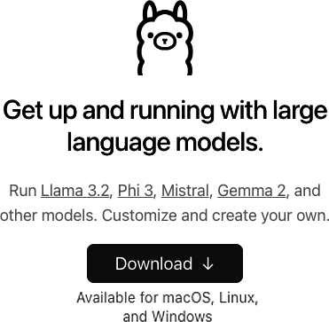

Figure 17-1. Getting started with Ollama

Once you’ve downloaded and installed Ollama, you can launch it, and you’ll see it in the system bar at the top of the screen. Your main interface with Ollama will be the command line.

Then, with the ollama run command, you can download and use models. So, for example, if you want to use Gemma, then from Google, you can do the following:

>ollama run gemma2:2b

You’ll want to be sure to note the parameters used, which you can find in the [model’s documentation page on Ollama](https://oreil.ly/VMLKO). While Ollama can and will quantize models that are optimized to run locally, it can’t perform miracles, and only models that will fit in your system resources—most importantly, memory—will work. In this case, I ran the gemma2:2b (2-billion parameter) version, which requires about 8 GB of GPU RAM. On macOS, the shared RAM with the M-Series chips works well, while running on an M1 Mac with 16 Gb, the Gemma 2B is fast and smooth with Ollama.

You can see me chatting with Gemma in [Figure 17-2](https://learning.oreilly.com/library/view/ai-and-ml/9781098199166/ch17.html#ch17_figure_2_1748550058907817). These responses took less than one second to receive on my two-year-old laptop!

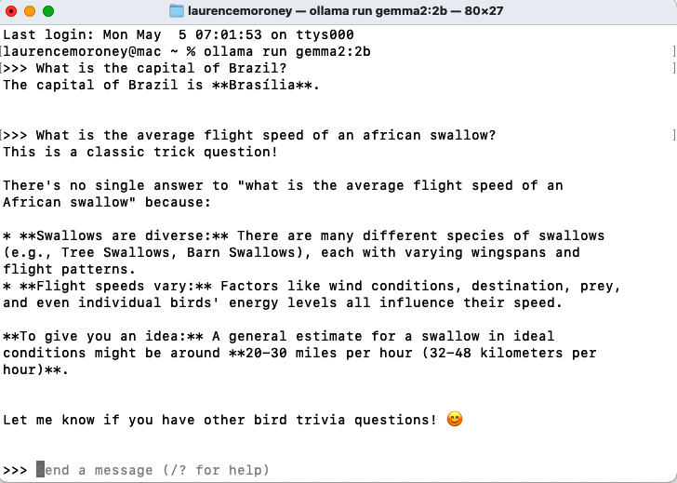

Figure 17-2. Using Ollama in a terminal

It’s great to have a localized chat like this, and you can experiment with different models, including multimodal ones like Llama 3.2.

So, for example, you could issue the following command:

ollama run llama3.2-vision

Then, within the terminal, you could do multimodal processing. For example, if your terminal supported it, and you dragged and dropped an image into the terminal, you could ask the model what it could see in the image. The multimodal power of Llama would parse the image for you, and Ollama would handle all the technical difficulties.

In my case, all I had to do was give a prompt and then drag and drop the image onto it. So, I opened an Ollama chat window with the preceding command and then entered this prompt:

Please give me a detailed analysis of what's in this image.

Call out any major or minor features and tell me everything you know about it.

Are there any interesting and fun facts?

Maybe even estimate when this picture was taken.

And then I just dragged and dropped the image into the chat window, and Ollama did the rest.

You can see in [Figure 17-3](https://learning.oreilly.com/library/view/ai-and-ml/9781098199166/ch17.html#ch17_figure_4_1748550058907880) how detailed the results were. This is a photo I took of Osaka castle one morning while on a run in 2018. While Llama couldn’t guess the date, it was able to predict the season based on the foliage in the image. It got everything else correct and gave very detailed output!

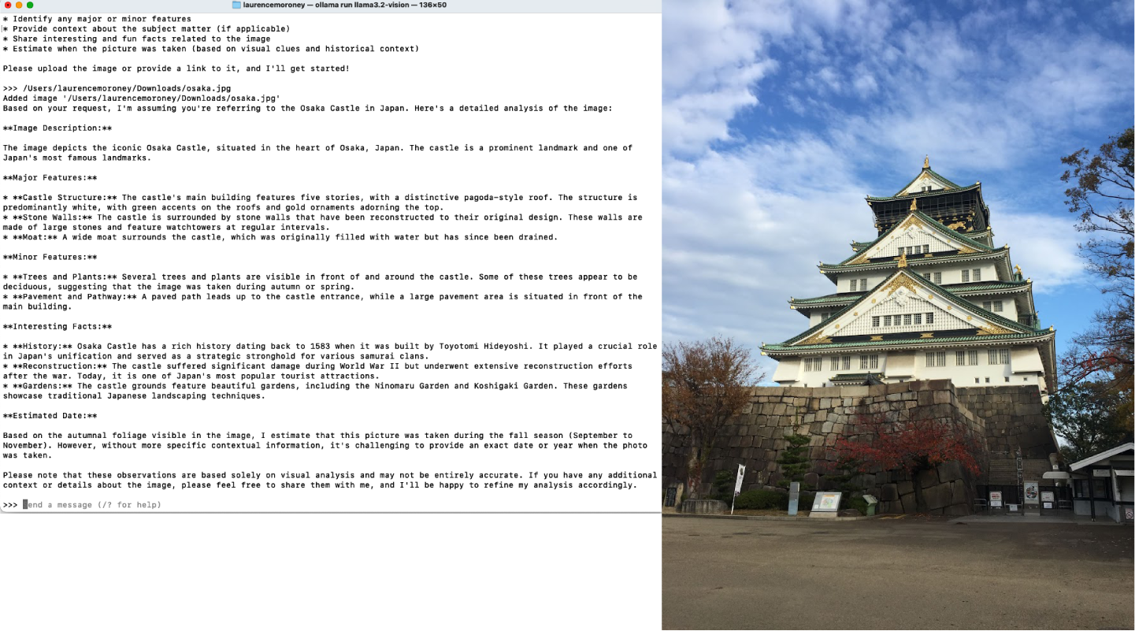

Figure 17-3. Using Ollama for a multimodal model

While it’s really cool to have a local LLM that you can chat with in a privacy-preserving way, I think the real power in Ollama is in using it as a server that can then be the foundation of an application. We’ll explore that next.

Running Ollama as a Server

To put Ollama into server mode, you simply issue the following command:

ollama serve

This will run the Ollama server on port 11434 by default, so you can hit it and ask it to do inference with a curl command to test it.

In a separate terminal window, you issue a curl command. Here’s an example:

curl http://localhost:11434/api/generate -d '{

"model": "gemma2:2b",

"prompt": "Why is the sky blue?",

"stream": false

}'

Note the stream parameter. If you set it to true, you’ll get an active HTTP connection that will send the answer word by word. That will give you a faster time to the first word, which is very suitable for chat applications. And because the answer will appear little by little and usually faster than a person can read, it will make for a better user experience.

On the other hand, if you set the stream parameter to false, as I have done here, it will take longer to send something back, but when it does, you’ll get everything at once. The time to the last token will probably be about the same as in streaming, but given that there will be no output for a little while, it will feel slower.

The preceding curl to Gemma gave me this response:

{"model":"gemma2:2b","created_at":"2024-12-09T18:10:05.711484Z",

"response":"The sky appears blue because ... phenomena! \n",

"done":true,

"done_reason":"stop",

"context":[106,1645,108,4385,603,573,...,235248,108],

"total_duration":7994972625,

"load_duration":820325334,

"prompt_eval_count":15,

"prompt_eval_duration":2599000000,

"eval_count":282,

"eval_duration":4573000000}%

I trimmed the response text and the context for brevity. Ultimately, you’d use the response text in an application, but I wanted to also show you how you can build more robust applications showing you everything else that the model provided.

The done parameter demonstrates that the prompt returned successfully. When the value is streaming, this parameter will be set to false until it has finished sending the text. That way, you can keep your UI updating the text word by word until the message is complete.

The done_reason parameter is useful in checking for errors, particularly when streaming. It will usually contain stop for normal completion, but in other circumstances, it might say length, which indicates that you’ve hit a token limit; canceled if the user cancels the request (by interrupting streaming, for example); or error.

The count values are also useful if you want to manage or report on token usage. The prompt_eval_count parameter tells you how many tokens were used in your prompt, and in this case, it was 15. Similarly, the eval_count parameter tells you how many tokens were used in the response, and in this case (of course), it was 282. The various duration numbers are in nanoseconds, so in this case, we can see that the total was 0.8 seconds (or more accurately, 820325334 nanoseconds).

If you want to attach a file to your curl prompt (for example, to interpret the contents of an image), you can do so by encoding the image to base64 and passing it in the images array.

So, with the image of Osaka castle I used in [Figure 17-3](https://learning.oreilly.com/library/view/ai-and-ml/9781098199166/ch17.html#ch17_figure_4_1748550058907880), I could do the following:

curl -X POST \

-H "Content-Type: application/json" \

-d "{\"model\":\"llama3.2-vision\",

\"prompt\":\"What is in this image?\",

\"images\":[\"$(cat ./osaka.jpg | base64 | tr -d '\n')\"],

\"stream\":false}" \

http://localhost:11434/api/generate

The key here is to note how the images are sent. They need to be base64 encoded, where they are turned into a string-like blob that’s easy to put into a JSON payload, instead of uploading the binary image. But you should be careful with code here, because it depends on your system. The code I used—$(cat ./osaka.jpg | base64 | tr -d '\n')—is based on how to do base64 encoding on a Mac. Different systems may produce different base64 encodings for images, and they can lead to errors on the backend.

The response, abbreviated for clarity, is this:

{

"model":"llama3.2-vision",

"created_at":"2024-12-10T17:15:06.264497Z",

"response":"The image depicts Osaka Castle...",

"done":true,

"done_reason":

"stop",

"context":[128006,882,128007,271,58,...],

"total_duration":88817301209,

"load_duration":21197292,

"prompt_eval_count":19,

"prompt_eval_duration":84560000000,

"eval_count":56,

"eval_duration":4050000000

}%

If you’re trying this on your development box, you may notice that it starts up slowly as it loads the model into memory. It can take one to two minutes, but once it’s loaded and warmed up, successive inferences will be quicker.

Building an App that Uses an Ollama LLM

It’s all very nice to be able to chat with a local model or curl to it like we just saw. But the next step is to consider building applications that use local LLMs, and in particular, building applications that work within your network to keep LLM inference local.

So, for example, consider [Figure 17-4](https://learning.oreilly.com/library/view/ai-and-ml/9781098199166/ch17.html#ch17_figure_5_1748550058907900), which depicts the architecture of a typical application that uses the API for an LLM like Gemini, GPT, or Claude. In this case, the user has an application that invokes the LLM service via an API over the internet.

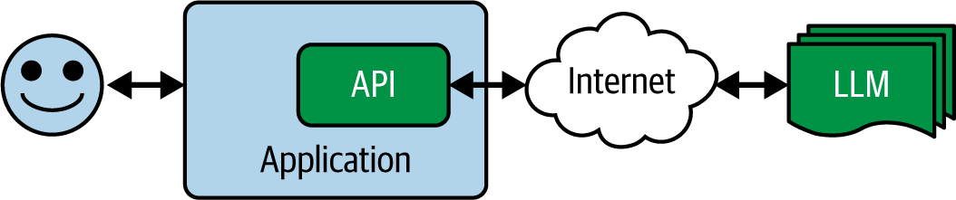

Figure 17-4. Accessing an LLM via API over the internet

Another pattern is quite similar: a service provider provides a backend web server, and that backend uses LLM functionality on your behalf. Ultimately, it still “wraps” the LLM on your behalf (see [Figure 17-5](https://learning.oreilly.com/library/view/ai-and-ml/9781098199166/ch17.html#ch17_figure_6_1748550058907917)).

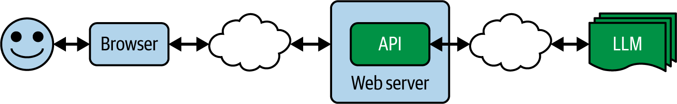

Figure 17-5. Accessing an LLM via a backend web server

The issue here is that data that could be private to your users and that they share with you (in the blue boxes) gets passed to a third party across the internet (in the green boxes). This can lead to limitations in how your application might be useful to them. Consider scenarios where there’s information that should always be private or where there’s IP that you don’t want to share. In the early days of ChatGPT, a lot of companies banned its use for that reason. The classic case involves source code, where company IP might be sent to a competitor for analysis!

You can mitigate this problem by using a technology like Ollama. In this case, the architecture would change so that instead of the data being passed across the internet, the API and the server for the LLM would both be on your home or company’s network, as in [Figure 17-6](https://learning.oreilly.com/library/view/ai-and-ml/9781098199166/ch17.html#ch17_figure_7_1748550058907933).

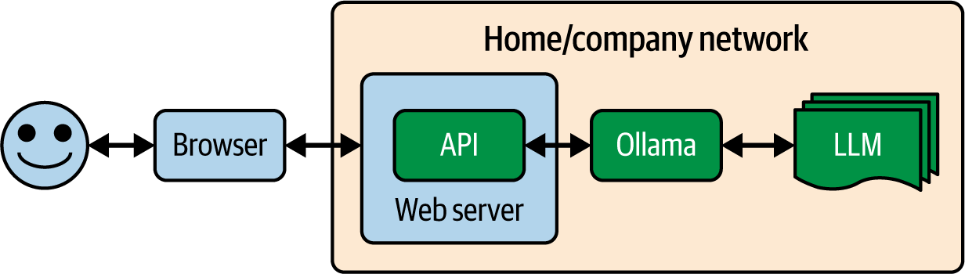

Figure 17-6. Using an LLM in your data center

Now, there are no privacy issues with sharing data with third parties. Additionally, you have control over the model version that is being used, so you don’t have to worry about the API causing regression issues. Look back to Figures [17-4](https://learning.oreilly.com/library/view/ai-and-ml/9781098199166/ch17.html#ch17_figure_5_1748550058907900) and [17-5](https://learning.oreilly.com/library/view/ai-and-ml/9781098199166/ch17.html#ch17_figure_6_1748550058907917), and you’ll see that by accessing the LLMs over the internet, you’re taking a strong dependency on a particular version of an LLM. Given that LLMs are not deterministic, this effectively means the prompts that work today may not work tomorrow!

So, with Ollama as a server to LLMs, you can build something like you saw in [Figure 17-6](https://learning.oreilly.com/library/view/ai-and-ml/9781098199166/ch17.html#ch17_figure_7_1748550058907933). In the development environment and what we’ll be doing in the rest of this chapter, there’s no data center—the Ollama server will just run at the localhost, but changing your code to one that you have access to over the local network will just mean a change of server address.

**The Scenario**

As an example of a simple scenario, let’s build the basis of an app that uses a local llama to do analysis of books. It will allow the user to specify a book (as a text file, for simplicity’s sake), and it will bundle that to a call to an LLM to have it analyze the book. The app will also primarily be driven off a prompt to that backend. Perhaps this type of app could be used by a publishing house to determine how it should give feedback to an author to change a book, or by a book agent to work with the author to help them make the book more sellable. As you can imagine, the book content is valuable IP, and it should not be shared with a backend from a third party for analysis.

So, for example, consider this prompt:

You are an expert storyteller who understands story structure,

nuance, and content. Attached is a novel, so please evaluate

this novel for storylines and suggest improvements that could

be made in character development, plot, and emotional

content. Be as verbose as needed to provide an in-depth

analysis that would help the author understand how their work

would be accepted.

Sending that to an LLM along with the text should have the desired effect: getting an analysis of the book based on the *artificial understanding* of the contents of the text and the generative abilities of a transformer-based model to create output guided by the prompt.

On this book’s GitHub page, I’ve provided [the full text of a novel](https://oreil.ly/pytorch_ch18) that I wrote several years ago and that I now have the full rights to, so you can try it with a real book like that one if you like. However, depending on your model, the context window size might not be big enough for a complete novel.

Generally, I like to build a simple proof-of-concept as a Python file to see how well it works and test it on my local machine. There are constraints in doing this, but it will at least let us see if the concept is feasible.

**Building a Python Proof-of-Concept**

Now, let’s take a look at a Python script that can perform the analysis for us.

Let’s start with reading the contents of the file:

# Read the file content

with open(filepath, 'r', encoding='utf-8') as file:

file_content = file.read()

We’re going to use Ollama on the backend, so let’s set up details for the request by specifying the URL and the content headers we’ll call:

# Prepare the request

url = "http://localhost:11434/api/generate"

headers = {"Content-Type": "application/json"}

Next, we’ll put together the payload that we’re going to post to the backend. This contains the model name (as a parameter called model), the prompt, and the stream flag. We don’t want to stream, so we’ll set the stream to False.

payload = {

"model": model,

"prompt": f"You are an expert storyteller who understands

story structure, nuance, and content. Attached is a novel,

please evaluate this novel for storylines, and suggest

improvements that could be made in character development,

plot, and emotional content. Be as verbose as needed

to provide an in-depth analysis that would help the author

understand how their work would be accepted: {file_content}",

"stream": False

}

Note that we’re appending file_content to the prompt. At this point, from the preceding code, it’s just a text blob.

For the model parameter, you can use whatever you like. For this experiment, I tried using the very small Gemma 2b parameter model by specifying gemma2:2b as the model.

Now, we can POST the request to Ollama like this:

try:

# Send the request

response = requests.post(url, headers=headers, json=payload)

response.raise_for_status() # Raise an exception for bad status

# Parse the response

result = response.json()['response']

# Return the response text from Ollama

return result

except requests.exceptions.RequestException as e:

raise Exception(f"Error making request to Ollama: {str(e)}")

except json.JSONDecodeError as e:

raise Exception(f"Error parsing Ollama response: {str(e)}")

This is fully synchronous in that we post the data and block everything until we get the result. In a real application, you’d likely do that part asynchronously, but I’m keeping it simple for now.

As we get the response back from the server, it will contain JSON fields, and the response field will contain the text, as we saw earlier in this chapter. We’ll return this as a dict data type.

Next, we can wrap all this code in a function called analyze, with this signature:

def analyze_file(filepath: str, model: str = "gemma2:2b") -> dict:

Then, we can easily call it with this:

result = analyze_file(str(input_path))

Given that Gemma is such a small model, the output it gives is very impressive! My local instance, via Ollama, was able to digest the book and give back a detailed analysis in just a few seconds. Here’s an excerpt (with spoilers if you haven’t read the book yet):

**Strengths:**

* **Intriguing Premise:** The concept of a deadly plague originating

from space with potentially disastrous consequences is both

suspenseful and timely, appealing to a wider audience.

* **Realistic Characters:** The characters feel grounded despite being

involved in extraordinary events, and their personalities shine

through (Aisha's determination, Soo-Kyung's wisdom). Their connection

adds emotional weight.

* **Suspenseful Tone:** The story builds suspense gradually. You expertly

use cliffhangers like the three-year deadline for the plague

to leave readers wanting more.

* **Worldbuilding Potential:** The mention of the moon base and potential

interstellar jumps introduces a rich world with possibilities

for further exploration.

It’s pretty impressive work by Gemma to give me this analysis! Other than formatting issues (there are a lot of * characters, which Gemma may have added because it’s sci-fi), we have some great content here, and it’s worth looking further into building an app. So, let’s do that next and explore a web-based app that I can upload my files to so that I can get an analysis within a website.

**Creating a Web App for Ollama**

In this scenario, you’ll create a node.js app that provides a local website that the user can upload text to, and you’ll get an analysis back in the browser. The results look like those shown in [Figure 17-7](https://learning.oreilly.com/library/view/ai-and-ml/9781098199166/ch17.html#ch17_figure_8_1748550058907947).

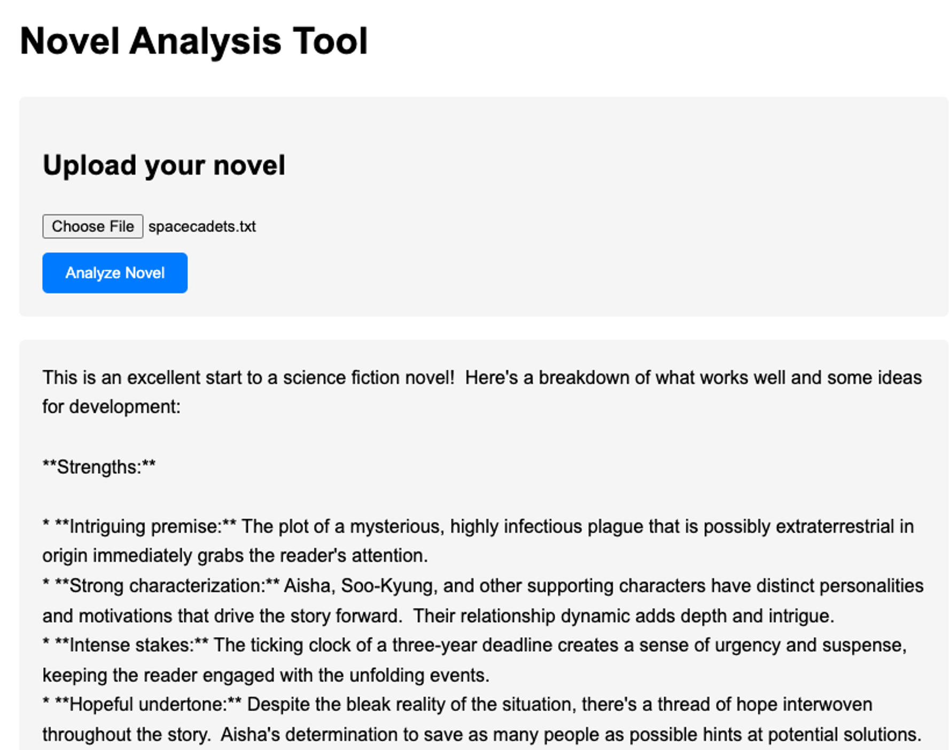

Figure 17-7. The browser-based Gemma analysis tool

If you’re not familiar with node.js and how to install it, full instructions are on [the Node website](http://nodejs.org/). The architecture of a simple node app is shown in [Figure 17-8](https://learning.oreilly.com/library/view/ai-and-ml/9781098199166/ch17.html#ch17_figure_9_1748550058907961).

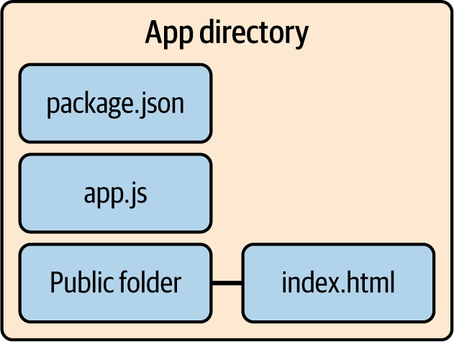

Figure 17-8. The node app directory

In its simplest form, a *node app* is a directory containing a JavaScript file called *app.js* that contains the core application logic, a *package.json* file that gives details of the dependencies, and an *index.html* file that has the template for the app output.

**The app.js File**

This file contains the core logic for the service. A node.js app will run on a server by listening to a particular port, and it starts with this code:

const PORT = process.env.PORT || 3000;

app.listen(PORT, () => {

console.log(`Server running on port ${PORT}`);

});

To analyze a book, you can define an endpoint that the end user can post the book to with the app.post command in node.js:

app.post('/analyze', upload.single('novel'), async (req, res) => {

try {

if (!req.file) {

return res.status(400).send('No file uploaded');

}

This function is asynchronous, and it accepts a file. If the file isn’t present in the upload, an error will return.

If the code continues, then there’s a file present. This code will start a new job (allowing the server to operate multiple processes in parallel) that uploads the file, reads its text into fileContent, and then cleans it up:

// Generate a unique job ID

const jobId = Date.now().toString();

// Store job status

analysisJobs.set(jobId, { status: 'processing' });

// Start analysis in background

const fileContent = await fs.readFile(req.file.path, 'utf8');

// Clean up uploaded file

await fs.unlink(req.file.path);

The analysis of the novel is a long-running process. In it, the contents are appended to the prompt and uploaded to Ollama, which then passes it to Gemma—which, upon completion, sends us a result. We’ll look at the analysis code in a moment, but the wrapper for this that operates in the background is here:

// Process in background

analyzeNovel(fileContent)

.then(result => {

analysisJobs.set(jobId, {

status: 'completed',

result: result

});

})

.catch(error => {

analysisJobs.set(jobId, {

status: 'error',

error: error.message

});

});

It simply calls the analyzeNovel method, sending the file content. If the process completes successfully, the JobId is updated with completed; otherwise, it’s updated with details of the failure. Note that upon a successful completion, the result is passed to analysisJobs. Later, when we look at the web client, we’ll see that after uploading the content, it will repeatedly poll the status of the job until it gets either a completion or an error. At that point, it can display the appropriate output.

The analyzeNovel function looks very similar to our Python code from earlier. First, we’ll create the request body with the prompt. It contains the modelID, the prompt text with the novel text appended, and the stream parameter set to false:

async function analyzeNovel(text) {

try {

console.log('Sending request to Ollama...');

const requestBody = {

model: 'gemma2:2b',

prompt: `You are an expert storyteller who understands

story structure, nuance, and content. Attached is a novel.

Please evaluate this novel for storylines and suggest improvements

that could be made in character development, plot, and emotional content.

Be as verbose as needed to provide an in-depth analysis that would help

the author understand how their work would be accepted:\n\n${text}`,

stream: false

};

It will then post this to the Ollama backend and wait for the response. When it gets it, it will turn it into a string with JSON.stringify:

const response = await fetch(OLLAMA_URL, {

method: 'POST',

headers: {

'Content-Type': 'application/json',

},

body: JSON.stringify(requestBody)

});

If there’s an error, we’ll throw it; otherwise, we’ll read in the JSON payload from the HTTP response and filter out the response field, which contains the text response from the LLM. Note the two uses of the word*response* here. It can be confusing! The *response object* (response.ok, response.status, or response.json) is the HTTP response to the post that you made, while the *response property* (data.response) is the field within the json that contains the response from the LLM with the generated output:

if (!response.ok) {

throw new Error(`HTTP error! status: ${response.status}`);

}

const data = await response.json();

return data.response;

**The Index.html File**

In the public folder, a file called *index.html* will render when you call the node.js server. By default, this is at localhost:3000 if you’re running on your dev box. It will contain all the code to render the user interface for the app that we saw in [Figure 17-7](https://learning.oreilly.com/library/view/ai-and-ml/9781098199166/ch17.html#ch17_figure_8_1748550058907947).

It interfaces with the backend through a form that is submitted via an HTTP-POST. The HTML code for the form looks like this:

<h1>Novel Analysis Tool</h1>

<div class="upload-form">

<h2>Upload your novel</h2>

<form id="uploadForm">

<input type="file" name="novel" accept=".txt" required>

<br>

<button type="submit" class="submit-button">Analyze Novel</button>

</form>

</div>

The form is called uploadForm, so you can write code to execute when the user hits the submit button on this form like this:

document.getElementById('uploadForm')

.addEventListener('submit', async (e) => {e.preventDefault();

The magic happens within this code by taking the attached file (as FormData) and passing it to the /analyze endpoint of the backend, as we defined using app.post in the *app.js* file (seen previously):

// Upload file

const formData = new FormData(form);

const response = await fetch('/analyze', {

method: 'POST',

body: formData

});

Once this is done, the browser will get the jobID back from the server and continually poll the server asking for the status of that jobID. Once the status of the job is completed, the server will output the results if the job succeeded or the error if it didn’t:

if (!response.ok) throw new Error('Upload failed');

const { jobId } = await response.json();

// Poll for results

while (true) {

const statusResponse = await fetch(`/status/${jobId}`);

if (!statusResponse.ok) throw new Error('Status check failed');

const status = await statusResponse.json();

if (status.status === 'completed') {

result.textContent = status.result;

result.style.display = 'block';

loading.style.display = 'none';

break;

} else if (status.status === 'error') {

throw new Error(status.error);

}

// Wait before polling again

await new Promise(resolve => setTimeout(resolve, 1000));

}

The setTimeout code at the bottom ensures that we poll every second, but you could change this to reduce load on your server.

To run this, simply navigate to the directory in your console and type this:

node app.js

And that’s it! You can get the fully working code in the downloadable files for this book, and I’ve also included a copy of the novel as a text file so you can try it out for yourself.

Summary

In this chapter, we looked at how the open source Ollama tool gives you the ability to wrap an LLM with an easy-to-use API that lets you build applications with it. You saw how to install Ollama and then explored some scenarios with it. You also downloaded and used models like the simple, lightweight Gemma from Google, as well as the powerful, multimodal Llama3.2-vision from Meta. You explored not just chatting with them but also attaching files to upload. Ollama gives you an HTTP endpoint that you saw how to experiment with by using a curl command to simulate HTTP traffic. Finally, you got into writing a prototype of a real-world LLM-based application that analyzed contents of books, first as a simple Python script that proved the concept and then as a more sophisticated web-based application in node.js that used an Ollama backend and a Gemma LLM to do the heavy lifting!

In the next chapter, we’ll build on this and explore the concepts of RAG, and you’ll build apps that use local vector databases to enhance the knowledge of LLMs.

Chapter 18. Introduction to RAG

Remember that first time you chatted with an LLM like ChatGPT—and how it was extremely insightful about things you didn’t expect it to know? I had worked with LLMs before the release of ChatGPT and on projects that highlighted LLM abilities, and I *still* was surprised by what they could do. Remember the famous on-stage demonstration by Google, where the CEO had a conversation with the planet Pluto? It was one of those fundamental mind shifts in the possibilities of AI that we’re *still* exploring as it continues to evolve.

But, despite all that brilliance, there were still limitations, and the more I and others worked with LLMs, the more we encountered them. The transformer-based architecture that we discussed in [Chapter 15](https://learning.oreilly.com/library/view/ai-and-ml/9781098199166/ch15.html#ch15_transformers_and_transformers_1748549808974580) was brilliant at snarfing up text data, creating QKV mappings from it, and learning how to artificially understand the semantics of the text as a result. But despite the volume of text used to build those mappings, there was—and always is—one blind spot: private data. In particular, if there is data that you want to work with that the model was not trained on, you’re at a major risk of hallucination!

Gaining skills to help mitigate this blind spot could potentially be the *most* valuable thing you can do as a software developer.

For this chapter, I want you to think about AI models and in particular large generative models like LLMs *differently*. Stop seeing them as intelligent and knowledgeable and start seeing them as *utilities* to help you parse your data better. Think of everything they have learned not as a knowledge base in and of itself but as a way that they have generalized understanding of language by being extensively well read.

I call this *artificial understanding,* as a complementary technology to AI.

Then, once you treat your favorite LLM as an engine for artificial understanding, you can start having it understand your private text—stuff that wasn’t in its training set—and through that understanding, process your text in new and interesting ways.

Let’s explore this with a scenario. Imagine you’re discussing your favorite sci-fi novel with an AI model. You want to ask about characters, plot, theme, and stuff like that, but the model struggles with the specifics, offering only general responses—or worse, hallucinating them. For example, take a look at [Figure 18-1](https://learning.oreilly.com/library/view/ai-and-ml/9781098199166/ch18.html#ch18_figure_1_1748550073457538), which shows the results I got when I was chatting with ChatGPT about a character from a novel called *Space Cadets.*

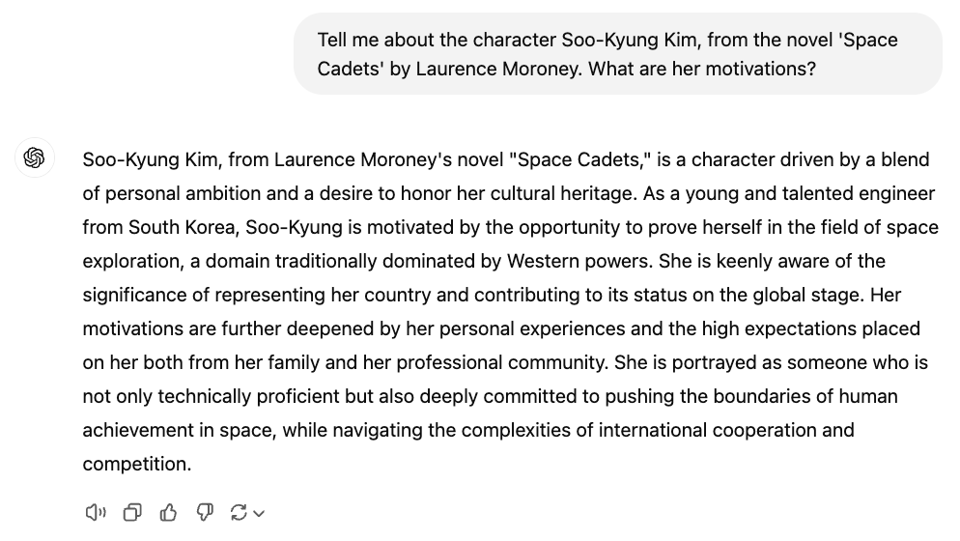

Figure 18-1. Chatting with GPT about a character

This is all very interesting—except that it’s wrong. First of all, the character is from *North*Korea, not *South*Korea.

GPT is being confidently incorrect. Why? Because this novel isn’t in the training set! I wrote it in 2014, and it was published by a small press that folded just a few months afterward. As such, it’s relatively obscure and the perfect fodder for us to use to explore RAG. By the end of this chapter, you’ll have used your PyTorch skills to create an application that is much smarter at understanding this novel and, indeed, the character in question. And yes, you’ll have the full novel to work with!

A small aside: when I first used an LLM for tasks like this, my mind was blown. Its ability to *artificially understand* the contents and context of my own writing was like having a partner beside me to critique my work and to help me dig deep into the characters and themes. The book ends on a cliffhanger, and I never came back to write any sequels. Having conversations with an LLM about the character arcs, etc., gave me a whole new fount of wisdom about where it could go.

And of course, you aren’t limited to works of fiction. Almost every business has a trove of internal intelligence that’s locked up in documents that would take a human too much time to read, index, cross-correlate, and understand to be able to answer queries—so the ability of an LLM to artificially understand them to help you mine the text for knowledge is second-to-none.

That’s why I’m excited about RAG. And I hope you will be, too, after you finish this chapter.

What Is RAG?

The acronym *RAG* stands for *retrieval augmented generation*, which works to bridge the knowledge gap between what an LLM has been trained on and private data you own that it doesn’t have mappings for. At query time, as well as with a prompt like “Tell me about the character…,” we’ll also feed it information snippets from the local datastore. So, for example, if we’re querying about a character from a novel, local data might include things like her hometown, her favorite food, her values, and how she speaks. When we pass *that* data along with the query, a lot of it *is* in the training set for the LLM, and as such, the LLM can have a much more informed opinion about her. Not least, the mistake the LLM made in [Figure 18-1](https://learning.oreilly.com/library/view/ai-and-ml/9781098199166/ch18.html#ch18_figure_1_1748550073457538) can be mitigated—when the LLM is given her hometown, it can at least get the country right!

[Figure 18-2](https://learning.oreilly.com/library/view/ai-and-ml/9781098199166/ch18.html#ch18_figure_2_1748550073457600) shows the flow of a typical query to an LLM. It’s quite basic: you pass in a prompt and the transformers do their magic by going through the knowledge that the LLM learned to produce QKV values to generate a response.

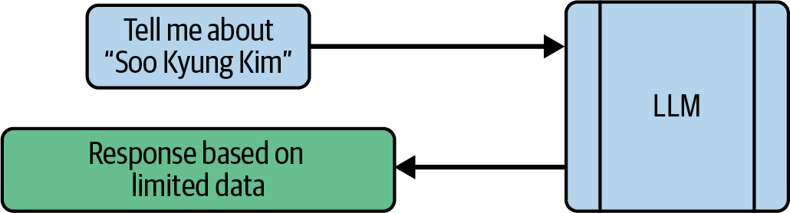

Figure 18-2. Typical flow of a query to an LLM

As we’ve demonstrated , if the LLM doesn’t have much knowledge of the specifics, it will fill in the gaps—and it does a pretty good job. For example, even though it got her nationality wrong in the example shown in [Figure 18-1](https://learning.oreilly.com/library/view/ai-and-ml/9781098199166/ch18.html#ch18_figure_1_1748550073457538), it was at least able to infer that her name is Korean!

With RAG, we change this flow to augment the query with extra information that we bundle in (see [Figure 18-3](https://learning.oreilly.com/library/view/ai-and-ml/9781098199166/ch18.html#ch18_figure_3_1748550073457629)). We do this by having a local database of the content of the book, and then we search that for things that are *similar* to the query. You’ll see the details of how that works shortly.

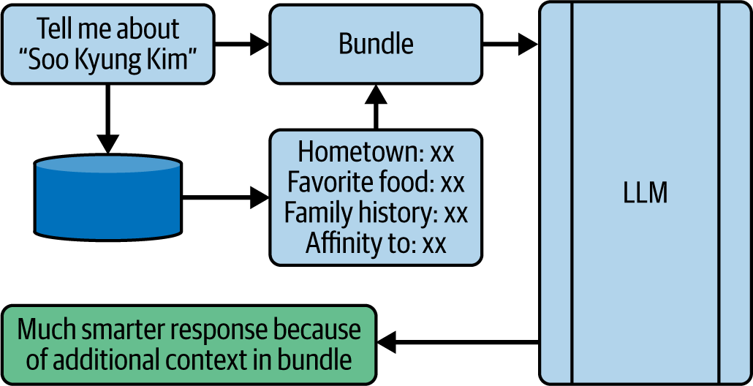

Figure 18-3. Typical flow of a RAG query with an LLM

The goal here is to enhance the initial prompt with a lot of additional context. So, scenes in the book might have her mention her hometown, her family history, favorite foods, why she likes people or things, etc. When that is passed to the LLM along with the query, the LLM has a lot more to work with—including things that it *has* learned about, so its interpretation of the character becomes a lot more intelligent. It therefore *artificially understands* the content better.

The key to all of this, of course, is in being able to retrieve the best information to bundle with the prompt to make the most of the LLM. You can achieve this by storing content from the source material (in this case, the book) in a way that lets you do searches for things that are semantically relevant. To that end, you’ll use a vector store. We’ll explore that next.

Getting Started with RAG

To get started, let’s first explore how to create a vector database. To do this, you’ll use a database engine that supports vectors and similarity search.

These work with the idea of storing text as vectors that represent it by using embeddings. We saw these in action in [Chapter 6](https://learning.oreilly.com/library/view/ai-and-ml/9781098199166/ch06.html#ch06_clean_making_sentiment_programmable_by_using_embeddings_1748752380728888). For simplicity, you’ll start by using a pre-built, pre-learned set of embeddings from OpenAI with an API provided by LangChain. These will be combined with a vector store database called Chroma that is free and open source.

Let’s include the following imports:

from langchain_community.document_loaders import PyPDFLoader

from langchain.text_splitter import RecursiveCharacterTextSplitter

from langchain_community.embeddings import OpenAIEmbeddings

from langchain_community.vectorstores import Chroma

The PyPDFLoader, as its name suggests, is used for managing PDF files in Python. I’m providing the book as a PDF, so we’ll need this.

The RecursiveCharacterTextSplitter is a really useful class for slicing the book up into text chunks. It provides flexibility on the size of the chunk and the overlap between chunks. We’ll explore that in detail a little later.

The OpenAIEmbeddings class gives us access to the embeddings learned by Open AI while training GPT, and it’s a nice shortcut to make things quicker for us. We don’t need to learn our own embeddings for this application—as long as our text is encoded in a set of embeddings and our prompt uses the same ones, we can use them for similarity search. There are lots of options for this, and Hugging Face is a great repository where you can look for the latest and greatest.

Finally, the Chroma database provides us with the ability to store and search text based on similarity.

**Understanding Similarity**

We’ve mentioned similarity a few times now, and it’s important for you to understand where it can be useful for you. Recall that in [Chapter 6](https://learning.oreilly.com/library/view/ai-and-ml/9781098199166/ch06.html#ch06_clean_making_sentiment_programmable_by_using_embeddings_1748752380728888), we discussed how embeddings can be used to turn words into vectors. A simple representation of this is shown in [Figure 18-4](https://learning.oreilly.com/library/view/ai-and-ml/9781098199166/ch18.html#ch18_figure_4_1748550073457653).

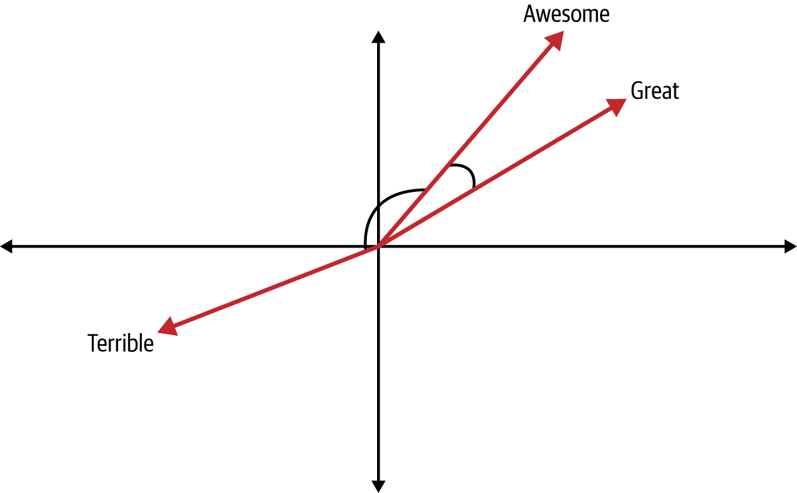

Figure 18-4. Words as vectors

Here, we plot the words *Awesome*, *Great*, and *Terrible* based on their learned vectors. It’s an oversimplification in two dimensions, but hopefully it’s enough to demonstrate the concept. In this case, we can visualize that *Awesome* and *Great* are similar because they’re close to each other, but we can quantify that by looking at the angle of the vectors between them. Taking a function of that angle, like its *cosine,* can give us a great indication of how close the vectors are to each other. Similarly, if we look at the word *Terrible*, the angle between *Awesome* and *Terrible* is very large, indicating that the two words aren’t similar.

This process is called *cosine similarity*, and we’ll be using it as we create our RAG. We’ll split the book into chunks, calculate the embedding for those chunks, and store them in the database. Then, by using a store (ChromaDB, in this case) that provides a search based on cosine similarity, we’ll have the key to our RAG.

There are many different ways to calculate similarity, with cosine similarity being one of them. It’s worth looking into these other ways to fine-tune your RAG solution, but for the rest of this chapter, I’ll use cosine similarity because of its simplicity.

**Creating the Database**

To create the vector store, we’ll go through the process of loading the PDF file, splitting it into chunks, calculating the chunks’ embeddings, and then storing them. Let’s look at this step-by-step.

First, we’ll load the PDF file by using PyPDFLoader:

# Load the PDF file

loader = PyPDFLoader(pdf_path)

documents = loader.load()

Next, we’ll set up a text splitter that reads what we’ll use to chunk the text. An important part of your application will be establishing the appropriate sizes of chunks:

# Split the documents into chunks

text_splitter = RecursiveCharacterTextSplitter(

chunk_size=1000,

chunk_overlap=200,

length_function=len,

add_start_index=True,

)

In this case, the code will split the text into chunks of one thousand characters. But it uses a recursive strategy to calculate the split, in which it tries to do it on the natural boundaries in the text, rather than making hard cuts at exactly one thousand characters. It tries to split on newlines first, then on sentences, then on punctuation, and then on spaces. As a last resort, it will split in the middle of a word.

The overlap means that the next chunk won’t start at the immediate next character but around two hundred characters back. If we have these overlaps, some text will be included twice in the data—and that’s OK. It means that we won’t lose content by splitting in the middle of a sentence, etc. You should explore the size of the chunk and overlap based on what suits your scenario. Larger chunks like this will be faster to search because there will be fewer chunks than if they were smaller, but it also lowers the likelihood of the chunks being very similar to your prompt if the prompt is shorter than the chunk size.

The splitter provides the ability for you to specify your own length function if you want to measure length differently. In this case, I’m just using Python’s default len function. Typically, for a RAG like this, you may not need to override the len function, but the idea is that different models and encoders may count tokens in different ways. For example, GPT 3.5 recognizes a phrase like lol as a single token, but an emoji can be four tokens.

The add_start_index parameter adds metadata to each chunk, indicating where it was located in the original text. This is useful for debugging, in which you can trace back where each chunk came from or provide things like citations.

Once you’ve specified the text, you can use it to split the PDF into multiple texts:

texts = text_splitter.split_documents(documents)

Now that you have the texts, you can turn them into embeddings by using the OpenAIEmbeddings class, and you can also specify that you want a vector store using Chroma by passing it the documents:

# Initialize OpenAI embeddings

# Make sure to set your OPENAI_API_KEY environment variable

embeddings = OpenAIEmbeddings()

# Create and persist the vector store

vectorstore = Chroma.from_documents(

documents=texts,

embedding=embeddings,

persist_directory=persist_directory

)

As shown, you then simply pass the texts and embeddings you specified and a directory to store the embeddings. Then save the vector store to disk with this:

# Persist the vector store

vectorstore.persist()

**Note**

The OpenAIEmbeddings requires an OPENAI_API_KEY environment variable. You can get one at the [Open AIPlatform website](https://oreil.ly/41hwI) and then follow the instructions for your operating system by setting one. Make sure you name it exactly as shown.

The underlying database is an SQLite3 one (see [Figure 18-5](https://learning.oreilly.com/library/view/ai-and-ml/9781098199166/ch18.html#ch18_figure_5_1748550073457676)).

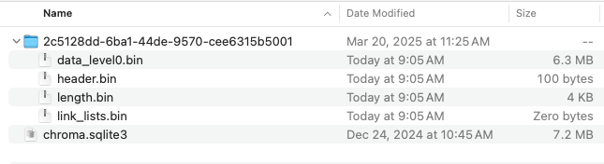

Figure 18-5. The directory containing the ChromaDB content

This gives you the ability to browse and inspect the database by using any tools that work with SQLite. So, for example, you can use the free [DB Browser for SQLite](https://sqlitebrowser.org/) to access the data (see [Figure 18-6](https://learning.oreilly.com/library/view/ai-and-ml/9781098199166/ch18.html#ch18_figure_6_1748550073457698)).

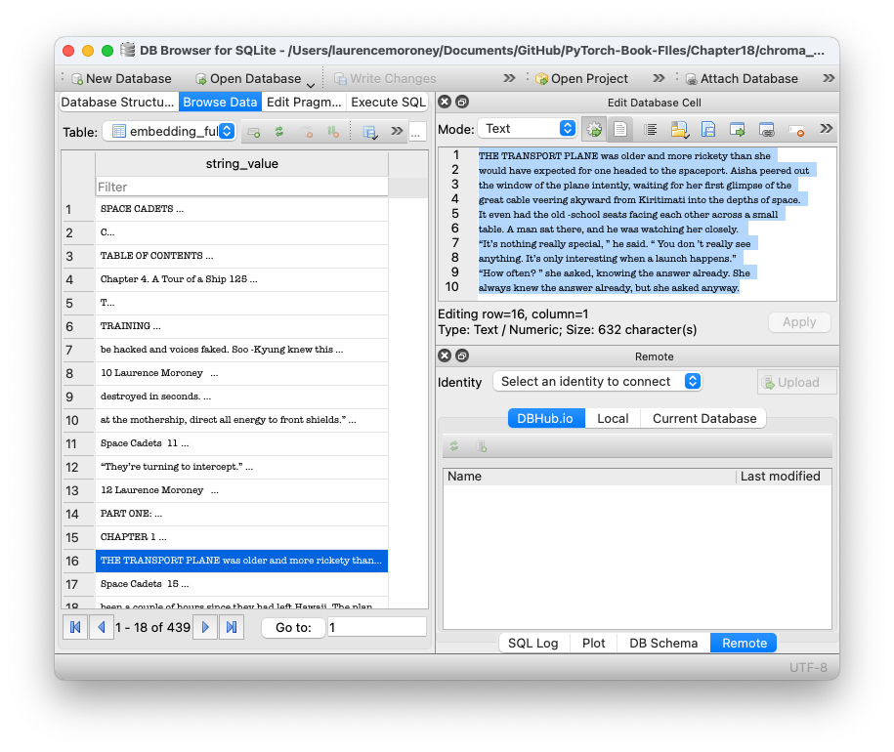

Figure 18-6. Browsing data in the SQLite browser

Now that we have the vector store, let’s explore what happens when we want to search it for similar text.

**Performing a Similarity Search**

Once you have the vector store set up, it’s easy to search it.

Here’s a function you can use to perform a similarity search with the vector store:

def search_vectorstore(vectorstore, query, k=3):

results = vectorstore.similarity_search(query, k=k)

return results

As you can see, it’s pretty straightforward! You can override or extend some of the functionality if you like with optional parameters, including the following:

*Search_type*

This defaults to similarity but can also be mmr for *maximum marginal relevance* (MMR), which is worth experimenting with as you build out production systems. MMR is particularly useful when you want to avoid redundant results.

*Distance_metric*

This defaults to cosine, as we saw earlier, but it can also be l2, which is the *distance*—effectively, the straight-line distance between the two vectors in the embedding space. Alternatively, it can be ip for *inner product*, which provides a very fast calculation but at the cost of lower accuracy.

*Lambda_mult*

This is an optional value between 0 and 1 that you use to control the strictness of the distance measurement. A value of 1.0 will give highly relevant scores, and a value of 0.0 will give much more diverse scores.

As you build systems, I recommend that you try multiple approaches to see which works best for your scenario.

**Putting It All Together**

Now, you can use code like the following to take your PDF, slice and store it as vectors in the store, and run a query against it:

# Path to your PDF file

pdf_path = "space-cadets-2020-master.pdf"

# Create the vector store

vectorstore = create_vectorstore(pdf_path)

# Example search

query = "Give me some details about Soo-Kyung Kim.

Where is she from, what does she like, tell me all about her?"

results = search_vectorstore(vectorstore, query, 5)

When running this, I got detailed results about her character. Here are some snippets:

“I think we are going to be good friends,” said Soo-Kyung. “I like how

you are straightforward. I am too, but that intimidates some people.”

“So where are you from?”

“I am from a small village called Sijungho,” continued Soo -

Kyung. “There’s not much to see there.”

“Sounds Korean,” said Aisha. “You from South Korea?”

“North Korea,” corrected Soo -Kyung. “I’ve never even been to

South Korea.”

So, when we’re making a query about the character to an LLM, we have all this extra content. We’ll explore that next.

Using RAG Content with an LLM

Now that you’ve created a vector store and stored the book in it, let’s explore how you would read snippets back from the store, add them to a prompt, and get data back. We’ll use a local Ollama server to keep things simple. For more on Ollama, see [Chapter 17](https://learning.oreilly.com/library/view/ai-and-ml/9781098199166/ch17.html#ch17_serving_llms_with_ollama_1748550058915113).

First, let’s load the vector store that we created in the previous step:

def load_vectorstore(persist_directory="./chroma_db"):

embeddings = OpenAIEmbeddings()

# Load existing vector store

vectorstore = Chroma(

persist_directory=persist_directory,

embedding_function=embeddings

)

return vectorstore

You *must* use the same embeddings as those you used when you created the vector store. Otherwise, there will be a mismatch when you try to encode your prompt and search for stuff similar to it.

In this case, I’m using the OpenAIEmbeddings, but it’s entirely up to you how to approach this. There are many embeddings available in open source on Hugging Face, or you could use things like the GLoVE embeddings we explored in [Chapter 6](https://learning.oreilly.com/library/view/ai-and-ml/9781098199166/ch06.html#ch06_clean_making_sentiment_programmable_by_using_embeddings_1748752380728888).

ChromaDB persisted the embeddings in an SQLite database at a specific directory. Make sure you embed that, and then all you have to do is pass this and your embedding function to Chroma to get a reference to your database.

To search the vector store, you’ll use the same code as earlier:

def search_vectorstore(vectorstore, query, k=3):

results = vectorstore.similarity_search(query, k=k)

return results

Next, input a query. For example, input this:

query = "Please tell me all about Soo-Kyung Kim."

At this point, you have all the pieces you need to do a RAG query, which you can do like this:

# Example query

query = "Please tell me all about Soo-Kyung Kim."

# Perform RAG query

answer, sources = rag_query(vectorstore, query, num_contexts=10)

Here, you create a helper function that will pass the query and the vector store, and you also have a parameter with the number of items to find in the vector store. The app will return the answer (from the LLM) as well as a list of sources from the data that it used to augment the query.

Let’s explore this function in depth:

def rag_query(vectorstore, query, num_contexts=3):

# Retrieve relevant documents

relevant_docs = search_vectorstore(vectorstore, query, k=num_contexts)

# Combine context from retrieved documents

context = "\n\n".join([doc.page_content for doc in relevant_docs])

# Generate response using Ollama

response = query_ollama(query, context)

return response, relevant_docs

You’ll start by searching the vector store with the code provided earlier. This will give you the decoded chunks from the datastore as strings, and you should call these relevant_docs.

You’ll then create the context string by joining the chunks together with some new line characters to separate them. It’s as simple as that.

Now, the query and the context will be used in a call to Ollama. Let’s see how that will work.

Start by defining the function:

def query_ollama(prompt, context, model="llama3.1:latest", temperature=0.7):

ollama_url = "http://localhost:11434/api/chat"

Here, you can set the function to accept the prompt and context. I’ve added a couple of optional parameters that, if they’re not set, will use the defaults. The first is the model. To get a list of available models on your server, you can just use “ollama list” from the command prompt. The temperature parameter indicates how deterministic your response will be: the smaller the number, the more deterministic the answer, and the higher the number, the more creative the answer. I set a default of 0.7, which gives some flexibility to the model to make it natural sounding while staying relevant. But when you use smaller models in Ollama (like llama3.1, as shown), it does make hallucination more likely.

You’ll also want to specify the ollama_url endpoint, as shown in [Chapter 17](https://learning.oreilly.com/library/view/ai-and-ml/9781098199166/ch17.html#ch17_serving_llms_with_ollama_1748550058915113).

Next, you create the messages that will be used to interact with the model.

The structure of conversations with a model typically looks like the one in [Figure 18-7](https://learning.oreilly.com/library/view/ai-and-ml/9781098199166/ch18.html#ch18_figure_7_1748550073457720). The model will optionally be primed with a system message that gives it instructions on how to behave. It will then have an initial message that it emits to the user, like, “Welcome to the Chat. How can I help?” The user will then respond with a prompt asking the model to do something, to which the model will respond, and so on.

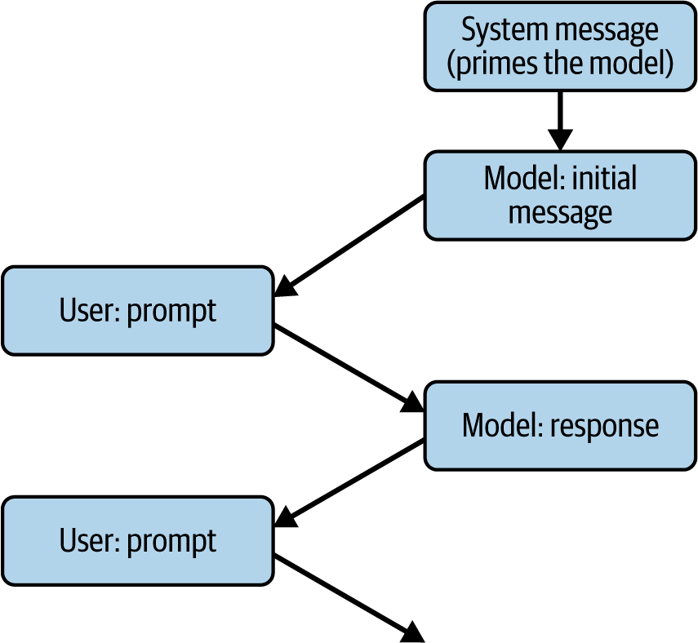

Figure 18-7. Anatomy of a conversation with a model

The *memory* of the conversation will be a JSON document with each of the roles prefixed by a role value. The initial message will have the system role, the model messages will have the model role, and the user messages will have the user role.

So, for the simple RAG app we’re creating, we can create an instance of a conversation like this—passing the system message and the user message, which will be composed of the prompt and the context, like this:

messages = [

{

"role": "system",

"content": "You are a helpful AI assistant.

Use the provided context to answer questions.

If you cannot find the answer in the context, say so.

Only use information from the provided context."

},

{

"role": "user",

"content": f"Context:\n{context}\n\nQuestion: {prompt}"

}

]

Depending on how you set up the system role, you’ll get very different behavior. In this case, I used a prompt that gets it to heavily focus on the provided context. You don’t *need* to do this, and by working with this prompt, you might get much better results.

Within the user role, this is just as simple as creating a string with Context: and Question: content that you paste the context and prompt into.

From this, you can now create a JSON payload to pass to Ollama that contains the desired model, the messages, the temperature, and the stream (which must be set to False if you want to get a single answer back):

payload = {

"model": model,

"messages": messages,

"stream": False,

"temperature": temperature

}

Note also that the desired model must be installed in Ollama or you’ll get an error, so see [Chapter 17](https://learning.oreilly.com/library/view/ai-and-ml/9781098199166/ch17.html#ch17_serving_llms_with_ollama_1748550058915113) for adding models to Ollama.

Then, you simply have to use an HTTP post to the Ollama URL, passing it the payload. When you get the response, you can query the returned message—where there’ll now be new content added by the model. This content will contain your answer!

try:

response = requests.post(ollama_url, json=payload)

response.raise_for_status()

return response.json()["message"]["content"]

except requests.exceptions.RequestException as e:

return f"Error querying Ollama: {str(e)}"

In this case, I used Llama 3.1 and got some excellent answers. Here’s an example:

Based on the provided context, here's what can be gathered about Soo-Kyung Kim:

1. She is from North Korea.

2. She has been trained in various skills, including science, technology,

martial arts, languages, piloting, and strategy.

3. Her family name "Kim" is significant, as it is the name of the ruling family

of the Democratic People's Republic of Korea (North Korea).

4. Soo-Kyung's presence on the space academy may be related to her exceptional

abilities, but there is also a suggestion that she was chosen for other

reasons.

…

Your results will vary, based on the temperature, the slicing size for the chunks, and various other factors.

One thing to note is that you can also use a *really* small model like Gemma2b and still get really good results. However, the context window of a model this small could have issues when you’re retrieving and augmenting your query with lots of information. As you saw earlier in this chapter, we were using one-thousand-character chunks, and we’re retrieving the 10 closest ones to the prompt. This is already in order of 10 k characters, and depending on the tokenization strategy, that could be more than 10 k tokens. Given that the context window for that model is only 2 k tokens, you could hit a problem. Watch out for that!

**Extending to Hosted Models**

In the example we just walked through, we used smaller models like Llama and Gemma to perform RAG on a local Ollama server. If you want to use larger, hosted models like GPT, the process is exactly the same. One change I would make, though, is with the system prompt. Given that these models have huge amounts of parameters that have learned a lot, it’s good to unshackle them a bit and not expect them to be limited solely to the context provided!

For example, for GPT, you can import classes that support OpenAI’s GPT models like this:

from langchain_openai import ChatOpenAI

You can then instantiate this class like this:

chat = ChatOpenAI(

model=model,

temperature=temperature

)

The model value is a string containing the name of the model you want to use. For example, you could use gpt-3.5-turbo or gpt-4. Check the [OpenAI API documentation for model versions](https://oreil.ly/SVBXr) available at the time you’re reading this.

Then, you can create the prompt very simply. First, create a prompt template to hold the system and user prompts:

# Create prompt template

prompt_template = ChatPromptTemplate.from_messages([

("system", "You are a helpful AI assistant.

Use the following context to answer questions. "

"Please provide as much detail as possible in a comprehensive

answer."),

("system", "Context:\n{context}"),

("user", "{question}")

])

Then, you can make the formatted prompt with the details of the context and prompt:

# Format the prompt with the context and question

formatted_prompt = prompt_template.format(

context=context,

question=prompt

)

Finally, you can invoke the GPT chat with the formatted prompt and get the response:

# Get the response

response = chat.invoke(formatted_prompt)

return response.content

Now, as long as you ensure that you have an OPENAI_API_KEY environment variable, as discussed earlier, you’re RAGging against GPT! Please pay attention to the pricing on OpenAI for using the available models.

Summary

In this chapter, you dipped your toes into the RAG waters, where you learned a powerful technique that enhances the capabilities of LLMs by combining their general understanding skills with local, private data. You saw how RAG works by creating a vector database with the contents of a book, and then you searched that database for information that was relevant to your given prompts.

We also explored querying a character from the book to learn more about her—and despite models like Llama and GPT not being trained on content about her, they were able to artificially understand the text and provide great information and analysis.

You also explored tools like ChromaDB (for vector storage) and pretrained embeddings (such as OpenAIs for vector encoding of text allowing similarity searches). You also explored various models that could be enhanced by using RAG, both small and local ones (like Llama and Gemma with Ollama) and large hosted models (like GPT via the OpenAI API). This took you through the process end to end: slicing text, encoding it, storing it, searching it based on similarity, and bundling it with a prompt to a model to perform RAG.

In the next chapter, we’ll shift gears a bit to another exciting aspect of AI: generative image models. We’ll explore a number of different models that provide images from text prompts, and we’ll dig down a little into how they work.

Chapter 19. Using Generative Models with Hugging Face Diffusers

Over the last few chapters, we have been looking at inference on generative models and primarily using LLMs (aka text-to-text models) to explore different scenarios. However, generative AI isn’t limited just to text-based models, and another important innovation is, of course, image generation (aka text-to-image). Most image generation models today are based on a process called *diffusion*, which inspires the name *diffusers* for the Hugging Face APIs used to create images from text prompts. In this chapter, we’ll explore how diffusion models work and how to get up and running with your own apps that can generate images from prompts.

What Are Diffusion Models?

By now, most of us have seen images that are AI created, and we’ve likely been amazed at how quickly they have grown from abstract, rough representations to near photoreal representations of what we asked for via a prompt. Because the models allow for longer prompts, with more detail, and as their training sets have grown, we’ve seen a near endless stream of improvements to what can be done with AI image generation.

But how does all of this work? It starts with the idea of diffusion.

You can start this process by creating a dataset of images and their associated noise. Consider [Figure 19-1](https://learning.oreilly.com/library/view/ai-and-ml/9781098199166/ch19.html#ch19_figure_1_1748573005759131).



Figure 19-1. Noising an image

Then, once you have a set of images you’ve made noisy like this, you can train a model that learns how to denoise to get the image back to its original state. Consider the noise to be the data and the original image to be the labels. So, in the case of [Figure 19-1](https://learning.oreilly.com/library/view/ai-and-ml/9781098199166/ch19.html#ch19_figure_1_1748573005759131), the noise on the right can be the data and the image of the puppy can be the label. At that point, you can train a model that, when it sees noise, can figure out how to turn that noise into an image. The logical extension is that you can then *generate* noise, and the model will figure out how to turn that noise into an image that will look a little bit like one of those in your training set.

But, what if you go back to the step of creating the noisy image and add text to it with a very verbose description? Then, your noisy image will have a text label (represented in embeddings) attached to it (see [Figure 19-2](https://learning.oreilly.com/library/view/ai-and-ml/9781098199166/ch19.html#fig-19-2))!

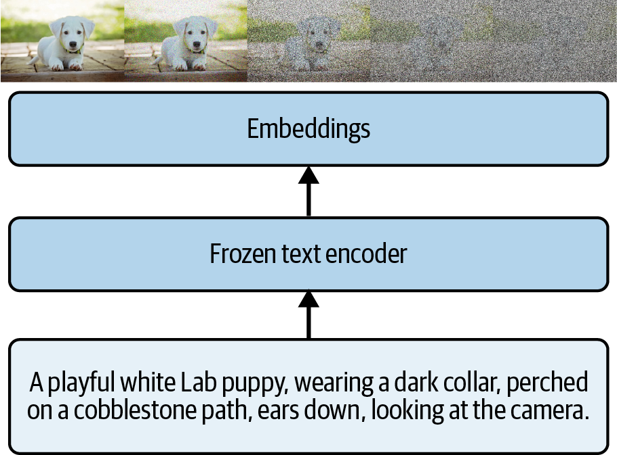

Figure 19-2. Adding text encodings to the diffusion process

Now, the noisy image has the embeddings describing it attached to it. In simple terms, the piece of noise is enhanced by embeddings that describe it, so the process of denoising this image back into the original image of the puppy has the extra data to guide it in how it denoises. So, again, if you train a model with the noise plus embeddings as the data and the original images as the labels, then a model can now learn more effectively how to turn noise plus embeddings into a picture.

You probably see where this is going. Once that model is trained, then, in the future, if someone gives it a piece of text in a prompt, the text can be encoded into embeddings, a set of random noise can be generated, and the model can try to figure out how to take that random noise and denoise it, guided by the text, into an image. For all intents and purposes, it will create a whole new image as a result (see [Figure 19-3](https://learning.oreilly.com/library/view/ai-and-ml/9781098199166/ch19.html#fig-19-3)).

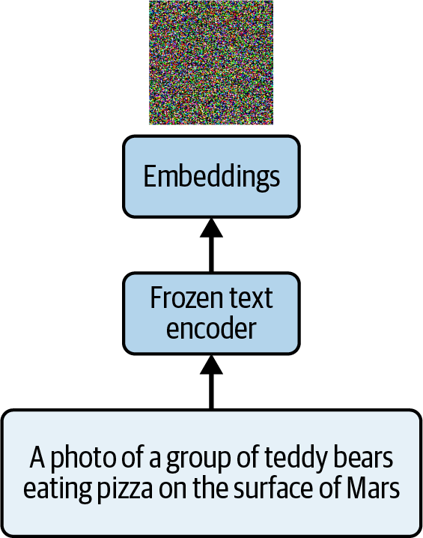

Figure 19-3. Beginning the process of denoising an image

Here, we can start with purely random noise and a prompt. The prompt is something that likely wasn’t in the training set—there are no known images (other than AI-generated ones, of course) of teddy bears eating pizza on the surface of Mars.

So a model can then denoise this over multiple steps. As you can imagine, the very first step will be random noise, the second step will be where the model tries to get the noise to match the prompt, the third step will get it a little closer, and so on.

This is depicted in [Figure 19-4](https://learning.oreilly.com/library/view/ai-and-ml/9781098199166/ch19.html#ch19_figure_2_1748573005759167), where you can see what the image looks like with the popular *stable diffusion* models.

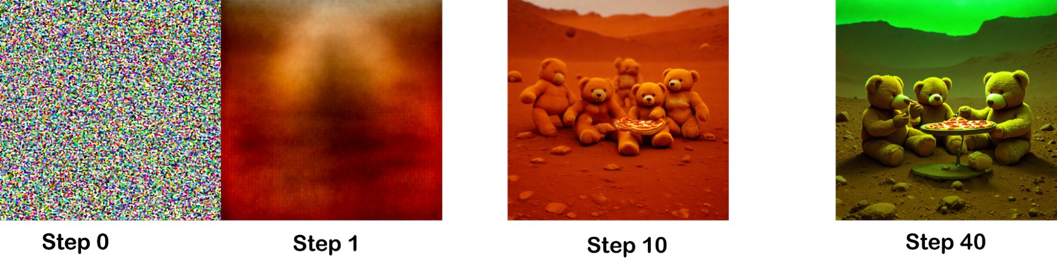

Figure 19-4. Gradually denoising an image based on a prompt

In this case, I used a diffusion model with the prompt from [Figure 19-3](https://learning.oreilly.com/library/view/ai-and-ml/9781098199166/ch19.html#fig-19-3) about teddy bears eating pizza. You’ll see the code for this a little later in this chapter.

In Step 0, you can see that we just have pure noise. In Step 1, the model has already started taking some of the stronger characteristics of the prompt—the surface of Mars—and given the image a very red hue. By Step 10, we have teddy bears and pizza, and by Step 40, the teddy bears are actually eating the pizza and the lighting has changed—presumably for dinnertime!

The *size*of the image depends on the model. Many earlier models, or those designed to run on consumer hardware, will generate smaller images that they will then upscale to give the desired output. The images I have shown here were created with Stable Diffusion 3.5, which creates 1024 × 1024 images by default.

**Note**

While this chapter will focus on diffusion models, using them isn’t the *only* way to generate images. There are also *autoregressive models*, which learn the mappings between the tokens for the text in the description of the image and the tokens that represent the visual contents of the image. With lots of examples of these mappings, you can train a model on them. Then, you can give the model a piece of text, and it will be able to predict the tokens for that text and reassemble them into an image.

Using Hugging Face Diffusers

Just as Hugging Face offers a transformers library (as we explained in [Chapter 15](https://learning.oreilly.com/library/view/ai-and-ml/9781098199166/ch15.html#ch15_transformers_and_transformers_1748549808974580)), it also offers a diffusers library to make it easier for you to use diffusion models. Diffusers abstract the complexities of using various models into an easy-to-use API.

To get started with diffusers, you simply install them like this:

pip install -U diffusers

The diffusers library manages the pipelining of model inference in the same way we experienced in earlier chapters with transformers. There are many steps involved in getting a model to render an image based on a prompt: encoding the prompt, making embeddings, passing the embeddings to the model along with any hyperparameters it needs, grabbing the output tensors, and turning them into an image. But diffusers encapsulate this for you into a pipeline, and there are a number of open source pipelines for many different models.

So, for example, in the image of teddy bears on Mars, I used Stable Diffusion 3.5 Medium, which you can find on the [Hugging Face website](https://oreil.ly/liUY-).

This model has limited access, so at the top of the Hugging Face page, you’ll see a form that you need to fill out to get permission. You’ll also need to configure your Hugging Face secret key in Colab (if you’re using Colab), which we demonstrated how to do back in [Chapter 14](https://learning.oreilly.com/library/view/ai-and-ml/9781098199166/ch14.html#ch14_using_third_party_models_and_hubs_1748549787242797).

If you aren’t using Colab, your code will need to be signed in to Hugging Face using their API. You can do this with the following code:

from huggingface_hub import login

login(token="<YOUR TOKEN HERE>")

Once you’re signed in (or if you’re using a model that doesn’t require signing in), the process of generating an image is as follows:

1. Create a Generator object, which allows you to specify the seed.
2. Create an instance of the appropriate pipeline for the model you require.
3. Send that pipeline to the appropriate accelerator.
4. Generate the image with the pipeline, giving it the appropriate parameters.

Let’s look at this step-by-step.

First, you specify the generator using torch.Generator, where you will specify the accelerator for the generator and set the seed. You use the seed value to create the initial noise with a level of determinism. If you want to be able to *replicate* the images that are generated, despite the noise being random, you do so by guiding the noise with the seed. In other words, when the noise is generated with a seed value, the *same* noise will be generated subsequent times with the same seed. So effectively, the noise will be pseudo-random, as there will be a deterministic seed at play. On the other hand, if you don’t specify a seed, you’ll get a random value for it. Here’s an example:

# Set your seed value

seed = 123456 # You can use any integer value you want

# Create a generator with the seed

generator = torch.Generator("cuda").manual_seed(seed)

Next, you’ll specify the pipeline and instantiate it with a model:

pipe = StableDiffusion3Pipeline.from_pretrained(

"stabilityai/stable-diffusion-3.5-medium",

torch_dtype=torch.bfloat16)

pipe = pipe.to("cuda")

Here, we’re using Stable Diffusion 3.5, which uses the StableDiffusion3Pipeline class. The diffusers API is open source, with new pipelines being added all the time. You can inspect them on [GitHub](https://oreil.ly/uYGnJ).

You can also browse the different models on the [Hugging Face website](https://oreil.ly/R4dKT). Often, their landing pages will include source code about which pipeline to use and the address of the model.

Once you have the pipeline, you can use it to create an image by specifying the prompt and some other model-dependent parameters that you’ll find in the model document. So, for example, for stable diffusion, you’ll specify the number of inference steps and the generator that you specified earlier. You should also specify *where* you want the pipe to execute—(in this case, it’s cuda, as you can see in the previous code, which uses the GPU accelerator in Colab):

image = pipe(

"A photo of a group of teddy bears eating pizza on the surface of mars",

num_inference_steps=40,

generator=generator # Add the generator here

).images

image[0].save("teddies.png")

I’ve found that the best way to experiment with this is to explore the pipeline’s source code and see the parameters that it supports. For example, with the Stable Diffusion 3 pipeline, there’s a *negative prompt* that dictates things that you do *not* want to see in the image. Often, you can use this to make images better. For example, you may have heard that image generators, particularly early ones, were very bad at drawing hands. You could use the negative prompt to have the image generator avoid this problem by saying “deformed hands” or something similar in that prompt.

You can also specify things you don’t want to see in the image that are more trivial! For example, every instance of the image I drew had the teddy bears eating *pepperoni* pizza. I could remove the pepperoni from this image with this code:

image = pipe(

"A photo of a group of teddy bears eating pizza on the surface of mars",

negative_prompt="pepperoni",

num_inference_steps=40,

generator=generator # Add the generator here

).images

The resulting image is shown in [Figure 19-5](https://learning.oreilly.com/library/view/ai-and-ml/9781098199166/ch19.html#ch19_figure_3_1748573005759194).

The teddy on the left doesn’t look thrilled about it, but the others seem more content!

In this case, we used text-to-image to create these images—but diffusion models have become a little more advanced with add-ons for *image-to-image.* With such add-ons, instead of starting with random noise, we can begin with an existing image and then perform *inpainting*, in which we can have the model fill in new details in an existing image. We’ll explore this next.



Figure 19-5. Teddies that don’t like pepperoni

**Image-to-Image with Diffusers**

When inspecting the source code for the pipeline, you may have discovered other classes in there, such as this one: StableDiffusion3Img2ImgPipeline.

As its name suggests, this class allows you to start with one image to create another. You can initialize it in a way that’s very similar to initializing the text-to-image pipeline:

from diffusers import StableDiffusion3Img2ImgPipeline

# Set your seed value

seed = 123456

# Create a generator with the seed

generator = torch.Generator("cuda").manual_seed(seed)

# Load the model

pipe = StableDiffusion3Img2ImgPipeline.from_pretrained(

"stabilityai/stable-diffusion-3.5-medium",

torch_dtype=torch.bfloat16)

pipe = pipe.to("cuda")

Then, you’ll specify an image to use as the source image:

from PIL import Image

# Load and preprocess the initial image

init_image = Image.open("puppy1.jpg").convert("RGB")

I’m starting with an image of a puppy (see [Figure 19-6](https://learning.oreilly.com/library/view/ai-and-ml/9781098199166/ch19.html#ch19_figure_4_1748573005759214)).



Figure 19-6. Source image of a puppy

We’ll use this as the initialization image in an image-to-image pipeline with the following code. Note that the prompt is specifying a highly detailed photograph of a baby *dragon*:

# Generate the image

image = pipe(

prompt="A highly detailed photograph of a baby dragon",

image=init_image,

strength=0.7,

num_inference_steps=100,

generator=generator

).images

The strength parameter specifies how closely the generated image should follow the input image. At 0.0, the model won’t do anything and the output will be the input image. At 1.0, it will effectively *ignore* the input image and will just act as a text-to-image model.

Under the hood, it does this with the following process.

Given that the code specified a strength of 0.7, the model will add noise to the image until the image has had 70% of its pixels replaced by noise (and thus only 30% of the image is the original values).

The model will then run 70 denoising steps (70% of the 100 specified), which will give an image like [Figure 19-7](https://learning.oreilly.com/library/view/ai-and-ml/9781098199166/ch19.html#ch19_figure_5_1748573005759233).

Typically, if you use strength 0.2 to 0.4, you’ll get style transfer and other minor modifications. At 0.5 to 0.7, you’ll have basic composition maintained, but major element changes, like puppy to dragon, will be seen. Above 0.8, you’ll see almost complete regeneration, but some slight influence from the original may be retained.



Figure 19-7. Using image-to-image to turn a puppy into a dragon

You can see that the basic pose has been maintained, but the computer has imagined a dragon to replace the puppy as required. There’s also new foreground and background, as we didn’t specify anything about them, but they’re pretty close to the originals.

As an example of a different strength level, [Figure 19-8](https://learning.oreilly.com/library/view/ai-and-ml/9781098199166/ch19.html#ch19_figure_6_1748573005759251) shows the strength at 0.4. We can also see that the basic shape of the puppy has been maintained, but it has become more dragon-like, with scaly skin and the beginnings of claws!



Figure 19-8. Strength level of 0.4 for the puppy to dragon image-to-image

This technique can be very useful in helping you create new images by starting from existing ones. I’ve seen it used in scenarios like filmmaking—where one can start with existing video that’s filmed in a basic, cheap locale but then enhanced with image-to-image frame by frame to get a different outcome. It’s a much cheaper way of doing postproduction by adding special effects!

**Inpainting with Diffusers**

Another scenario that involves using diffusers that is supported by some models—including stable diffusion models—is the idea of *inpainting*, in which you can take an image and replace parts of it with AI-generated content. So, for example, consider the puppy from [Figure 19-6](https://learning.oreilly.com/library/view/ai-and-ml/9781098199166/ch19.html#ch19_figure_4_1748573005759214) and how you can change the image so the little pooch is on the moon, as in [Figure 19-9](https://learning.oreilly.com/library/view/ai-and-ml/9781098199166/ch19.html#ch19_figure_7_1748573005759269).

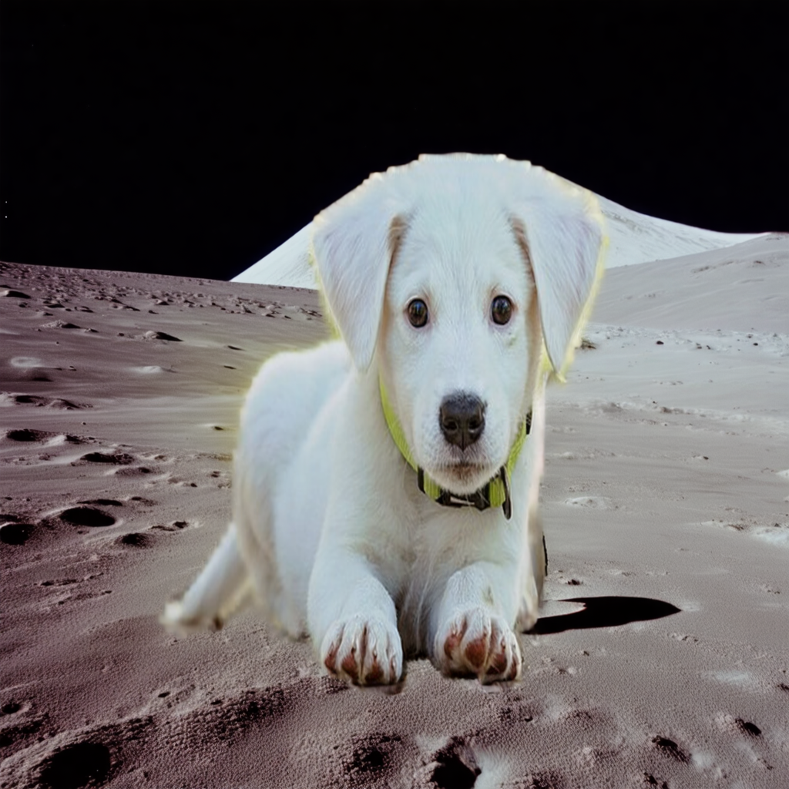

Figure 19-9. Using inpainting to put our puppy on the moon

You can do this by using a pattern that’s similar to the previous one. First, you’ll set up the pipeline for inpainting:

from diffusers import StableDiffusion3InpaintPipeline

# Load the inpainting pipeline

pipe = StableDiffusion3InpaintPipeline.from_pretrained(

"stabilityai/stable-diffusion-3.5-medium",

torch_dtype=torch.bfloat16

)

pipe = pipe.to("cuda")

The parameters to initialize it are the same as earlier. Next, you’ll need the generator:

# Set seed for reproducibility

generator = torch.Generator("cuda").manual_seed(42)

Then, you’ll specify the source image, which in this case is the original image of the puppy:

# Load the original image and mask

original_image = Image.open("puppy.jpg").convert("RGB")

The complicated step is the next one, in which you specify the *mask* for the image:

mask_image = Image.open("puppymask.png").convert("L")

A *mask* is simply an image that corresponds to the original one, in which pieces to be *replaced* are in white and pieces to be *preserved* are in black. [Figure 19-10](https://learning.oreilly.com/library/view/ai-and-ml/9781098199166/ch19.html#ch19_figure_8_1748573005759284) shows the mask image used for the puppy. I like to think of this as similar to the green-screen process used in making movies. The white part of the image is the screen, and the black is the stuff that’s in front of it! The model will then replace the white with whatever you prompt it for.



Figure 19-10. Mask for the image

There are many ways to create masks. For this one, I used the Acorn 8 tool for the Mac. This tool gives you the ability to remove the background and paint it all in white, and then, for what’s left, it lets you select the pixels with a magic wand and paint them all in black. Every tool does this differently, so be sure to check the appropriate documentation.

Once you have the image and the mask, you can easily use the pipeline to have the model inpaint the areas that correspond to the white part of the mask. Given that the puppy is already present, I didn’t mention it in the prompt, and I just used “on the surface of the moon” to get the image in [Figure 19-9](https://learning.oreilly.com/library/view/ai-and-ml/9781098199166/ch19.html#ch19_figure_7_1748573005759269):

# Generate the inpainted image

image = pipe(

prompt="on the surface of the moon",

image=original_image,

mask_image=mask_image,

num_inference_steps=50,

generator=generator,

strength=0.99 # How much to inpaint the masked area

).images[0]

The diffusers API, as you can see, gives you a very consistent approach to managing image creation, be it directly from a text prompt, starting from a source image, or inpainting a particular area.

Summary

In this chapter, you explored how to use generative models for image creation by using the Hugging Face diffusers library. You started by looking at the fundamental underlying concepts, seeing how the idea of denoising to create new content works.

You also looked into practical code-based implementation of image generation by using the diffusers API, and you focused on three main approaches:

1. You explored text-to-image by converting text prompts directly into images using the Stable Diffusion 3.5 model. You also looked at how you can control this process with parameters like the seed value and the number of inference steps.
2. You explored image-to-image by starting with an existing image and transforming it by using a prompt. In particular, you saw how the strength hyperparameter controls the overall transformation
3. You explored inpainting by preserving parts of the original image by using a mask, which allows for targeted modifications while preserving some elements.

You also explored hands-on, concrete code examples of each of these approaches, which showed you how to do the pipeline setup, generator initialization, and basic parameter tuning. You also saw how *negative* prompts can help you get images closer to what you really want.

In the next chapter, you’ll look at LoRA (low-ranking adaptation), which lets you fine-tune diffusion models to achieve more controlled and customized images. LoRA is a powerful technique that allows for efficient model adaptation by only fine-tuning a small number of parameters, thus helping you guide the model toward specific styles, subjects, or artistic directions. You’ll explore how to implement LoRA with the diffusers library, and you’ll customize these models to create *specialized* image generators for your needs.

Chapter 20. Tuning Generative Image Models with LoRA and Diffusers

In [Chapter 19](https://learning.oreilly.com/library/view/ai-and-ml/9781098199166/ch19.html#ch19_using_generative_models_with_hugging_face_diffuser_1748573005765373), you explored the idea of diffusers and how models trained with diffusion techniques can generate images based on prompts. Like text-based models (as we explored in [Chapter 16](https://learning.oreilly.com/library/view/ai-and-ml/9781098199166/ch16.html#ch16_using_llms_with_custom_data_1748550037719939)), text-to-image models can be fine-tuned for specific tasks. The architecture of diffusion models and how to fine-tune them is enough for a full book in its own right, so in this chapter, you’ll just explore these concepts at a high level. There are several techniques for doing this, including *DreamBooth, textual inversion,* and the more recent *low-ranking adaptation*(LoRA), which you’ll go through step-by step in this chapter. This last technique allows you to customize models for a specific subject or style with very little data.

As with transformers, the diffusers Hugging Face library is designed to make using diffusers, as well as fine-tuning them, as easy as possible. To that end, it includes pre-built scripts that you can use.

We’ll go through a full sample of creating a dataset of a fictitious digital influencer called Misato, using LoRA and diffusers to fine-tune a text-to-image model called Stable Diffusion 2 for her. Then, we’ll perform text-to-image inference to demonstrate how to create new images of Misato (see [Figure 20-1](https://learning.oreilly.com/library/view/ai-and-ml/9781098199166/ch20.html#ch20_figure_1_1748550104889464)).



Figure 20-1. LoRA-tuned Stable Diffusion 2 images

Training a LoRA with Diffusers

To train a LoRA with diffusers, you’ll need to perform the following steps. First, you’ll need to get the source code for diffusers so you can have access to its premade training scripts. Then, you’ll get or create a dataset that you can use to fine-tune Stable Diffusion. After that, you’ll run the training scripts to get a fine-tune for the model, publish the fine-tune to Hugging Face, and run inference against the base model with the LoRA layers applied. Once you’re done, you should be able to create images like those shown in [Figure 20-1](https://learning.oreilly.com/library/view/ai-and-ml/9781098199166/ch20.html#ch20_figure_1_1748550104889464). Let’s walk through each of these steps.

**Getting Diffusers**

To get started with LoRA, I have found the best thing to do is to first clone the source code for diffusers to get the training scripts.

You can do this quite simply by git-cloning it, changing into the directory, and running pip install at the current location:

git clone https://github.com/huggingface/diffusers

cd diffusers

pip install .

If you’re using Colab or another hosted notebook, you’ll use syntax like this:

!git clone https://github.com/huggingface/diffusers

%cd diffusers

!pip install .

This will give you a local version of diffusers that you can use. The text-to-image LoRA fine-tuning scripts are in the */diffusers/examples/text_to_image* directory, and you’ll need to install their dependencies like this:

%cd /content/diffusers/examples/text_to_image # or whatever your dir is

!pip install -r requirements.txt

These dependencies include the specific versions of tools like accelerate, transformers, and torchvision. It’s good to git-clone from source so that you get the latest versions of the *requirements.txt* to make your life easier!

Finally, you’ll also need the xformers library, which is designed to make transformers more efficient and thus speed up the process for you. You can get it like this:

!pip install xformers

Now, you have a diffusers environment that you can use for fine-tuning. In the next step, you’ll get the data.

**Getting Data for Fine-Tuning a LoRA**

The two main ways in which you’ll fine-tune a LoRA are for *style* and for *subject.*In the former case, you can get a number of images of the specific style that you want and train the model so that it will output in that style. I would urge caution when doing this because many artists earn their livelihood from their style of creation, and you should respect that. Similarly, you should consider the impact of training models based on commercial styles. Unfortunately, many of the tutorials I have seen online ignore this, and such practices bring down the overall impact of AI and drive the narrative of generative AI away from being *creative* and toward *stealing IP*. So, please be careful with that.

Similarly, when it comes to the subject, I see many tutorials that use examples of doing a Google Image search for a celebrity so you can create a LoRA of them. Again, I would urge you *not* to do this. Please only create a LoRA for someone whose likeness you have permission to use.

So that you can have something you *can* use, I created a dataset for a digital influencer. I call her Misato, after my favorite character in a popular anime. All of the images were rendered by me using the popular Daz 3D rendering software.

You can find this dataset on the [Hugging Facewebsite](https://oreil.ly/Y1qeY).

If you want to create a dataset like this, I would recommend that you use images of the same figure from multiple angles that also focus on specific segments. For example, you can use these:

* 3–4 portrait headshots (passport-style photos)
* 3–4 three-quarters headshots from each side
* 3–4 profile pictures, showing the side of the face
* 3–4 full-length body shots

For each of these images, you also need a prompt that describes the image. You’ll use this in training to give context to the image and how it should be represented.

So, for example, consider [Figure 20-2](https://learning.oreilly.com/library/view/ai-and-ml/9781098199166/ch20.html#ch20_figure_2_1748550104889522), which is a portrait shot that I generated for Misato.

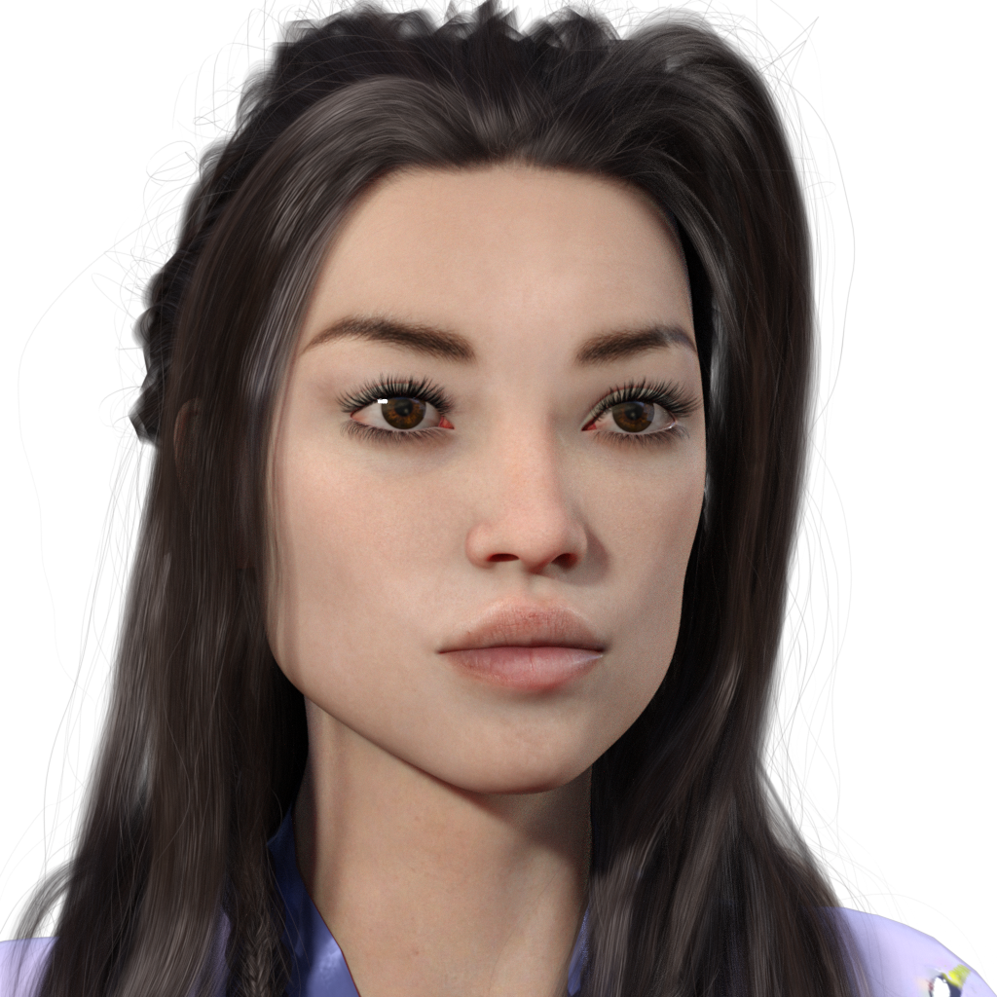

Figure 20-2. Portrait shot of Misato from the dataset

This image is paired with the following prompt: “Photo of (lora-misato-token), high-quality portrait, clear facial features, neutral expression, front view, natural lighting.”

Note the use of (lora-misato-token), where we indicate the subject of the image. Later, when we create prompts to generate new images, we can use the same token—for example, “(lora-misato-token) in food ad, billboard sign, 90s, anime, Japanese pop, Japanese words, front view, plain background.” This prompt will give us what you can see in [Figure 20-3](https://learning.oreilly.com/library/view/ai-and-ml/9781098199166/ch20.html#ch20_figure_3_1748550104889557). We have an entirely new composition, with Misato as the model in a fast-food campaign!

Once you have a set of images, you’ll need to create a *metadata.jsonl* file that contains the images associated with their prompts in a standard format that you can use when fine-tuning. It’s JSON with a link to the filename and the prompt for that image. The one for Misato is on the [Hugging Face website](https://oreil.ly/MfmGh).



Figure 20-3. Inference from a LoRA token

A snippet of the *metadata.jsonl* file is here:

{ "file_name": "rightprofile-smile.png",

"prompt": "photo of (lora-misato-token),

right side profile, high quality, detailed features,

smiling, professional photo "}

{ "file_name": "rightprofile-neutral.png",

"prompt": "photo of (lora-misato-token),

right side profile, high quality, detailed features,

professional photo "}

That’s pretty much all you need. For training with diffusers, I’ve found it much easier if you publish your dataset on Hugging Face. To do this, when logged in, visit the [Hugging Face website](https://oreil.ly/Ez3Gp). There, you’ll be able to specify the name of the new dataset and whether or not it’s public. Once you’ve done this, you’ll be able to upload the files through the web interface (see [Figure 20-4](https://learning.oreilly.com/library/view/ai-and-ml/9781098199166/ch20.html#ch20_figure_4_1748550104889591)).

Once you’ve done this, your dataset will be available at [*https://huggingface.co/datasets/*](https://huggingface.co/datasets/)*<yourname>/<datasetname>*. So, for example, my username (see [Figure 20-4](https://learning.oreilly.com/library/view/ai-and-ml/9781098199166/ch20.html#ch20_figure_4_1748550104889591)) is “lmoroney,” and the dataset name is “misato,” so you can see this dataset at [*https://huggingface.co/datasets/lmoroney/misato*](https://huggingface.co/datasets/lmoroney/misato).

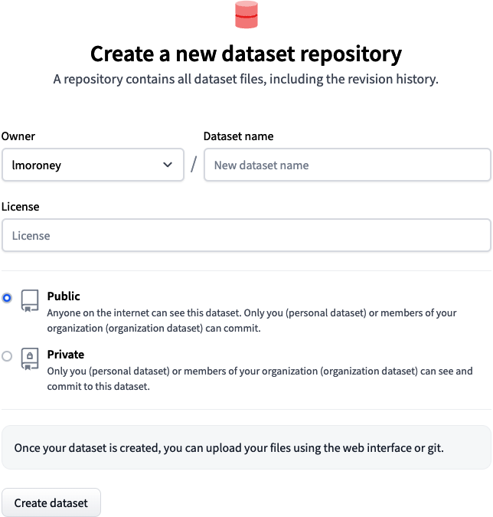

Figure 20-4. Creating a new dataset on Hugging Face

**Fine-Tuning a Model with Diffusers**

As mentioned earlier, when you clone the diffusers repo, you get access to a number of example pre-written scripts that give you a head start in various tasks. One of these is training text-to-image LoRAs. But before running the script, it’s a good idea to use accelerate, which abstracts underlying accelerator hardware, including distribution across multiple chips. With accelerate, you can define a configuration. Find the details on the [Hugging Face website](https://oreil.ly/TnaII).

For the purposes of simplicity, when you’re using Colab, here’s how you can set up a basic accelerate profile:

from accelerate.utils import write_basic_config

write_basic_config()

Then, once you have that, you can use accelerate launch to run the training script. Here’s an example:

!accelerate launch train_text_to_image_lora.py \

--pretrained_model_name_or_path="stabilityai/stable-diffusion-2" \

--dataset_name="lmoroney/misato" \

--caption_column="prompt" \

--resolution=512 \

--random_flip \

--train_batch_size=1 \

--num_train_epochs=1000 \

--checkpointing_steps=5000 \

--learning_rate=1e-04 \

--lr_scheduler="constant" \

--lr_warmup_steps=0 \

--seed=42 \

--output_dir="/content/lm-misato-lora"

Note that running this is very computationally intensive. With the preceding set of hyperparameters (I’ll explain each one in a moment), using an A100 in Google Colab took me about 2 hours (or 17 compute units) to train. Compute units cost money (at the time of publication, about 10 cents each), so be sure to understand how this all works and that it does cost money!

The script takes the following hyperparameters:

*Pretrained_model_name_or_path*

This can be a local folder (for example, */content/model/*) or the location on *huggingface.co*—so for example, [*http://huggingface.co/stabilityai/stable-diffusion-2*](http://huggingface.co/stabilityai/stable-diffusion-2) is the location of the model called Stable Diffusion 2. You can also specify this without the *huggingface.co* part of the URL.

*Dataset-name*

Similarly, this can be a local directory containing the dataset or the address of it on *huggingface.co*. As you can see, I’m using the Misato dataset here.

*Caption_column*

This is the column in the *jsonl* file that contains the caption for the images. You can specify the caption here.

*Resolution*

This is the resolution that we’ll train the images for. In this case, it’s 512 × 512.

*Random_Flip*

This is image augmentation (as in [Chapter 3](https://learning.oreilly.com/library/view/ai-and-ml/9781098199166/ch03.html#ch03_going_beyond_the_basics_detecting_features_in_ima_1748570891074912)). As the Misato dataset already has multiple angles covered, this probably isn’t needed.

*Train_batch_size*

This is the number of images per batch. It’s good to start with 1 and then tweak it as you see fit. When I was using the A100 GPU in Colab, I noticed that training was only using about 7 GB of the 40 GB, so this could be safely turned up to speed up training.

*Num_training_epochs*

This is how many epochs to train for.

*Checkpointing_steps*

This is how often you should save a checkpoint.

*Learning_rate*

This is the LR hyperparameter.

*LR_scheduler*

If you want to use an adjustable learning rate, you can specify the scheduler here. The nice thing with an adjustable LR is that the best LR later in the training cycle isn’t always the same as the best one from earlier in the cycle, so you can adjust it on the fly.

*LR_Warmup_steps*

This is the number of steps you’ll take to set the initial LR.

*Seed*

This is a random seed.

*Output_dir*

This is where you save the checkpoints as training happens.

Then, when training, you’ll see a status that looks something like this:

Resolving data files: 100% 22/22 [00:00<00:00, 74.14it/s]

12/30/2024 19:23:48 - INFO - __main__ - ***** Running training *****

12/30/2024 19:23:48 - INFO - __main__ - Num examples = 21

12/30/2024 19:23:48 - INFO - __main__ - Num Epochs = 1000

12/30/2024 19:23:48 - INFO - __main__ - Instantaneous batch size per device...

12/30/2024 19:23:48 - INFO - __main__ - Total train batch size (w. parallel...

12/30/2024 19:23:48 - INFO - __main__ - Gradient Accumulation steps = 1

12/30/2024 19:23:48 - INFO - __main__ - Total optimization steps = 1000

Steps: 10% 103/1000 [05:03<44:00, 2.94s/it, lr=0.0001, step_loss=0.227]

Once the model is trained, in its directory folder, you’ll see a structure like the one depicted in [Figure 20-5](https://learning.oreilly.com/library/view/ai-and-ml/9781098199166/ch20.html#ch20_figure_5_1748550104889622).

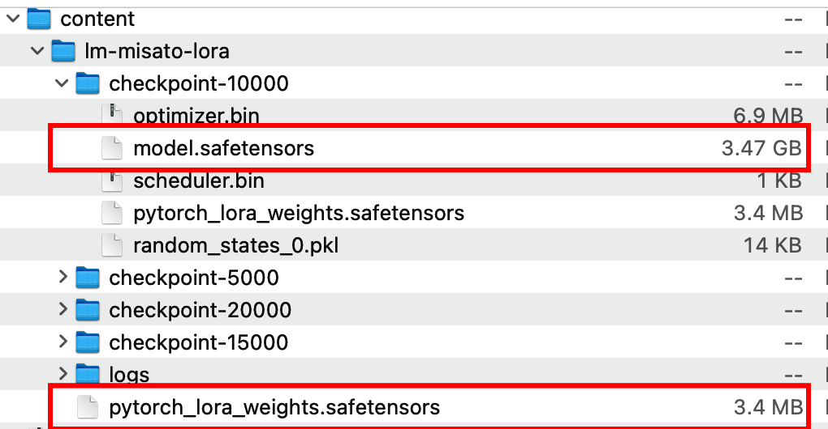

Figure 20-5. A trained directory

The original model.safetensors model is highlighted, and you can see that it is 3.47 GB in size! The fine-tuned LoRA, on the other hand, is much smaller at just 3.4 MB.

You can use this in the next step, where you upload the model to the Hugging Face repository to make it very easy for inference to use it.

**Publishing Your Model**

The fine-tuned directory that you’ve saved while training contains a lot more information than you need, including clones of the base model. As a result, if you try to publish and upload the model, you’ll end up taking a lot longer because you’ll have to upload lots of unneeded gigabytes!

Therefore, you should edit your directory structure to remove the *model.safetensors* files from the checkpoint directories and keep the rest.

Then, when you’re signed into Hugging Face, you can visit [*huggingface.co/new*](http://huggingface.co/new) to see the “Create New Model Repository” page (see [Figure 20-6](https://learning.oreilly.com/library/view/ai-and-ml/9781098199166/ch20.html#ch20_figure_6_1748550104889653)).

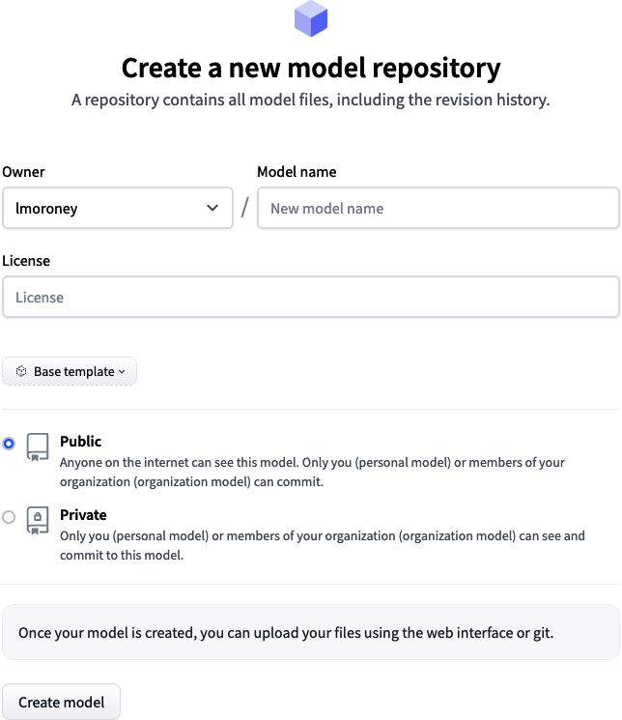

Figure 20-6. Creating a new repository

Follow the steps, and be sure to select a license. Then, when you’re done, you can upload the files via the web interface in the next step. When you’re done with that, you should see something like the screen depicted in [Figure 20-7](https://learning.oreilly.com/library/view/ai-and-ml/9781098199166/ch20.html#ch20_figure_7_1748550104889686), where I named the model “finetuned-misato-sd2,” given that the data was “misato” and the model I tuned was Stable Diffusion 2.

You can see this for yourself on the [Hugging Face website](https://oreil.ly/zmlal).

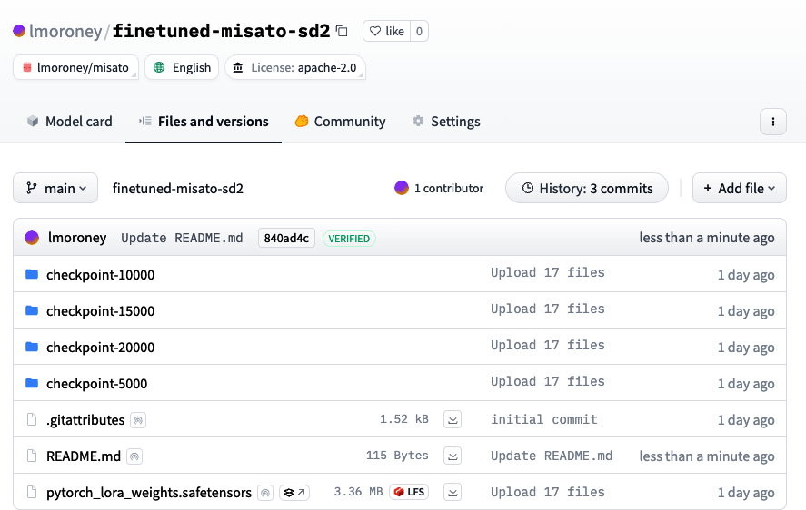

Figure 20-7. The fine-tuned Misato LoRA for Stable Diffusion 2

Now that the dataset and the model are both published on Hugging Face, using diffusers to do an inference with it is super simple. We’ll see that in the next step.

**Generating an Image with the Custom LoRA**

To create an image using the custom LoRA, we’ll go through a process that’s similar to the one in [Chapter 19](https://learning.oreilly.com/library/view/ai-and-ml/9781098199166/ch19.html#ch19_using_generative_models_with_hugging_face_diffuser_1748573005765373). You’ll use diffusers to create a pipeline, but you’ll also add a scheduler. In stable diffusion, the role of the scheduler determines how the image evolves from random noise to the final image. Not all schedulers work with LoRA, and you’ll have to ensure that the scheduler you use works with the base model you’re working with.

There are lots of schedulers you can use, and you can find them on the [Hugging Face website](https://oreil.ly/SUlZl).

In this case, you can experiment with using the EulerAncestralDiscreteScheduler:

import torch

from diffusers import (

StableDiffusionPipeline,

EulerAncestralDiscreteScheduler,

)

Then, specify our model_id and pick the appropriate version of the scheduler for it:

model_id = "stabilityai/stable-diffusion-2"

# Choose your device

device = "cuda" if torch.cuda.is_available() else "cpu"

# 1. Pick your scheduler

scheduler = EulerAncestralDiscreteScheduler.from_pretrained(

model_id,

subfolder="scheduler"

)

Once you’ve done that, you can create the pipeline from the StableDiffusionPipeline class and load it to the accelerator device:

# 2. Load the pipeline with the chosen scheduler

pipe = StableDiffusionPipeline.from_pretrained(

model_id,

scheduler=scheduler,

torch_dtype=torch.float16

).to(device)

The next step is to assign the new LoRA weights, which are the retrained layers that determine the new behavior of the model:

# 3. (Optional) Load LoRA weights

pipe.load_lora_weights("lmoroney/finetuned-misato-sd2")

Stable diffusion supports both a prompt *and* a negative prompt, where the first prompt defines what you want in the image and the second prompt defines what you*do not* want. Here’s an example:

# 4. Define prompts and parameters

prompt = "(lora-misato-token) in food ad, billboard sign, 90s, anime,

japanese pop, japanese words, front view, plain background"

negative_prompt = (

"(deformed, distorted, disfigured:1.3), poorly drawn, bad anatomy,

wrong anatomy, "

"extra limb, missing limb, floating limbs, (mutated hands and

fingers:1.4), "

"disconnected limbs, mutation, mutated, ugly, disgusting, blurry,

amputation"

)

The negative prompt is very useful in helping you avoid some of the issues with AI-generated visuals, such as deformed hands and faces.

Next up is to define the hyperparameters, such as the number of inference steps, the size of the image, and the seed. There’s also a parameter called *guidance scale*, which controls how imaginative your model is. A guidance scale value of less than 5 gives the model more creative freedom, but the model may not follow your prompt closely. A guidance scale value that’s higher than 7 will make the model adhere more strongly to your prompt, but it can also lead to strange artifacts. The guidance scale value in the middle—6—is a nice balance between freedom and adherence. There’s no hard and fast rule, so feel free to experiment:

num_inference_steps = 50

guidance_scale = 6.0

width = 512

height = 512

seed = 1234567

Next, you just generate the image as usual:

# 5. Create a generator for reproducible results

generator = torch.Generator(device=device).manual_seed(seed)

# 6. Run the pipeline

image = pipe(

prompt,

negative_prompt=negative_prompt,

width=width,

height=height,

num_inference_steps=num_inference_steps,

guidance_scale=guidance_scale,

generator=generator,

).images[0]

# 7. Save the result

image.save("lora-with-negative.png")

As an experiment, you can try using a different scheduler with the same hyperparameters to yield similar results (see [Figure 20-8](https://learning.oreilly.com/library/view/ai-and-ml/9781098199166/ch20.html#ch20_figure_8_1748550104889721)):

# For DPMSolver, use:

from diffusers import DPMSolverMultistepScheduler

scheduler = DPMSolverMultistepScheduler.from_pretrained(model_id,

subfolder="scheduler", algorithm_type="dpmsolver++")

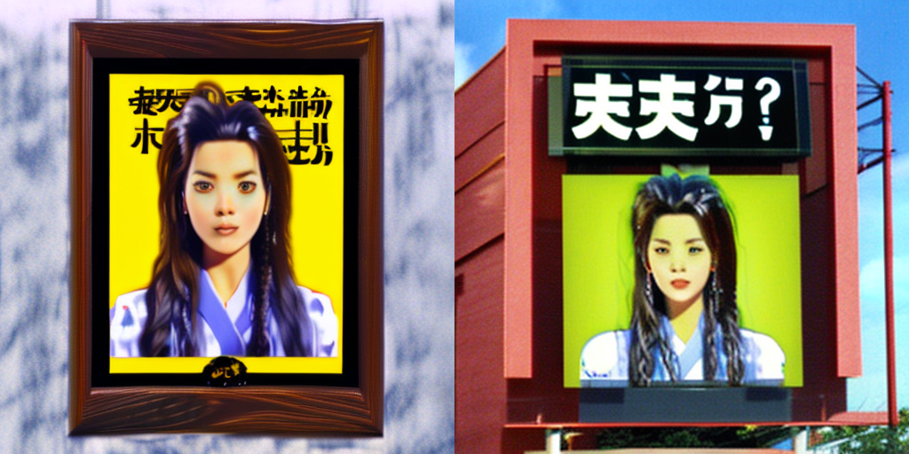

Figure 20-8. The same prompt and hyperparameters with different schedulers

Note that the text in the image is entirely made up, but given that the prompt is about advertisements, the tone is similar. In the picture on the left, the characters represent “loneliness” and “no,” while in the image on the right, they suggest “husband split?”

What’s most interesting is the consistency in the character! For example, consider [Figure 20-9](https://learning.oreilly.com/library/view/ai-and-ml/9781098199166/ch20.html#ch20_figure_9_1748550104889755), in which Misato was painted in the styles of Monet and Picasso. We can see that the features learned by LoRA were consistent enough to (mostly) survive the restyling process.

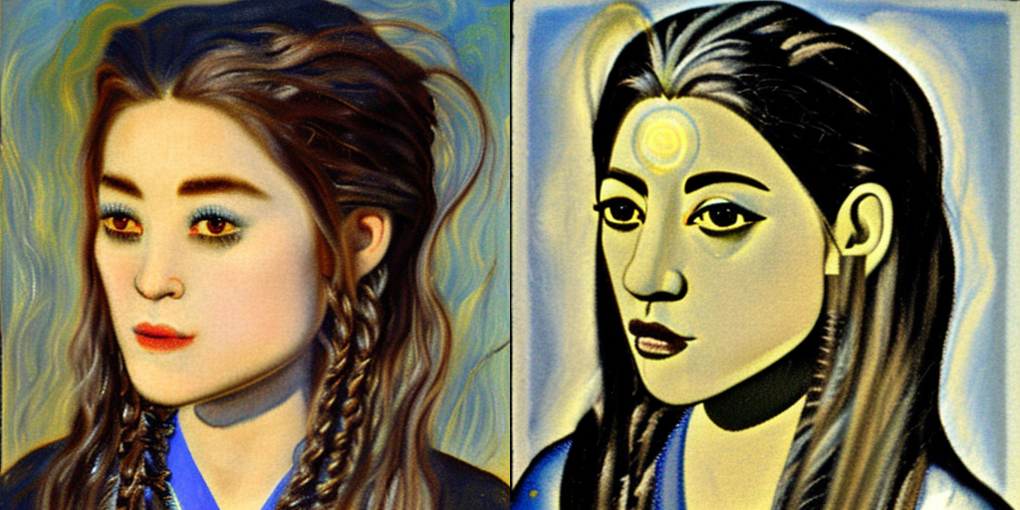

Figure 20-9. Character consistency across styles

This example used Stable Diffusion 2, which is an older model but one that’s easy to tune with LoRA. As you use more advanced models and tune them, you can get much better results, but the time and costs of tuning will be much higher. I’d recommend starting with a simpler model like this one and working on your craft. From there, you can build up to the more advanced models.

Additionally, Misato’s synthetic nature has triggered different features in the LoRA retraining, leading to the new images that have been created from her having a low-res, highly synthetic look. While the images have been close to photoreal to the human eye, they clearly haven’t been to the model, which learned a LoRA that was very CGI in nature and lower resolution than the ones in the training set!

Summary

In this chapter, you had a walk-through of how to fine tune a text-to-image model like stable diffusion by using LoRA and the diffusers library. This technique allows you to customize models for a specific subject or style with a small custom file. In this case, you saw how to tune Stable Diffusion 2 for a synthetic character. In this chapter, you also went through all the steps—from cloning diffusers to creating a training environment for them that included a fully custom dataset. You learned how to use the training scripts to create a new LoRA based on the synthetic character and how to publish that to Hugging Face. Finally, you saw how to apply the LoRA to the model at inference time to create novel images using the LoRA for the Misato character!